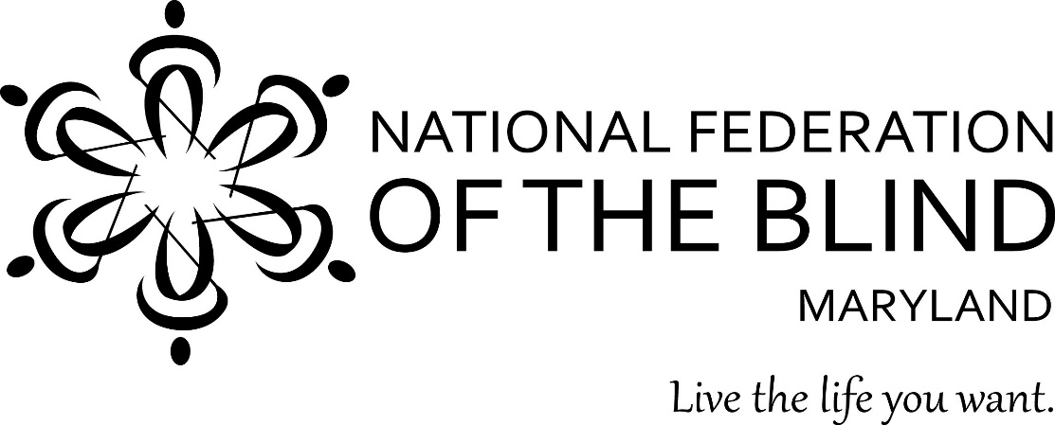
Dear Friend:

On behalf of the National Federation of the Blind of Maryland (NFBMD), we invite you to partner with us. By serving as a sponsor for our 54th NFB of Maryland annual convention, being held November 6-8, 2020 anywhere and everywhere, you will be creating opportunities for the blind of Maryland to live the lives we want. It is also an opportunity for you to access a unique customer base while promoting your establishment as a socially responsible organization.

The NFB of Maryland convention generally attracts approximately five hundred blind and low vision individuals, our families, friends, and blindness professionals. Nonetheless, with a virtual convention this year, we anticipate this number to approximately double. As a sponsor, it is an unparalleled opportunity to reach out to blind individuals, highlight your products and services, and support the programs of the NFB of Maryland.

The funding you provide by serving as a sponsor goes far beyond helping support the important activities of the convention. These resources contribute to our work throughout the year as we implement programs to improve education and employment opportunities, raise awareness, shatter misconceptions, provide resources and advocacy, and promote the independence of the blind throughout Maryland.

In this time of uncertainty, our organization is experiencing significant financial challenges. This is due to physical distancing and public health mandates that have resulted in cancelation of activities that fund the bulk of our work as well as an increased need for advocacy around issues facing the blind due to the pandemic. Consequently, sponsorship is a critical way for us to meet our financial challenges and for your organization to support our efforts in a particularly unique time of need.

The programming of our NFBMD Convention will be robust and engaging. Our virtual Exhibit Hall will afford you the opportunity to interface with our convention participants in a real and meaningful way.

We are therefore inviting you to serve as a sponsor at the 54th Annual Convention of the National Federation of the Blind of Maryland.

We look forward to partnering with you. Enclosed please find information about sponsor opportunities for our 2020 NFB of Maryland Convention. If you have any questions, please contact me at 443-426-4110 or via email at President@nfbmd.org.

With Overwhelming Gratitude,
Ronza Othman, President
National Federation of the Blind of Maryland
National Federation of the Blind of Maryland
2020 Annual Convention
“Rise Up”

November 6-8, 2020
Anywhere and Everywhere!

Sponsorship Opportunities

Title Sponsor: $2,500
This sponsorship level is exclusive to the first sponsor to secure this spot.
An opportunity to address the convention of the NFB of Maryland (approximately one thousand participants in attendance
Full-page ad in the convention agenda
Promotional announcement on the convention live stream
Link to corporate website from www.nfbmd.org
Promotion in NFBMD social media
Two exhibit tables at the NFBMD Virtual Exhibit Hall
Opportunity to share corporate materials throughout the convention and/or provide premium items for distribution to registrants

Independence: $1,500
Opportunity to be promoted as a luncheon, Workshop, or seminar sponsor—for example, sponsor of the parents of blind children seminar
Half-page ad in the convention agenda
Periodic promotional announcement during the convention stream
Link to corporate website from www.nfbmd.org
Promotion in NFBMD social media
One exhibit table at NFBMD Virtual Exhibit Hall

Equality: $1,000
Quarter-page ad in the convention agenda
Link to corporate website from www.nfbmd.org
Promotion in NFBMD social media
One exhibit table at NFBMD Virtual Exhibit Hall

Opportunity: $500
- Listing under convention sponsors in the convention agenda
- Acknowledgement of sponsorship at www.nfbmd.org
- One exhibit table at NFBMD Virtual Exhibit Hall

Exhibitor: $200
One exhibit table at NFBMD Virtual Exhibit Hall

In addition to these opportunities, we are seeking door prizes (minimum $25.00 value), such as cash, tickets, or company items, to be given away during our convention. Given the virtual nature of the Convention, our preference for door prizes is to receive checks, event tickets, or corporate gifts of a non-perishable nature. Please send any donations for door prizes by October 23, 2020 to National Federation of the Blind of Maryland, 1800 Johnson Street, Suite N1, Baltimore, MD 21230. Be sure to include the name of your organization so that we can provide appropriate acknowledgment.

National Federation of the Blind of Maryland
2020 Annual Convention
Sponsor Registration Form

Please return this form via email to President@nfbmd.org by October 9, 2020.

I would like to participate as a:
( ) Title Sponsor ($2,500)
( ) Independence Sponsor ($1,500)
( ) Equality Sponsor ($1,000)
( ) Opportunity Sponsor ($500)
( ) Exhibitor ($200 per table)

Name of Organization:
Address:
City, State, Zip:
Web Address:

Contact Person Name:
Telephone:
Email Address:

If exhibiting, please provide a brief description of your product(s)/Service(s) :

Please send this completed application by October 9, 2020 via email to President@nfbmd.org and mail your check, made payable to the NFB of Maryland, to: National Federation of the Blind of Maryland, 1800 Johnson Street, Suite N1, Baltimore, MD 21230.

