National Federation of the Blind of Maryland

2020 Annual Convention: Rise Up!

Friday, November 6 to Sunday, November 8

AGENDA

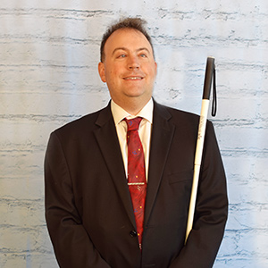
Image: Mark Riccobono
President
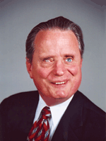
National Federation of the Blind

Image: Marc Maurer
Immediate Past President
National Federation of the Blind

  - The Members of the Board of Directors and
  - the Convention Host Committee
  - Welcome You to the 54th Annual Convention of the
  - National Federation of the Blind of Maryland

Ronza M Othman, President
National Federation of the Blind of Maryland
15 Charles Plaza, #3002
Baltimore, Maryland 21201

Scott White, Chairman
Convention Host Committee

ANYWHERE & EVERYWHERE!

WELCOME!
Welcome to the 54th annual convention of the National Federation of the Blind of Maryland being held anywhere and everywhere. The COVID-19 pandemic has altered the ways we ordinarily connect to advance our movement, but it has not changed the spirit of the Federation. Extraordinary times call for extraordinary measures, in addition to love, hope, and determination that always will transcend distance. Though the format of this year’s convention is new for all of us, there still are many of the same opportunities to learn new things, be inspired by our colleagues, renew Federation family friendships, and participate in the conversations that raise the expectations for blind people. Though apart, we will still build the Federation together.

Special Information for First-Time Attendees:
All first-time convention attendees are cordially invited to attend a First-Timers Orientation from 8 to 9:30 p.m., on Wednesday, November 4. The Ambassadors Committee will walk you through the events that will take place throughout the weekend, explain processes such as door prizes and voting, as well as make sure every first-time convention attendee is matched with a mentor.
Meeting ID: 624 813 8327

INCLUSIVITY, DIVERSITY, AND SOCIAL CONDUCT
We are committed to providing a harassment-free environment for everyone. Thank you for cultivating an atmosphere in which participants from diverse backgrounds can learn, network, and share with each other in an environment of mutual respect. We are committed to diversity, equity, and the free expression of ideas. These principles have been outlined in our code of conduct, which can be found at NFB.org/Code-Conduct.

We recognize a shared responsibility to create and uphold that atmosphere for the benefit of all. Prohibited behaviors include harassment, unwelcome sexual attention, and inappropriate use of the NFBMD virtual convention platform. Prohibited behavior or misuse of the platform will not be tolerated and may result in removal from the convention and/or other consequences. For assistance or to report an incident at the convention, please call 504-621-4162 or email Convention@nfbmd.org for immediate attention. Formal reports can be submitted to the NFB National Office at NFB.org/About-Us/History-and-Governance/Code-Conduct/Grievance-Report-Form. All formal reports will be fully investigated according to the steps in our code of conduct. Thank you for doing your part to contribute to our community and the high expectations we strive to maintain.

ACCESSING THE CONVENTION
The 54th Annual Convention of the National Federation of the Blind of Maryland will be accessible via Zoom, web streaming, Smart Speaker, Newsline, and Direct Dial Conference Line.

Zoom:
Click on the imbedded links in the agenda to launch the Zoom desktop client or mobile application. Alternatively, dial 301-715-8592 and enter the ten- or eleven-digit Conference ID listed in the agenda followed by the pound key.

Web Streaming:
Visit http://nfbmd.org/convention/stream.

Smart Speaker:
Ask your Amazon device to Open Federation of Maryland.

Newsline:
Find the stream on the Maryland information channel.

Direct Dial Conference Line:
Call 339-209-4083.

*Please note, the web stream, Smart Speaker, Newsline, and Direct Dial methods of access are enabled for listening only and do not permit interactive engagement. Consequently, those wishing to engage with the convention, including for the auction, door prizes, and other activities will need to do so using either the Convention Virtual Information Table or via email.

PREREGISTRATION AND LATE REGISTRATION
Preregistration:
Convention preregistration was conducted online and closed on October 16. Those who preregistered will receive exclusive email announcements and be eligible to win door prizes during convention. In order to be eligible to cast votes in state elections and the consideration of resolutions, individuals must have:
- preregistered for the convention on or before October 16;
- paid 2020 chapter and/or division dues to an NFBMD chapter and/or division prior to September 30; and
- enrolled in the NFBMD voting platform on or before October 16.

Late Registration:
Late registration is available online only and is available at NFBMD.org/Convention. Late registration costs $25 per person.

If you did not preregister, you are strongly encouraged to register using the online portal. NFBMD would like to have contact information for those participating in the convention to communicate important information and opportunities. Those who do not register may attend all convention events as listed in the agenda that follows.

VIRTUAL INFORMATION TABLE
NFBMD will offer a Virtual Information Table throughout the convention to provide assistance, confirm eligibility for door prizes, sign up for committees, bid on auction items, and conduct other business. The Virtual Information Table is available via email at Convention@nfbmd.org or by phone at 410-261-4550. It will operate on Friday, November 6, from 10:30 a.m. to 6 p.m.; Saturday, November 7, from 8 a.m. to the end of the banquet; and Sunday, November 8 from 8:30 a.m. to adjournment.

EXHIBIT HALL
The NFBMD exhibit hall will be virtual and consist of three components this year. The live components will operate on Friday, November 6, from
1 to 5 p.m.
- Exhibitor Virtual Showcase: Exhibitors and sponsors will address the convention during the Exhibitor Virtual Showcase on November 6, from 1 to 3 p.m.
- Exhibitor Office Hours: Visitors to the NFBMD Exhibit Hall will be able to directly interact and conduct business with exhibitors and sponsors from 3 to 5 p.m., on November 6. Each participating exhibitor and/or sponsor will be available remotely to answer questions, share information, and transact business.
- Exhibitor Information Page: Exhibitor and sponsor information, including customer service information, will be available at NFBMD.org/ExhibitHall.

DOOR PRIZES
In order to be eligible to win door prizes, convention attendees must have pre-registered for the convention on or before October 16. When a person’s name is called for a door prize, that individual must let the Door Prize Committee know within two minutes that the individual is present. Winners can raise their hands in Zoom, send email to DoorPrizes@nfbmd.org, or call the Virtual Information Table at
410-261-4550. Winners must give the code word when calling the Virtual Information Table or sending emails. They also may be asked to give the code word if using Zoom via telephone so the committee can verify the identities of those whose names do not appear in Zoom. The code word will be announced when the door prizes are drawn.

PRE-AUTHORIZED CONTRIBUTION PROGRAM
We encourage all convention participants to join the NFB Pre-Authorized Contribution (PAC) Program. This program raises funds for the National Federation of the Blind by automatically debiting your checking account or charging your credit card the specified monthly amount you designate. Individuals are encouraged to enroll in the PAC Program, or if already enrolled, raise their monthly contributions. NFBMD will enter into a drawing any individual from Maryland who, during the 2020 State Convention, enrolls in the PAC Program or raises their monthly contributions. The winner of the drawing will receive lodging at the 2021 NFBMD annual convention.

NFBMD will not take financial and banking information this year. Instead, we will assist in completing the online PAC form for those who would like assistance. The form is located at NFB.org/PAC. Individuals may call the NFBMD PAC Hotline at 410-618-4151 during the convention for assistance in completing the form. Individuals who complete the form themselves should send a copy of the email confirmation they receive to PAC@nfbmd.org in order to be entered into the drawing. The National Center staff will contact individuals for financial and banking information following the convention. Individuals who complete the form but do not actually enroll in or increase their contributions to the PAC Plan will be determined ineligible for the drawing prize.

NFBMD CONVENTION TOURS
The Convention Host Committee is finalizing plans for virtual tours. Visit NFBMD.org/Convention for the most up-to-date information about this year’s tours.

VOTING
Those individuals who: 1) enrolled in the voting platform prior to October 16, 2020; 2) pre-registered for the convention prior to October 16, 2020; and 3) were dues paying members in good standing of an NFBMD chapter or division on or before September 30, 2020 are eligible to vote during the convention. To vote, eligible individuals may text or call 916-915-0920. We will practice voting on a question with no policy implications during the convention weekend.

NFBMD CONVENTION BREAKFAST CLUB
We will hold a meeting every morning throughout the convention to help orient participants to that day’s activities and provide access information for specific events. The Breakfast Club will take place on Friday from 8 – 8:45, Saturday from 7:30 – 8:15, and Sunday from 8 – 8:45. To participate, call 339-209-4083.

SPECIAL ATTENTION ITEMS
- The convention agenda has been assembled using Eastern Standard Time (EST). Please be mindful to convert published times to your appropriate time zone.
- Banquet tickets will neither be sold nor exchanged this year. You are encouraged to arrange for your favorite entrée and imagine yourself at a table of 10 at 7 p.m. on Saturday night.
- Darlene Price is the chairman of the Door Prize Committee, and the Convention Host Committee is responsible for gathering door prizes. Please contact Convention Host Committee Chairman Scott White at Swhite@nfb.org or at 410-868-9519 to arrange to contribute door prizes. Due to the virtual nature of the convention, we request door prize donations be monetary in nature. You must be registered for the convention and present when your name is called in order to win a door prize. Door prizes will be awarded during the general sessions on Saturday and Sunday and during the convention banquet.
- Mike Bullis is the Chairman of the National Funding Support Committee, which manages our Convention Auction. Please consider donating experiences and commitments to make baked goods, such as cooking lessons for this auction. Please contact Convention Host Committee Chairman Scott White at Swhite@nfb.org or at 410-868-9519 to arrange to contribute auction items.
- You are strongly encouraged to have your NFB membership coins with you during the NFBMD Convention and keep them in your possession at all times. There may be specific incentives, activities, and prizes for those carrying their NFB membership coins.
- The Maryland Parents of Blind Children Division Seminar will be convened virtually. Information for this year’s seminar can be found at NFBMD.org/Convention. Visit the site to register for the conference and to find a full agenda for adult and family events.
- The Maryland Seniors Issues Division Seminar will be convened virtually. Information for this year’s seminar can be found at NFBMD.org/SeniorSeminar. Visit the site to register for the conference and to view the agenda.
The Ambassadors Committee will hold an orientation for first-time convention attendees on Wednesday, November 4, beginning at 8 p.m. This meeting is for those attending the National Federation of the Blind of Maryland Convention for the first time and/or those attending the NFBMD convention virtually for the first time. Come to get oriented to the activities that will take place throughout the weekend. Get all of your questions answered.
Meeting ID: 624 813 8327

  - Organization Information

National Federation of the Blind of Maryland
15 Charles Plaza, #3002, Baltimore, MD 21201
443-426-4110; President@nfbmd.org

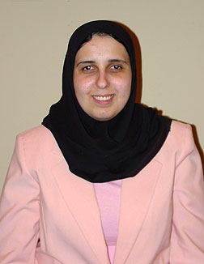
Image: Ronza Othman
President
National Federation of the Blind of Maryland
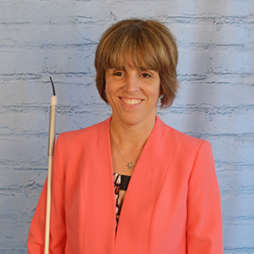
Image: Pam Allen
President and National Representative
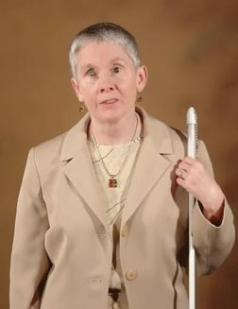
National Federation of the Blind of Louisiana
Image: Sharon Maneki
Immediate Past President
National Federation of the Blind of Maryland

Officers:
Ronza Othman, President, Baltimore
Deborah Brown, First Vice President, Rockville
Anil Lewis, Second Vice President, Baltimore
Judy Rasmussen, Secretary, Kensington
Shawn Jacobson, Treasurer, Olney

Board of Directors:
Dezman Jackson, Baltimore
Sharon Maneki, Columbia
Maurice Peret, Baltimore
Melissa Riccobono, Baltimore
Melba Taylor, Bowie
Marguerite Woods, Baltimore

Our Credo
The National Federation of the Blind knows that blindness is not the characteristic that defines you or your future. Every day we raise the expectations of blind people, because low expectations create obstacles between blind people and our dreams. You can live the life you want; blindness is not what holds you back!

The National Federation of the Blind Pledge
I pledge to participate actively in the efforts of the National Federation of the Blind to achieve equality, opportunity, and security for the blind; to support the policies and programs of the federation; and to abide by its constitution.

About the National Federation of the Blind of Maryland
The National Federation of the Blind of Maryland (NFBMD), an affiliate of the National Federation of the Blind (NFB), is an organization of blind people and their friends. We believe in the full capacity of blind people; we have the power, influence, diversity and determination to help transform our dreams into reality. Our members work together for a brighter tomorrow by raising the expectations for blind people everywhere so that blind persons can live the lives they want.

Who We Are
The National Federation of the Blind of Maryland is a 501c(3) nonprofit made up of blind people of all ages, and their families and friends. Our strong local chapters and divisions, and well-trained leaders help newly blind people adjust to vision loss and promote the full participation and integration of blind people in our communities. We bring our collective experiences together to effect change at the state and national level.

What We Do
- Assist blind persons to acquire the skills of independence
- Help blind persons to develop confidence in themselves through our many service activities
- Teach blind persons the skills of leadership through active participation in conventions, chapter meetings, and civic activities
- Encourage blind seniors to continue their active and meaningful lifestyles
- Prepare blind students for productive tax-paying careers through academic and training scholarships
- Inform people with diabetes about their options for coping with vision loss
- Support parents and friends of blind children with information about the capabilities of the blind
- Protect and promote the civil rights of blind persons through public education and legislative action
- Advocate for policies that eliminate discrimination and guarantee equal access to educational programs and high-quality rehabilitation
- Educate the public through seminars, community activities and our publications
AdNet Advertisement: AdNet Advocates for Workplace Excellence and Equality
Leader in providing professionals with Accounting/Finance, Human Resource and Legal expertise
Serving the blind, deaf and mobility impaired community in their workplace by providing Reasonable Accommodations Support Services to government and corporate entities.
Contact Betsy Cerulo, CEO, bcerulo@adnetp3.com, 410-715-4035

LIVE THE LIFE YOU WANT

Lyrics copied from October 2015 Presidential Release

Chorus: Live the life you want. Nobody can stop you.
Shoot for the sun and break on through.
So you're blind. You'll be fine. We've got good news!
You can live the life you want. Yes, we know the truth.

Grab a cane, get trained, gotta get movin'.
Make a change in the wage, that's what we're doin'.
Come with me, yeah

Chorus

You and me, NFB, let's dream together.
NFB, you and me, lives on forever.
You will see yeah

Chorus

You can live the life you want. You’ll know the truth.

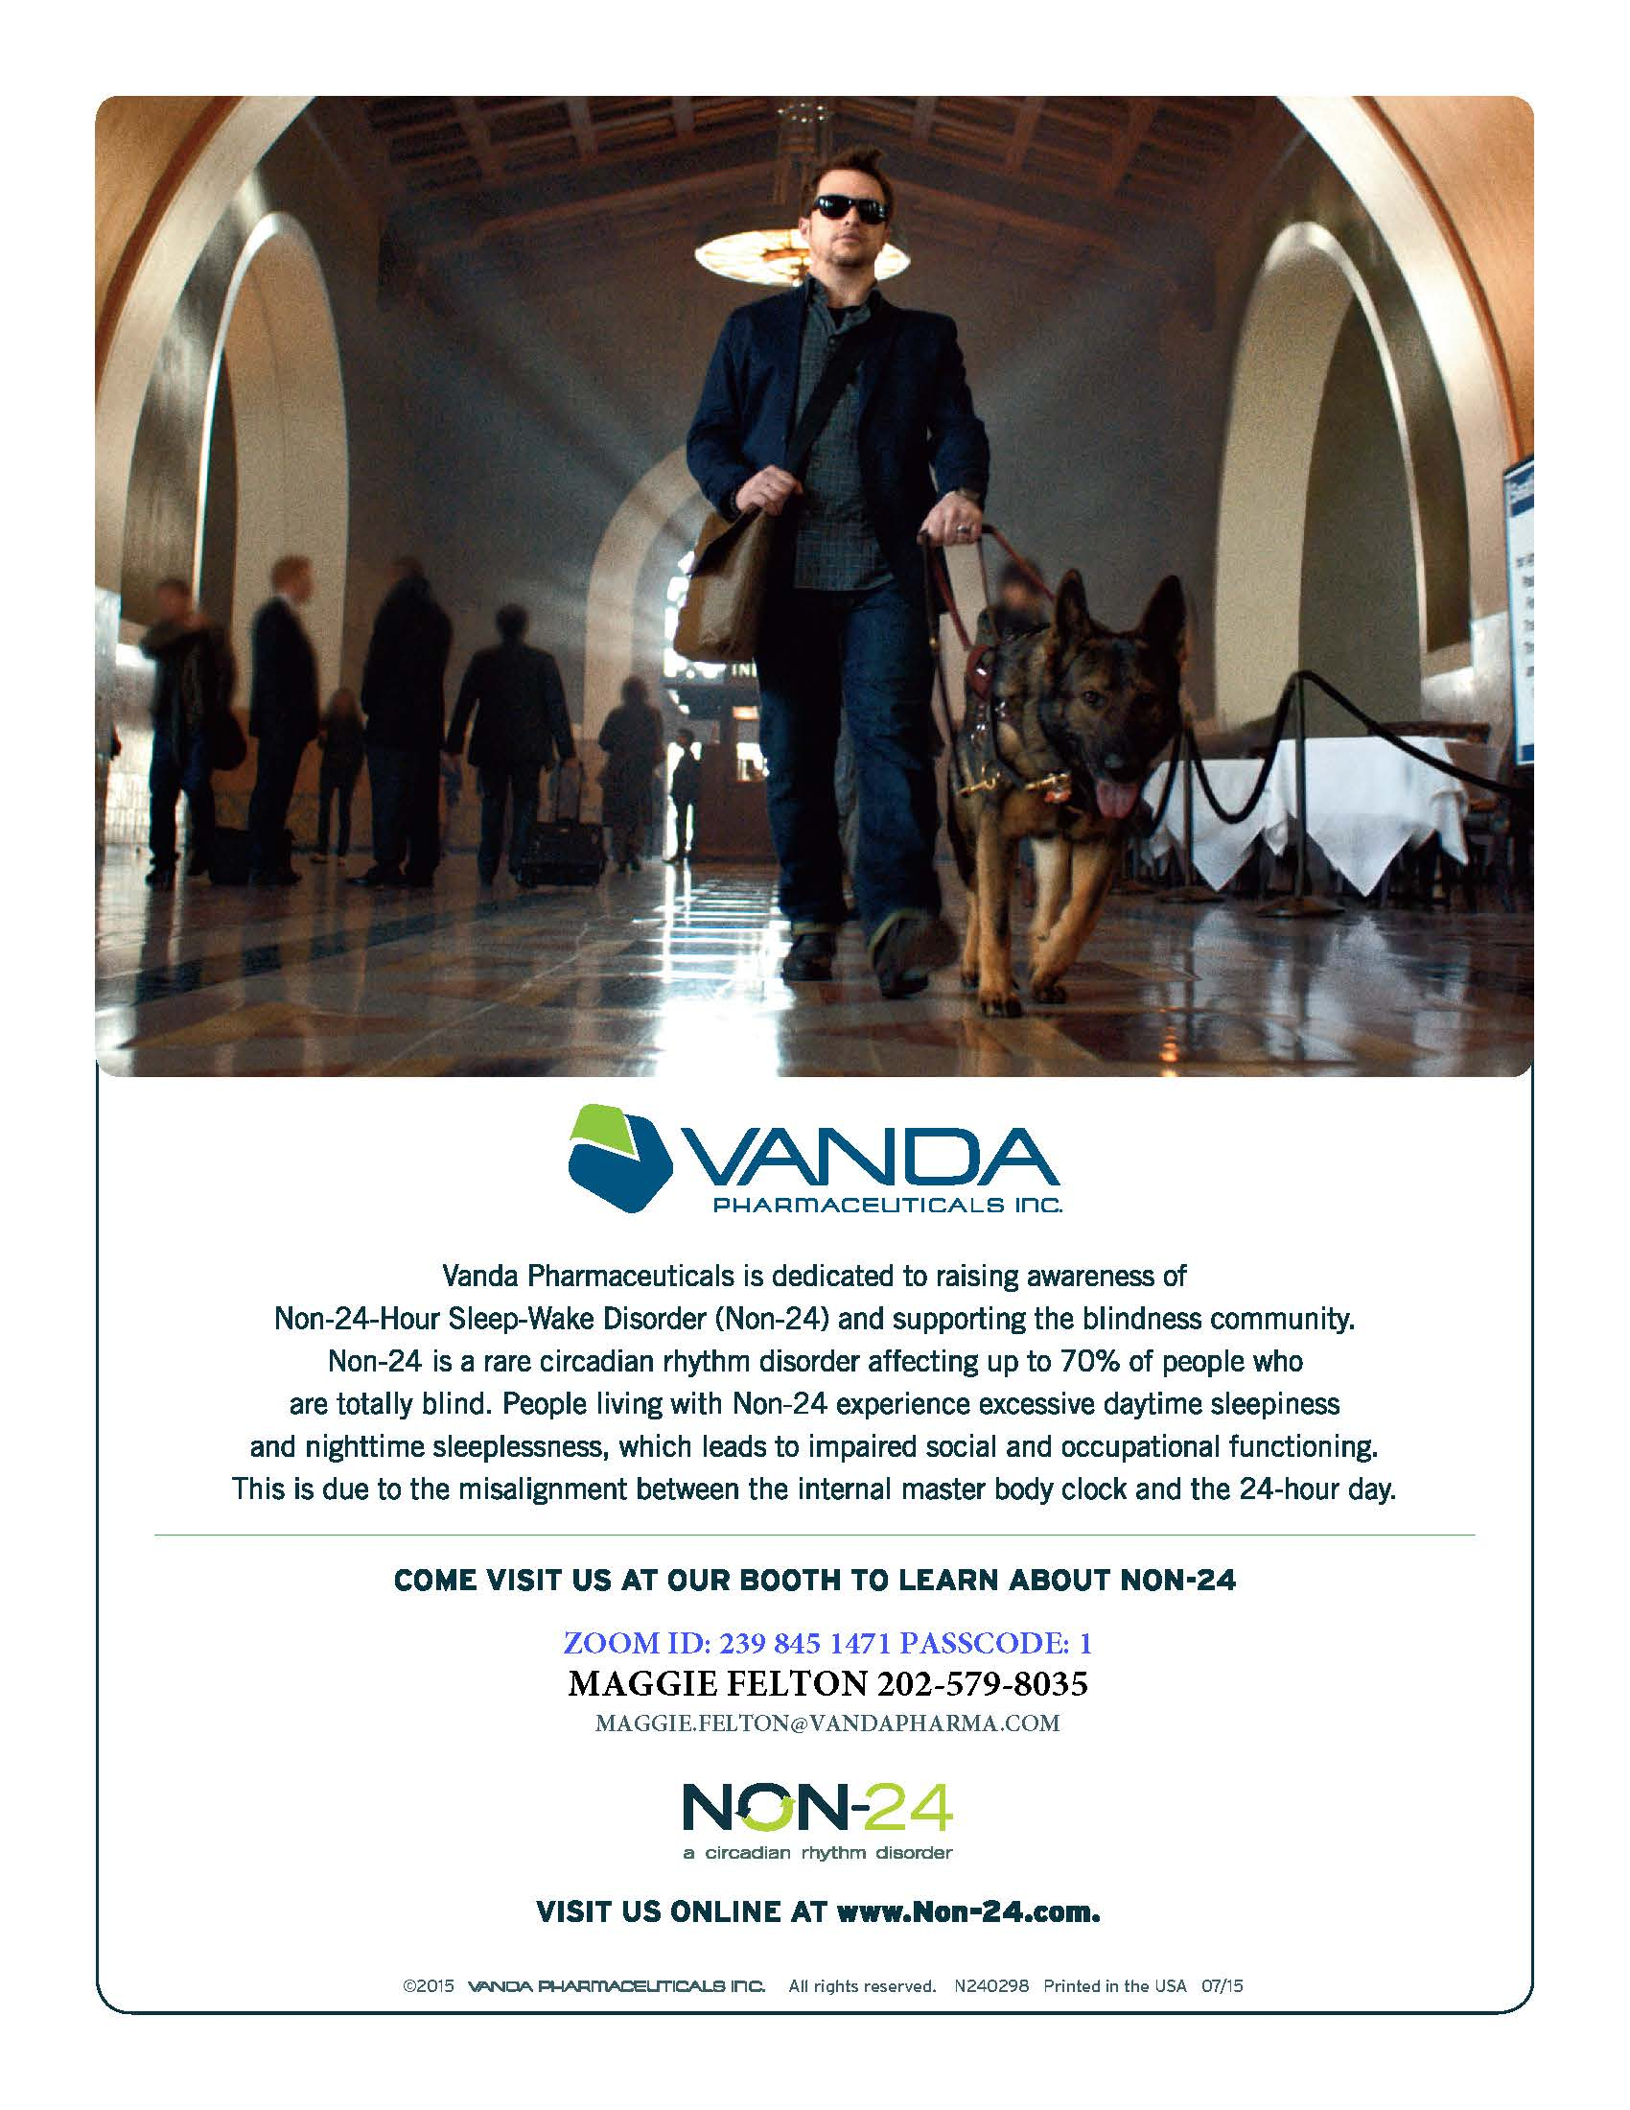
Vanda Pharmaceuticals Advertisement: Vanda Pharmaceuticals is dedicated to raising awareness of Non-24-Hour Sleep-Wake Disorder (Non-24) and supporting the blindness community. Non-24 is a rare circadian rhythm disorder affecting up to 70% of people who are totally blind. People living with Non-24 experience excessive daytime sleepiness and nighttime sleeplessness, which leads to impaired social and occupational functioning. This is due to the misalignment between the internal master body clock and the 24-hour day. Come visit us at our booth to learn about non-24. Zoom ID: 239 845 1471 Passcode: 1; Maggie Felton 202-579-8035, Maggie_felton@vandapharma.com
Visit us online at www.non-24.com.

We Extend Profuse Thanks to the Following Convention Sponsors:

Title Level Sponsor
Vanda Pharmaceuticals

Independence Level Sponsors
AdNet/AccountNet, Inc.
Maryland Relay

Equality Level Sponsors
Blind Savvy USA, LLC
Brown, Goldstein and Levy LLP
Sipbound Corporation

Opportunity Level Sponsors
Friends of the Maryland State Library for the Blind and Print Disabled
Maryland Technology Assistance Program
The Flower Barn and The Clayground Studio and Gallery
The Low Vision Shop

Freedom Level Sponsor
3DPhotoWorks
Custom Canes / You Cane Give

CHAPTERS AND DIVISIONS OF
THE NATIONAL FEDERATION OF THE BLIND OF MARYLAND

At Large Chapter
Marguerite Woods, president, 443-271-1668, mmwoods719@gmail.com
Monthly meetings third Tuesday at 7:30 p.m., via phone:
(605) 313-4818, access code 720125

Baltimore County Chapter
Ruth Sager, president, 410-602-9030, rsager78@gmail.com
Monthly meetings fourth Wednesday in Pikesville

Central Maryland Chapter
Graham Mehl, president, 301-875-8295, blind@trailstone.com
Monthly meetings first Tuesday in Columbia

Eastern Shore Chapter
Heather Guy, president, 410-430-8954, hguy403@comcast.net
Monthly meetings second Saturday in Salisbury

Greater Baltimore Chapter
Anil Lewis, president, 410-659-9314, ext. 2374, alewis@nfb.org
Monthly meetings third Saturday in Baltimore

Greater Carroll County Chapter
Brian Keseling, president, 410-855-5605, bkmaverick@gmail.com
Monthly meetings second Tuesday in Westminster

Greater Cumberland Chapter
Jean Faulkner, president, 301-729-8942
Monthly meetings third Wednesday in Cumberland

Maryland Association of Blind Students
Qualik Ford, president, 301-312-9813, qsford@outlook.com
Periodic meetings throughout the year

Maryland Association of Blind Merchants
Melba Taylor, president, 240-381-1637, m.taylor@encoreassoc.com
Periodic meetings throughout the year

Maryland Parents of Blind Children
James “Garret” Mooney, president, 480-433-8003, james.garret.mooney@gmail.com
Periodic meetings throughout the year

National Harbor Chapter
Amber Woods, president, 301-978-6686, woodsamber83@gmail.com
Monthly meetings fourth Saturday in Suitland

Senior Issues Division
Ruth Sager, president, 410-602-9030, rsager78@gmail.com.
Periodic meetings throughout the year

Sligo Creek Chapter
Debbie Brown, president, 301-881-1892, Deborahb14@verizon.net
Monthly meetings second Saturday primarily in Silver Spring

TLC Chapter
Meleah Jensen, president, 504-621-4162, MeleahHeather@gmail.com
Meetings third Thursday in Towson

MARYLAND RELAY
Telecommunications Access of Maryland (TAM) is a division of the Maryland Department of Disabilities and operates the Maryland Relay and Maryland Accessible Telecommunications programs. Maryland Relay is a free, public service for individuals who are Deaf, hard of hearing, DeafBlind, or speech-disabled that enables them to communicate using the telephone. The Maryland Accessible Telecommunications (MAT) program offers a wide variety of solutions and tools—from amplified phones to Braille TTYs to tablets— needed to independently make or receive phone calls.

Visit www.mdrelay.org for information.

COMMITTEES OF THE
NATIONAL FEDERATION OF THE BLIND OF MARYLAND
If you’re interested in being appointed to a particular committee, notify the NFBMD president at president@nfbmd.org or 443-426-4110.

Advocacy Committee
Sharon Maneki, chairperson

Ambassadors Committee
Judy Rasmussen, chairperson

Audit Committee
Barry Hond, chairperson

BELL Committee
Lizzy Muhammad Park, chairperson

Braille Spectator Committee
Ronza Othman and Sharon Maneki, editors

Deaf-Blind and Hearing Loss Issues Committee
Janice Toothman, chairman

Development and Fundraising Committee
Anil Lewis and Shawn Jacobson, co-chairpersons

Diversity and Inclusion Committee
Anil Lewis, chairperson

Employment Committee
Pam Goodman, chairperson

Guide Dog Issues Committee
Ashley Alvey and Janice Toothman, co-chairpersons

Legislation Committee
Sharon Maneki, chairperson

Membership Committee
Dezman Jackson, chairperson

PAC Plan Committee
John G. Paré Jr., chairperson
Stephanie Flint, vice chairperson

Public Relations Committee
Chris Danielsen, chairperson

Resolutions Committee
Jesse Hartle, chairperson

Scholarship Committee
Mildred Rivera, chairperson

Sharon Maneki Youth Empowerment Grant Committee
Sharon Maneki, chairperson

Social Media Committee
Karen Anderson, chairperson

Website and Technology Committee
Graham Mehl, chairperson

Youth Activity Committee
Lizzy Muhammad Park, chairperson

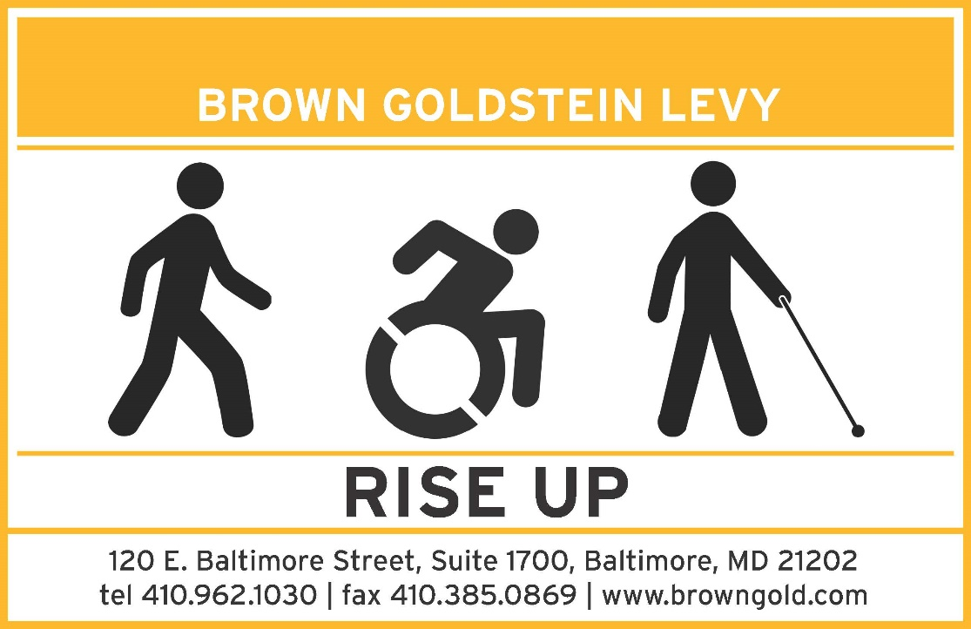
Brown Goldstein Levy Advertisement Rise Up
120 E. Baltimore Street, Suite 1700, Baltimore, MD 21202
tel. 410.962.1030; fax 410.385.0869; www.browngold.com

Convention-Related Committees:

Anna Freysz Cable Award Committee
Debbie Brown, chairperson

Convention Host Committee
Scott White, chairperson

Convention Organization and Activities
Meleah Jensen, chairperson

Convention Registration Committee
Marie Marucci, chairperson

Distinguished Educator of Blind Children Award Committee
Teresa Graham, chairperson

Door Prize Committee
Darlene Price, chairperson

Jennifer Baker Award Committee
Trudy Pickrel, chairperson

Kenneth Jernigan Award Committee
Dr. Marc Maurer, chairperson

National Funding Support Auction Committee
Michael Bullis, chairperson

Nominating Committee
Ellen Ringlein, chairperson

Leaving A Legacy

Dream Makers Circle
You can help build a future of opportunity for the blind by becoming a member of our Dream Makers Circle. It is easier than you think. Just visit your bank and convert an account to a P.O.D. (payable on death) bank account, which is payable after your passing to the National Federation of the Blind or the National Federation of the Blind of Maryland. Your legacy gift to the National Federation of the Blind or the National Federation of the Blind of Maryland can be made in the form of a will or living trust, an income generating gift, or by naming us as the beneficiary of a retirement plan, IRA, pension, or a life insurance policy. You can designate a specific amount, a percentage, or list NFB as one of several beneficiaries. For additional information, please contact Patti Chang at 410-659-9314, ext. 2422, or at pchang@nfb.org.

Voice, Data and Cloud Services
877-336-7747
www.cloudsouth.com
877-336-7747

Blind Savvy USA, LLC
Your Disability Trainers and Advisors
www.blindsavvyusa.com
congratulates the National Federation of the Blind of MD on your first virtual convention!
“Thanks for all you do for blind people!”

STAY CONNECTED AND INFORMED:
Follow the National Federation of the Blind of Maryland on Twitter:
Twitter.com/NFBMD

Friend the National Federation of the Blind of Maryland on Facebook: Facebook.com/NationalFederationoftheBlindofMaryland
Stay connected with your fellow Maryland Federationists by joining our state email listserv. This list allows you to receive affiliate and national announcements, and also start and participate in discussions regarding blindness and blindness issues. To sign up, visit NFBnet.org, click on “Join or Drop NFB Mailing Lists,” activate “NFBMD” link, and follow the instructions. Many of our local chapters also now have listservs. Talk to your chapter president to learn how to sign up so you don’t miss important information about chapter news and events.

Visit our website at NFBMD.org. Check out our blog for the President’s Messages. We welcome blogposts from all of our members. Be sure to check out the Blindness Resources link, and the Know Your Rights link to keep up to date on important information. Be sure to download and print “About NFBMD,” in the “About Us” tab on NFBMD.org, for use at chapter outreach events.

STRIVE
Lyrics by Barbara Elliott

Sometimes people tell me blind people should be quiet and sit down
But I say "No!" I say "No!" I say "No."
They contend that I should be content to let others lead me around,
But I say "No!" I say "No!" I say "No."
Everybody needs somebody to help sometimes, but I'm in charge of me,

CHORUS: I've gotta strive, strive, strive a little farther,
Reach, reach, reach a little longer,
Work, work, work a little harder,
Hope, hope, hope a little stronger.
Watch me, watch me, watch me.
Nothin's gonna stop me, stop me, stop me.
I'm spreading my wings, soaring on a dream,
I can do anything!
I gotta be brave even when I'm afraid to do hard things.
I'll tell myself "Go!" I'll just go, I will go.
I'm not a fool; I need training and tools to live out my dreams.
So I'll say "Go!" I'll just go, I will go.
I'm not a passenger in my life. I'm gonna take control and drive.

Chorus

EXPANDING OUR PROMINANCE IN MARYLAND

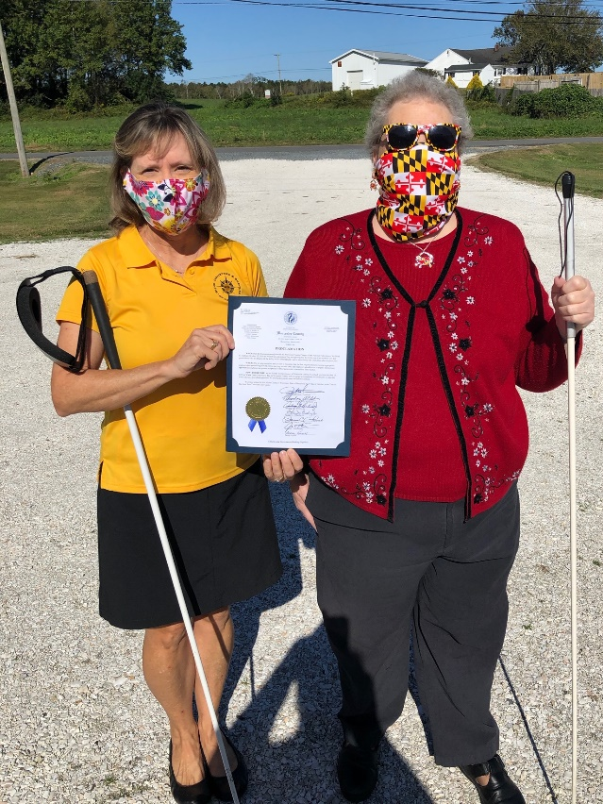
Image: NFBMD Eastern Shore Chapter Members Amy Crouse and Mary Elligson
receive White Cane Awareness Day Proclamation for Worcester County

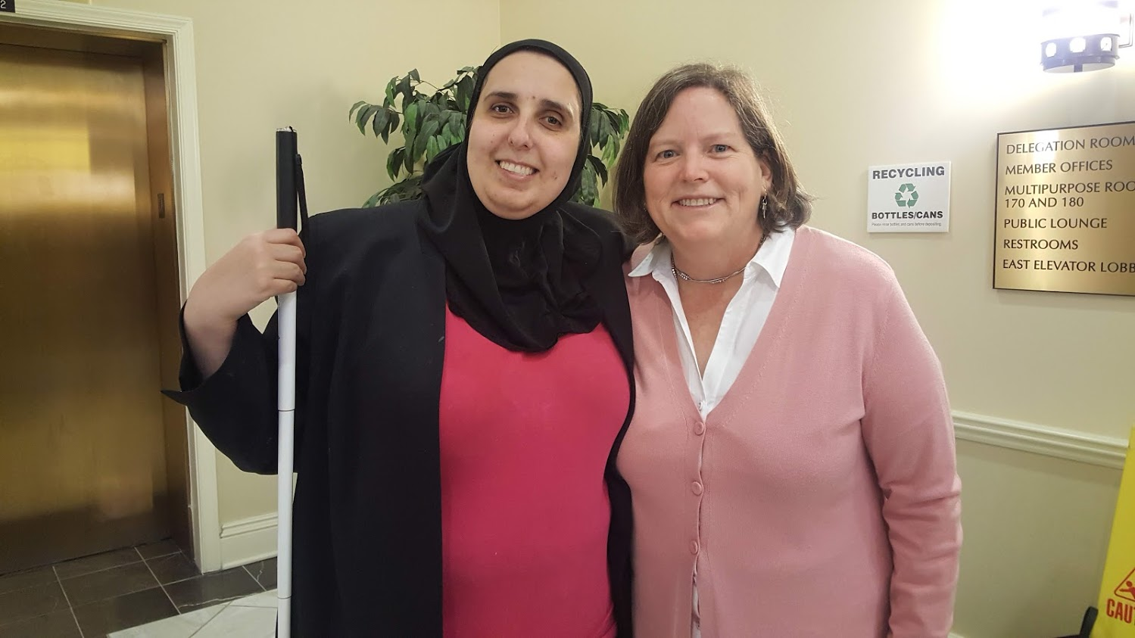
Image: NFBMD President Ronza Othman with Delegate Cathi Forbes in Annapolis advocating to modernize the name of our Library so it becomes the Maryland Library for the Blind and Print Disabled
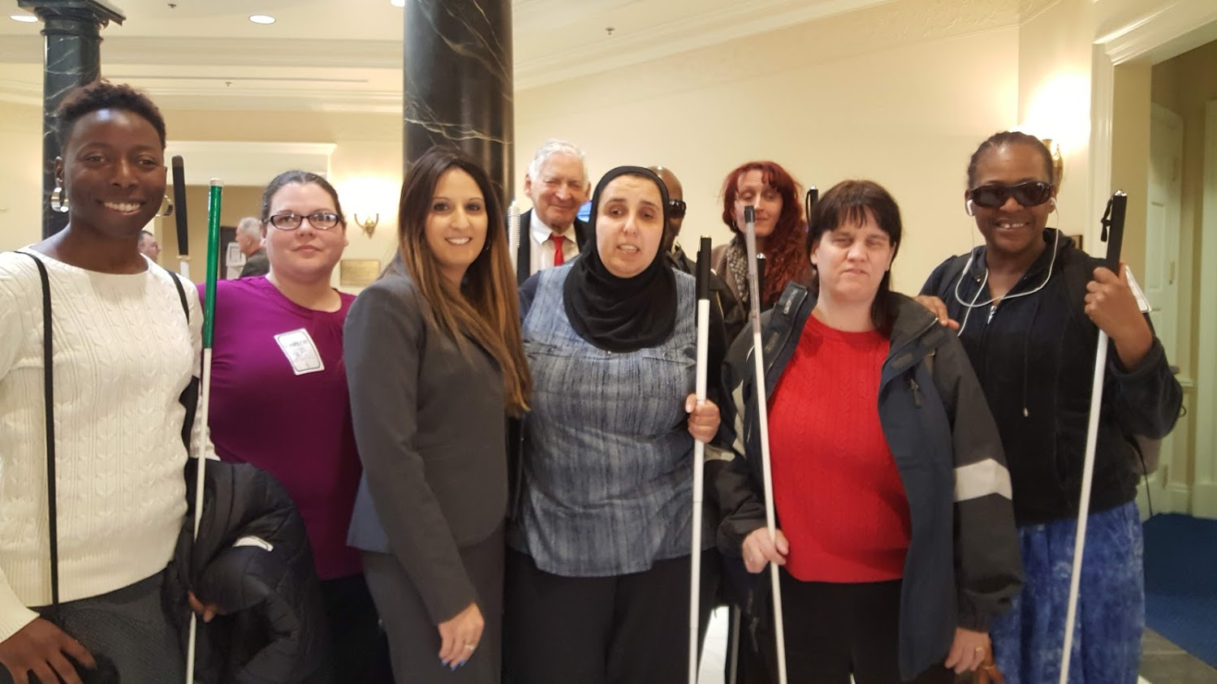
Image: NFBMD engaged in legislative advocacy in Annapolis with Delegate Attar fighting for access to information concerning electric low-speed scooters

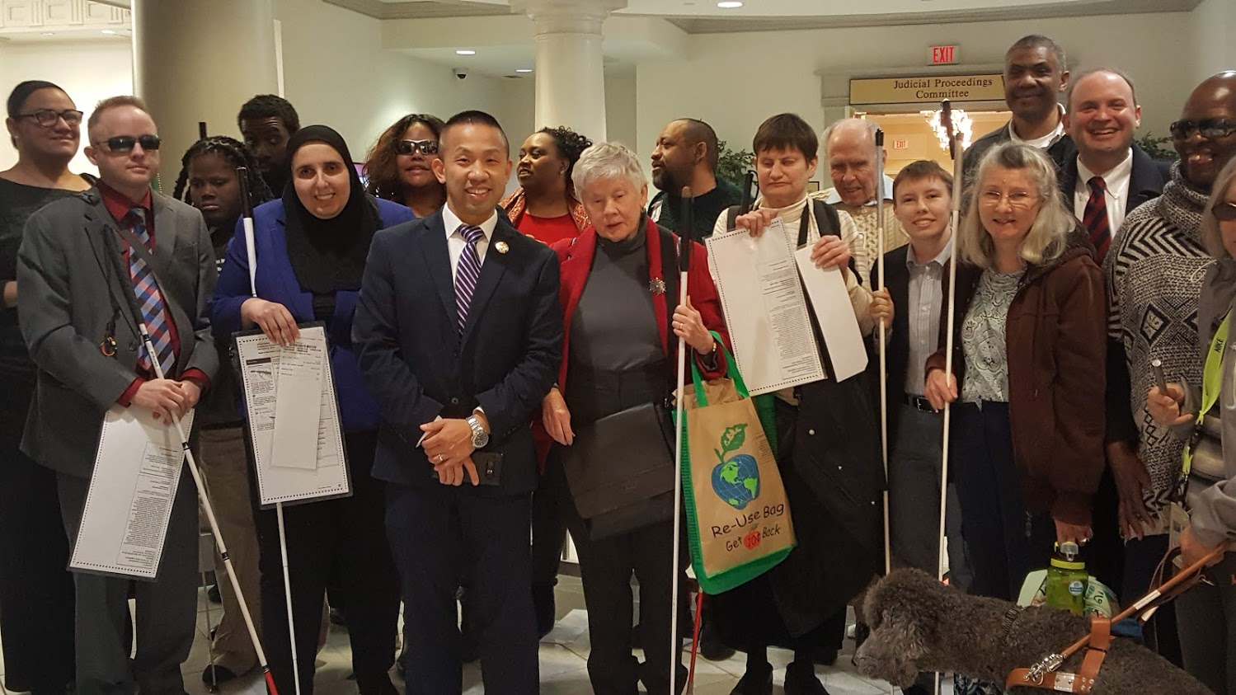
Image: NFBMD engaged in legislative advocacy in Annapolis with Senator Clarence Lam fighting for desegregated voting based on disability

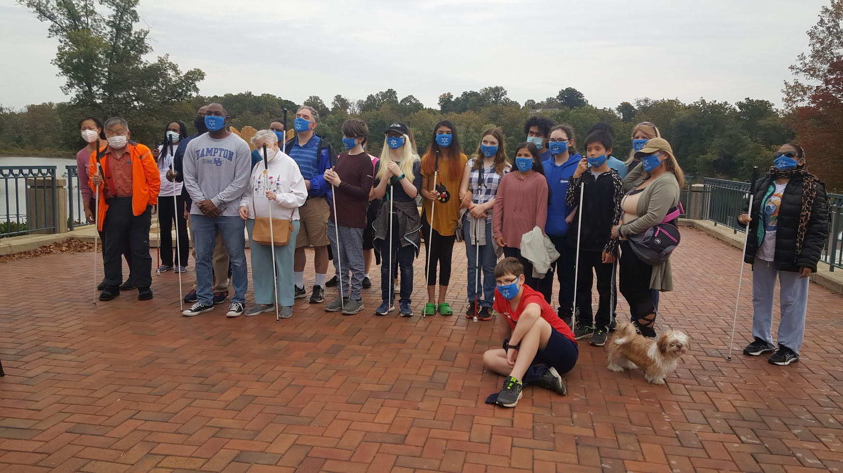
Image: NFBMD Central Maryland Chapter Meet the Blind Month Hike with Councilman Opel Jones

  - Convention Agenda

FRIDAY, NOVEMBER 6

9 a.m. to 12 p.m.—Annual Conference for Parents and Teachers of Blind Children: Maryland Parents of Blind Children
Meeting ID: 898 9205 8751

We will learn about the best ways to advocate for your child under the conditions of COVID-19. Also, we will have presenters from the Colorado Center for the Blind and the Louisiana Center for the Blind explain how their summer programs can make up for any lost instruction as a result of COVID-19. Additionally, parents can learn how to cope with the stresses of our new virtual world.

Host: Garret Mooney, president, Maryland Parents of Blind Children Division; Baltimore, Maryland

9 to 10:30 a.m.—NFBMD Board of Directors Meeting (Open to All)
Meeting ID: 624 813 8327

This is an official business meeting.

10:30 to 11:30 a.m.—Resolutions Committee Meeting
Meeting ID: 942 0234 6609

All are welcome!

Host: Jesse Hartle, Resolutions Committee chairperson, National Federation of the Blind of Maryland; Lutherville, Maryland

11:30 to 1 p.m.—NFBMD New Member Town Hall
Meeting ID: 930 5016 1538

Come learn about the NFB and the NFB of Maryland, how to become a member, why to become a member, and what makes the NFB unique. This town hall is for those who are new to the NFB, those who are interested in joining, and those who have questions about the organization.
Hosts: Jeannie Massay, treasurer, National Federation of the Blind; chairperson, NFB Membership Committee; Norman, Oklahoma
Dezman Jackson, Membership Committee chairperson; Board Member, National Federation of the Blind of Maryland; Baltimore, Maryland

1 to 4 p.m.—Living Successfully with Vision Loss – Tips and Tricks
Meeting ID: 991 6981 2809

Learn about regaining independence after losing vision. All are welcome!

Host: Ruth Sager, president, Maryland Senior Issues Division, National Federation of the Blind of Maryland; Baltimore, Maryland

1 to 5 p.m.—Exhibits
Meeting ID: 624 813 8327

Check out the latest offerings from a variety of companies and organizations that provide technology and services for the blind.

Host: Jen White, Sponsorship and Exhibits coordinator; Owings Mills, Maryland

1 to 3 p.m.—Exhibitor Showcase
Come hear about the products and services NFBMD sponsors and exhibitors have to offer.

3 to 5 p.m.—Exhibitor Office Hours
Connect directly with NFBMD sponsors and exhibitors to ask questions, get additional information, and transact business. Visit NFBMD.org/ExhibitHall to get direct connect information.

3 to 4 p.m.—Blind Parents Meeting
Meeting ID: 810 4428 4520

Share tips and tricks on how to parent using non-visual techniques. Network with other blind parents and caregivers.

Host: Melissa Riccobono, chairman; Baltimore, Maryland

3 to 4 p.m.—Maryland Career Mentoring Mixer
Meeting ID: 977 0927 2542

Are you a participant in the NFB Career Mentoring Program? Are you interested in becoming a mentor? Are you between the ages of 14 and 21? If you answered “yes” to any of these questions, this session is for you. Come network and mingle with current and prospective participants in the NFB Career Mentoring Program.

Host: National Federation of the Blind of Maryland

4 to 5 p.m.—At-Large Chapter Mixer
Meeting ID: 942 1497 1127

The At-Large Chapter will meet to network.

Host: Marguerite Woods, president; Baltimore, Maryland

4 to 7 p.m.—Student Workshop
Meeting ID: 973 7060 8918

Come learn about matters of interest to students including how to self-advocate in school, with potential employers, and in the world. Learn what resources are available for students.

Host: Qualik Ford, president, Maryland Association of Blind Students Division; Baltimore, Maryland

5 to 6 p.m.—Deaf-Blind and Hearing Loss Issues Committee Meeting
Meeting ID: 834 5402 4569

Share strategies and ideas to maintain independence. Anyone interested is invited to attend.

Host: Janice Toothman, chairman; Bowie, Maryland

5:30 to 7 p.m.—Maryland Association of Blind Merchants Symposium and Networking Mixer
Meeting ID: 950 7772 4586

Come learn about matters of interest to blind merchants and network with fellow blind entrepreneurs.

Host: Melba Taylor, president, Maryland Association of Blind Merchants Division; Bowie, Maryland

6 to 7 p.m.—Parent and Families Networking Hour
Meeting ID: 831 9061 1917

Participants of the Parent and Teacher Seminar, as well as those with school-aged children are invited to a networking event. This is an opportunity for families to chat and get to know one another.

Host: Garret Mooney, president, Maryland Parents of Blind Children Division; Baltimore, Maryland

6 to 7 p.m.—Protecting the Rights of Guide Dog Users
Meeting ID: 943 3945 6573

Share strategies and ideas on how to ensure the rights of guide dog users are protected.

Hosts: Ashley Alvey, co-chairman; Baltimore Maryland; Janice Toothman, co-chairman; Bowie, Maryland

7 to 8:30 p.m.—Virtual Picnic and a Play
Meeting ID: 624 813 8327

The Braille is Beautiful players will perform “Sorry Wrong Number,” an NFBMD favorite.

Host: Debbie Brown, play director; first vice president, National Federation of the Blind of Maryland; Rockville, Maryland

8:30 - 10:00 p.m.—NFBMD Games Night
Meeting ID: 624 813 8327

This gameshow style evening promises to be fun for all ages.

Host: Melissa Riccobono, board member, National Federation of the Blind of Maryland; Baltimore, Maryland

SATURDAY, NOVEMBER 7

7 to 8:15 a.m.—Maryland Association of Blind Students Annual Meeting
Meeting ID: 943 8928 1029

The Maryland Association of Blind Students will hold its annual business meeting, including planning future workshops and events and holding elections.

Host: Qualik Ford, president, Maryland Association of Blind Students Division; Baltimore, Maryland

8:30 a.m. to Noon—Saturday Morning Session
Meeting ID: 624 813 8327

8:30 a.m.—Call to Order, Opening Ceremonies, and Invocation

8:50 a.m.—Voting Rules of Engagement and Constitutional Amendment Consideration

9:05 a.m.—Legislative Welcome
Presenter: President Pro Tem Melany G. Griffith, District 25, Maryland State Senate; Annapolis, Maryland

9:15 a.m.—Rise Up and PAC
Presenters: John Paré, executive director of Advocacy and Policy, National Federation of the Blind, Maryland PAC Plan chairman; Baltimore, Maryland

Stephanie Flint, Government Affairs Specialist, National Federation of the Blind, Maryland PAC Plan Vice Chairman; Baltimore, Maryland

9:25 a.m.—We Rise as a National Movement: A Report from Our National Office
Presenter: Pam Allen, first vice president and chairperson, Board of Directors, National Federation of the Blind; President, NFB of Louisiana; executive director, Louisiana Center for the Blind; Ruston, Louisiana

10 a.m.—Rise Up in Partnership: Libraries and Legislation
Presenters: John Owen, director, Maryland State Library for the Blind and Print Disabled; Baltimore, Maryland

Delegate Catherine Forbes, District 42A, Maryland House of Delegates; Annapolis, Maryland

10:25 a.m.—Rise Up in Innovation: Excellence in Nonvisual Access and Blindness Programs
Presenters: Anil Lewis, executive director of Blindness Initiatives, National Federation of the Blind; second vice president, National Federation of the Blind of Maryland; Baltimore, Maryland

Susan Vowels, DBA, Accessibility Inclusion fellow, Center of Excellence in Nonvisual Access; Constance F. and Carl W. Ferris associate professor and chair, Department of Business Management, co-director, Information Systems Minor, Washington College; Chestertown, Maryland

Renee Hill, Accessibility Inclusion fellow, Center of Excellence in Nonvisual Access; principal lecturer, College of Information Studies, University of Maryland; College Park, Maryland

10:55 a.m.—Rise Up and Get Training
Presenters: Pam Allen, executive director, Louisiana Center for the Blind; Ruston Louisiana

Julie Deden, executive director, Colorado Center for the Blind; Littleton, Colorado

Jennifer Kennedy, executive director, Blind, Inc.; Minneapolis, Minnesota

11:25 a.m.—Questions and Discussion

11:30 a.m.—Rise Up for Equal Pay: Celebrating the End of Subminimum Wages in Maryland
Moderator: Sharon Maneki, director of Legislation and Advocacy and board member, National Federation of the Blind of Maryland; Columbia, Maryland

Presenters: Leah Palmer, member, Greater Baltimore Chapter; Owings Mills, Maryland

Thomas Ampomah, member, Central Maryland Chapter; Columbia, Maryland

Matthew Rice, policy specialist, People on the Go Maryland; Windsor Mill, Maryland

Rachel London, executive director, Maryland Developmental Disabilities Council; Baltimore, Maryland

Bob Hoffman, executive director, Maryland Works; Columbia, Maryland

NOON—ADJOURN

12 - 1:55 p.m.—Luncheon: The Education of Blind and Low-Vision Students
Meeting ID: 966 4768 7165

For parents, teachers of the blind, and those interested in matters concerning blind students.

Host: Garret Mooney, president, Maryland Parents of Blind Children Division, National Federation of the Blind of Maryland; Baltimore, Maryland

12 - 1:55 p.m.—Luncheon: Reclaiming Independence After Vision Loss
Meeting ID: 910 4513 7973

For seniors and others facing vision loss.

Host: Ruth Sager, president, Maryland Senior Issues Division, National Federation of the Blind of Maryland; Baltimore, Maryland

2 to 5 p.m.—Saturday Afternoon Session
Meeting ID: 624 813 8327

2 p.m.—Call to Order

2:05 p.m.—Rise Up
Presenter: Ronza Othman, president, National Federation of the Blind of Maryland; Baltimore, Maryland

2:45 p.m.—Celebrating the 30th Anniversary of the Americans with Disabilities Act
Presenters: Marc Maurer, immediate past president, National Federation of the Blind; Catonsville, Maryland

Tracey Hall Hennigan, second vice president, Greater Baltimore Chapter, National Federation of the Blind of Maryland; Gwynn Oak, Maryland

Sharon Maneki, immediate past president and member, Board of Directors, National Federation of the Blind of Maryland; Columbia, Maryland

3:15 p.m.—The Bridges Project: A Helpdesk for Transition
Presenters: Carlton Anne Cook Walker, Esq., project manager for the Bridges Project, The Image Center of Maryland; Blindness Education and Advocacy Resource (BEAR) teacher of students with blindness/low vision; president, National Organization of Parents of Blind Children; Carlisle, Pennsylvania

Hindley Williams, project coordinator for the Bridges Project, independent living specialist, The Image Center of Maryland; Secretary, TLC Chapter; Towson, Maryland

3:25 p.m.—All Rise: State-Wide Services and Initiatives for the Blind
Presenters: Carol Beatty, secretary, Maryland Department of Disability; Baltimore, Maryland

Toni March, director, Office of Blindness and Vision Services, Maryland Division of Rehabilitation Services (DORS); Baltimore, Maryland

W. Robert Hair, superintendent, Maryland School for the Blind; Baltimore, Maryland

Michael Gosse, director of accessibility, Blind Industries and Services of Maryland; Baltimore, Maryland

4:00 p.m.—Questions and Discussion

4:05 p.m.—Rise and Shine: A Report from Our Title Sponsor
Presenter: Magdalena Felton, clinical nurse educator, Vanda Pharmaceuticals; Hunt Valley, Maryland

4:15 p.m.—Rise Up: Ensuring Equal Access to Education During a Global Pandemic
Moderator: Melissa Riccobono, member, Board of Directors, National Federation of the Blind of Maryland; Board Member, Maryland Parents of Blind Children; Baltimore, Maryland

Presenters: Brittany Bomboy, member, Maryland Parents of Blind Children; Baltimore, Maryland

Juhi Narula, secretary, Maryland Association of Blind Students; Bowie, Maryland

Naudia Graham, member, Central Maryland Chapter, National Federation of the Blind of Maryland; Ellicott City, Maryland

4:45 p.m.—QUESTIONS AND DISCUSSION

4:50 p.m.—REPORTS AND RESOLUTIONS

5 p.m.—ADJOURN

7 p.m.—54th Annual Convention Banquet
Meeting ID: 624 813 8327

Master of Ceremonies: Marc Maurer, immediate past president, National Federation of the Blind; Catonsville, Maryland

Keynote Banquet Address: Pam Allen, first vice president and chairperson, Board of Directors, National Federation of the Blind; President, NFB of Louisiana; Executive Director, Louisiana Center for the Blind, Ruston, Louisiana

Scholarships and Awards.

SUNDAY, NOVEMBER 8

9 a.m. to Noon—Sunday Morning Session
Meeting ID: 624 813 8327

9 a.m.—Call to Order

9:05 a.m.—Federal Welcome
Senator Chris Van Hollen, United States Senate; Maryland

9:15 a.m.—Rise Up and Salute: Recognizing Our Veterans
Presenter: Ed Jackson, board member, Greater Baltimore Chapter, National Federation of the Blind of Maryland; Baltimore, Maryland
James Vale, national service director, Veterans Benefits and Policy, Blinded Veterans Association; Alexandria, Virginia

9:35 a.m.—Rise Up and Protect Pedestrians
Presenter: Delegate Dalya Attar, District 41, Maryland House of Delegates; Baltimore, Maryland

9:50 a.m.—Teach ‘Em to Rise Up When They’re Young: NFBMD BELL and STEAM Programs
Presenters: Lizzy Muhammad-Park, NFB BELL Academy coordinator for Maryland; Baltimore, Maryland

Karen Anderson, first vice president, Greater Baltimore Chapter, National Federation of the Blind of Maryland; Baltimore, Maryland

10:20 a.m.—Rise Up for Students: A Report from the National Association of Blind Students
Presenter: Kenia Flores, First Vice President, National Association of Blind Students; Ruston, Louisiana

10:40 a.m.—Rise Up for Entrepreneurship
Presenters: Melba Taylor, board member, National Federation of the Blind of Maryland; President, Maryland Association of Blind Merchants; Bowie, Maryland

Eileen Rivera-Ley, treasurer, TLC Chapter, National Federation of the Blind of Maryland; Baltimore, Maryland

Christopher Myers, member, Greater Cumberland Chapter, National Federation of the Blind of Maryland; Cumberland, Maryland

11 a.m.—Financial Report
Presenter: Shawn Jacobson, treasurer, National Federation of the Blind of Maryland; Olney, Maryland

11:15 a.m.—Affiliate Elections

11:30 a.m.—Resolutions and Other Business

Noon—Adjourn

A CLOSING MESSAGE
On behalf of the officers and Board of Directors, I’d like to take this opportunity to thank all Federationists and friends for your generous monetary donations and gifts of goods and services. We had a very successful year and an outstanding convention because of your help!
Ronza Othman, President

BRAILLE IS BEAUTIFUL

Na na na-na na na, na na na-na nah.
Na na na na nah, na na na-na nah.

Chorus:
Go on and live your life,
Don't need a bit of sight.
In the end you'll find
Braille is beautiful.
Put your fingers on the page.
Tell your friends it's all the rage.
It's all gonna be OK, yeah
Braille is beautiful!

Na na na na na na, Na na na-na nah Braille is beautiful!
Na na na-na nah, Na na na-na nah.

Verse
Louis Braille was his name. Slate 'n' stylus was his game.
They tried to stop him, but we adopted the code that paved the way.

Chorus

Na na na na na na, Na na na-na nah Braille is beautiful!
Na na na-na nah, Na na na-na nah.
Na na na-na nah, Na na na-na nah.

BRAILLE IS BEAUTIFUL!

  - 2020 NFBMD EXHIBITORS

The following is a list of organizations that will participate in the 2020 NFBMD Virtual Exhibit Hall. Check NFBMD.org for updates and additions to this list.

- Vanda Pharmaceuticals
- AdNet/AccountNet, Inc.
- Maryland Relay
- Blind Savvy, LLC
- Low Vision Specialists of Maryland and Virginia
- Maryland State Library for the Blind and Print Disabled
- Maryland Technology Assistance Program
- Custom Canes / You Cane Give
- Aira
- Centers for Medicare & Medicaid Services (CMS)
- Maryland ABLE
- Maryland Division of Rehabilitation Services (DORS)
- The Image Center of Maryland
- Vispero

