**NFB Staff Appreciation Day**

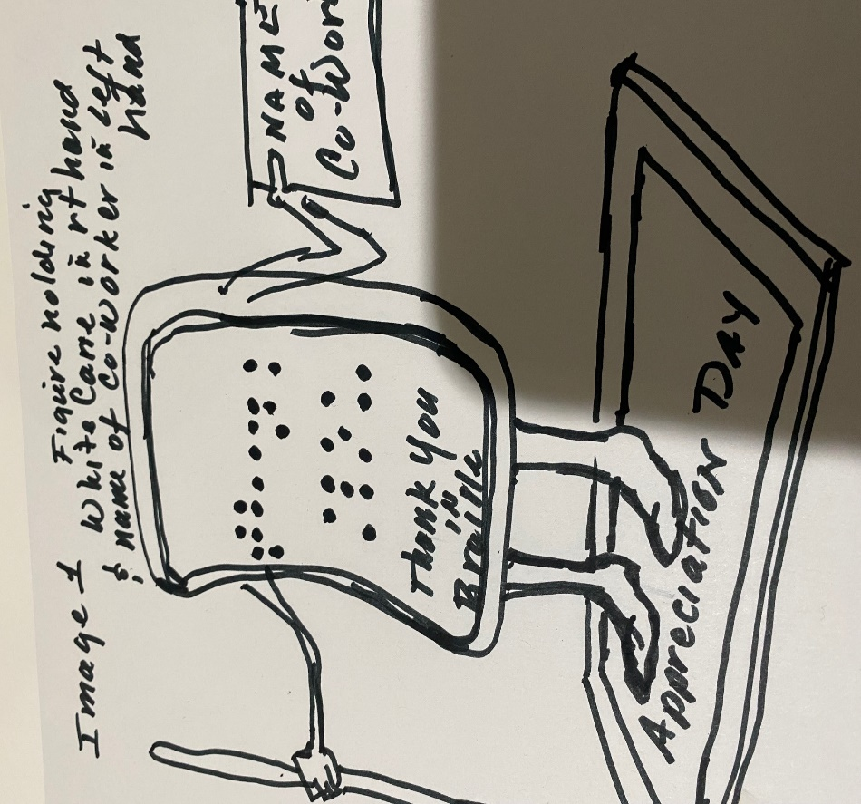

**Explanation of Image**

**Sculpture of an animated character the size of a cell-phone, with buttons spelling out THANK YOU in Braille, right-hand holding a White Cane and Left hand holding a sign with name of staff member, standing on a base with engraving of NFB Staff Appreciation Day, with NFB Logo and Date**

**Images 2& 3**

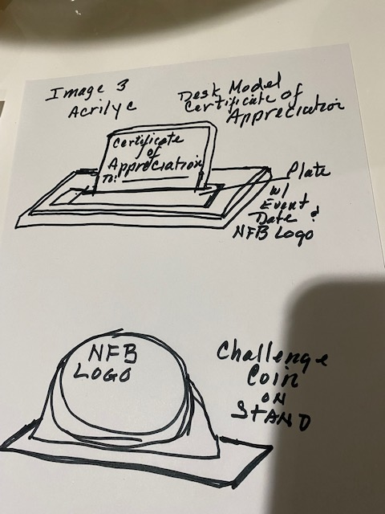

**Explanation of Images**

**Image 2**

**An Acrylic Certificate, engraved with NFB logo conveying Appreciation for Staff person (name) for their service to NFB on this, Date ( / / 2022) slotted on a wood base with metal plate engraving (Desk model)**

**Image 3**

**Is a Large Coin with NFB Logo slotted on a wood base (desk model), with a metal base engraved with NFB logo and Staff Appreciation day and date**