**Passover**

Judaism

*Alternate titles: Festival of Unleavened Bread, Hag ha-Matzot, Pesaḥ, Pesach*

[**Print**](https://www.britannica.com/print/article/445894) Cite Share More

**By** [The Editors of Encyclopaedia Britannica](https://www.britannica.com/editor/The-Editors-of-Encyclopaedia-Britannica/4419) • Last Updated: Feb 16, 2022 • [Edit History](https://www.britannica.com/topic/Passover/additional-info#history)

[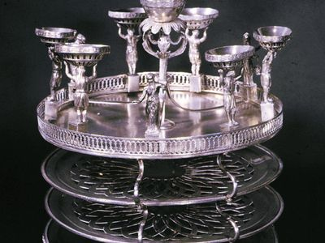](https://cdn.britannica.com/72/76572-050-F40B8573/plate-Vienna-Jewish-Museum-New-York-City-1807.jpg)

Passover plate

[**See all media**](https://www.britannica.com/topic/Passover/images-videos)

**Related Topics:**

[seder](https://www.britannica.com/topic/seder-Passover-meal) [ḥol ha-moʿed](https://www.britannica.com/topic/hol-ha-moed) [Elijah’s cup](https://www.britannica.com/topic/Elijahs-cup) [matzo](https://www.britannica.com/topic/matzo) [Haggadah](https://www.britannica.com/topic/Haggada-biblical-Exodus)

[**See all related content →**](https://www.britannica.com/facts/Passover)

**Passover**, Hebrew **Pesaḥ** or **Pesach**, in [Judaism](https://www.britannica.com/topic/Judaism), holiday [commemorating](https://www.merriam-webster.com/dictionary/commemorating) the Hebrews’ liberation from [slavery](https://www.britannica.com/topic/slavery-sociology) in Egypt and the “passing over” of the forces of destruction, or the sparing of the firstborn of the Israelites, when the Lord “smote the land of Egypt” on the eve of the [Exodus](https://www.britannica.com/event/Exodus-Old-Testament). Passover begins with the 15th and ends with the 21st (or, outside of [Israel](https://www.britannica.com/place/Israel) and among Reform Jews, the 22nd) day of the month of Nisan (March or April). On these seven (or eight) days, all leaven, whether in [bread](https://www.britannica.com/topic/bread) or other mixture, is prohibited, and only unleavened bread, called [matzo](https://www.britannica.com/topic/matzo), may be eaten. The matzo symbolizes both the Hebrews’ suffering while in bondage and the haste with which they left Egypt in the course of the [Exodus](https://www.britannica.com/dictionary/Exodus). Passover is also sometimes called the Festival of Unleavened Bread. Passover is celebrated from Saturday, April 16 to Saturday, April 23 in 2022.

Passover is often celebrated with great pomp and ceremony, especially on the first night, when a special family meal called the [seder](https://www.britannica.com/topic/seder-Passover-meal) is held. At the seder, foods of symbolic significance commemorating the Hebrews’ liberation are eaten, and prayers and traditional recitations are performed. Though the [festival](https://www.britannica.com/topic/feast-religion) of Passover is meant to be one of great rejoicing, strict dietary laws must be observed, and special prohibitions restrict work at the beginning and end of the celebration. *See also* [matzo](https://www.britannica.com/topic/matzo); [seder](https://www.britannica.com/topic/seder-Passover-meal).