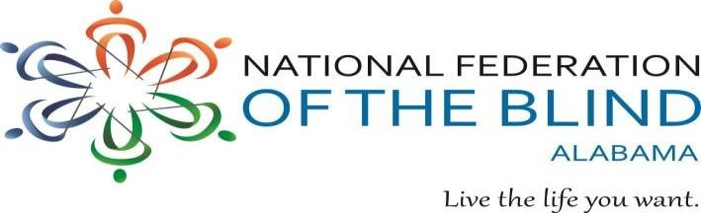

National Federation of the Blind of Alabama 2021 Anywhere and Everywhere Annual Virtual Convention
“Maximizing Your Potential”
March 3-7, 2021

Registration Form

Please fill out the following form or register online at www.nfbal.pixelthin.com. To be eligible for door prizes, you must register by February 20, 2021.

Please complete a form for each attendee. There is no registration fee but donations are encouraged.

Name: __________________________________________________________________________

Address: ________________________________________________________________________

City, State, Zip: ___________________________________________________________________

Phone: ____________________________ E-mail: _______________________________________

Organization: _____________________________________________________________________

Mail registration form and/or donations to:

NFB of Alabama
121 Cork Alley
Madison, AL 35758

If you have questions concerning your registration, contact Larry Povinelli, Convention Chair, at (703)969-6476 or lpovinelli@aol.com

