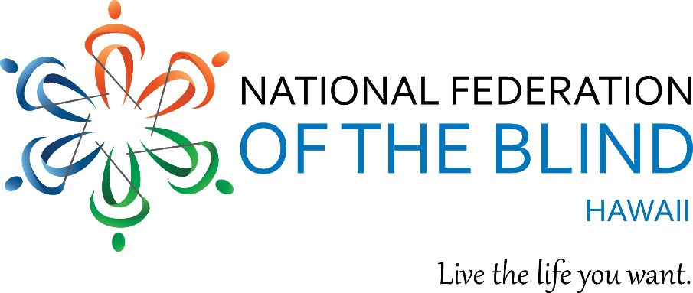
You are invited to attend our 2021 Annual State Convention
The National Federation of the Blind of Hawaii!

Friday May 14, 12:00 PM HST and Saturday May 15, 10:00 AM HST, 2021.
Anywhere and everywhere! Virtually via Zoom!

Our Theme - Mana O'hana, makes us stronger together!

All the fun you expect from our NFB of Hawaii conventions: meet up with old friends, meet new friends, win door prizes, get inspired again, Exhibits to learn about new devices for the blind, learn how to live the life you want!

Save the dates and join us. And register now – it’s free! And easy!
- Go to hawaii.nfb.org
- Click on the link for NFB of HI convention.
- Then click on Register now.
- Watch for more details to come.

for more information contact: Virgil Stinnett, NFB of Hawaii president
M: 808-722-4243
E: nfbhpresident@gmail.com
W: hawaii.nfb.org

