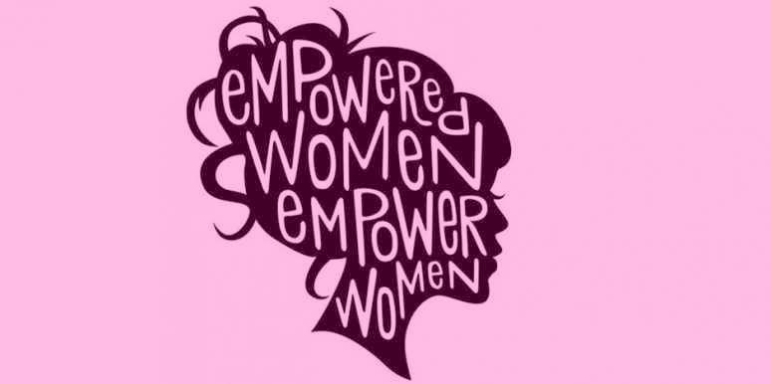

Theme: Women on Fire!

THE NFB OF DC PROUDLY PRESENTS OUR 6TH ANNUAL BLIND WOMEN’S EMPOWERMENT CONFERENCE VIA ZOOM

Bringing to you an awesome panel of diverse blind women along with dynamic keynote speaker, SharonManeki. These talented women will be telling it to you from their hearts to your hearts. Get ready to be dazzled, rejuvenated, and inspired to live the life you want.

When: Friday October 15, 2021
Time: 12:00 P.M. - 3:00 P.M.
This is a free event and all Women Are Welcome!
The Zoom information will be sent out on the week of the conference
▪ for more information contact Libra Robinson at (202) 427-3600 or email leelibra342@gmail.com no later than October 11, 2021
It’s Time to get empowered!

