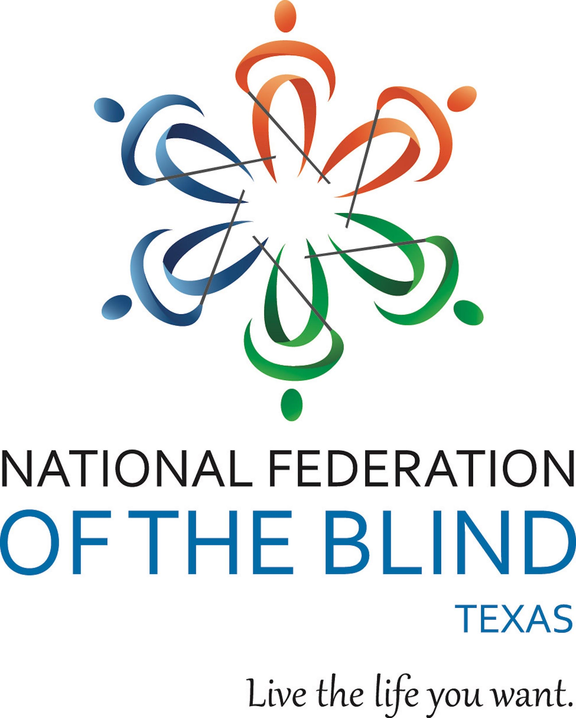

70TH ANNUAL CONVENTION
Anywhere in Texas that your heart may long to be
“CELEBRATING THE PAST & LOOKING TOWARD THE FUTURE”

Zoom Logistics
All meetings and events during the 2021 NFB of Texas state convention will take place on the Zoom platform. Using Zoom is quite easy whether you dial in from a land line or mobile phone, or connect from a smartphone, tablet, or computer using the free Zoom app, which can be downloaded from the Zoom Downloads Page, or from your smartphone’s App Store/Google Play Store.
For those who will be dialing into the meetings using a land line or mobile phone, the same phone number will be used for all events. The only difference is that you will need to enter the specific 11-digit meeting ID for the event you want to join. While there is a passcode for those who connect from the Zoom app, this passcode is not required for dial-in users.

ZOOM ACCESS
- The local Houston Zoom number to dial is 346-248-7799. Please note that it is your responsibility to consider long distance charges (if any).
- The passcode for all Zoom meetings is 70. This passcode will not need to be entered if joining via the direct-connect link.
- Direct-connect links are found in the meeting ID numbers of this document. For example, The Texas Room is used for all general sessions. The meeting ID is 852 7275 4719 and right-clicking, tapping, or using the context menu while focused on the ID numbers themselves will give the option of opening the link and connecting to the meeting via the Zoom app without having to enter the passcode of 70.

USING ZOOM
While Zoom has many features, you do not need to be a technical expert to participate in meetings and have a positive experience.

- Remaining Muted. One of the most important rules about proper Zoom etiquette is to remain muted while you are not speaking. Doing so will ensure that sudden background noises, conversations, or other distracting situations do not interfere with the presenters.
  - Mute and unmute from a phone: Dial *6
  - Mute and unmute from Windows: Press ALT+A
  - Mute and unmute from Mac: Press CMD+SHIFT+A
  - Mute and unmute from the smartphone or tablet app: Tap the Mute button located at the bottom left of the screen
- Raising Your Hand. There may be times when asking questions or seeking the floor is appropriate. If this happens, raising your virtual hand is the best way to do this, especially if the meeting host has disabled the ability to unmute yourself.
  - Raise your hand from a phone: Dial *9
  - Raise your hand from Windows: Press ALT+Y
  - Raise your hand from Mac: Press OPTION+Y
  - Raise your hand from the smartphone or tablet app: Tap the More button located at the bottom of the screen, then tap the Raise Hand button
- Controlling Your Video. While there are situations where your video may need to be enabled, this will not be necessary to participate in convention activities. Regardless, it is extremely important that when using video, you are doing so in an appropriate environment. This includes your appearance and your background.
  - Enable and disable your video from a phone: This is not possible
  - Enable and disable your video from Windows: Press ALT+V
  - Enable and disable your video from Mac: Press CMD+SHIFT+V
  - Enable and disable your video from the smartphone or tablet app: Tap the Video button located at the bottom of the screen, next to the Mute button

AGENDA

FRIDAY, NOVEMBER 5, 2021

10:00 AM-Noon Chapter Leadership Meeting: The Future of Our Affiliate
Location: The Texas Room
Meeting ID: 852 7275 4719
One Tap Mobile: +13462487799,,85272754719#

11:00 AM-2:00 PM Access Technology Showcase
Location: The Houston Room
Meeting ID: 831 6553 1036
One Tap Mobile: +13462487799,,83165531036#

1:00-4:00 PM Silver Bells Training: The Future for Blind Seniors
Location: The Coastal Bend Room
Meeting ID: 890 6021 4817
One Tap Mobile: +13462487799,,89060214817#

3:30-5:00 PM Fair Housing Law and the Disabled
Location: The Fort Worth Room
Meeting ID: 861 0958 4284
One Tap Mobile: +13462487799,,86109584284#

5:00-6:00 PM Building a Diverse Future: Getting to Know Our Diversity, Equity, and Inclusion Committee
Location: The Austin Room
Meeting ID: 854 6121 7971
One Tap Mobile: +13462487799,,85461217971#

6:00-7:00 PM Board of Directors Meeting
Location: The Texas Room
Meeting ID: 852 7275 4719
One Tap Mobile: +13462487799,,85272754719#

7:00-7:45 PM Resolutions Committee Meeting
Location: The Texas Room
Meeting ID: 852 7275 4719
One Tap Mobile: +13462487799,,85272754719#

7:00-11:00 PM Texas Association of Blind Students: The Future of Our Movement
Location: The Dallas Room
Meeting ID: 872 6740 4865
One Tap Mobile: +13462487799,,87267404865#

9:00-10:00 PM Texas Parents of Blind Children: Growing Our Future Leaders
Location: The TPOBC Room
Meeting ID: 817 6592 8205
One Tap Mobile: +13462487799,,81765928205#

SATURDAY, NOVEMBER 6, 2021

7:30 AM-8:45 AM Coffee & Connections: Leading the Way With NFB-NEWSLINE TEXAS
Location: The Arlington Room
Meeting ID: 843 3279 8967
One Tap Mobile: +13462487799,,84332798967#

9:00 AM-12:00 PM GENERAL SESSION
Location: The Texas Room
Meeting ID: 852 7275 4719
One Tap Mobile: +13462487799,,85272754719#

1:30-3:00 PM BREAKOUT SESSIONS
breakout sessions will run concurrently, giving attendees the choice to visit more than one session. Each breakout session will be hosted in its own room.

Tools for Success
Location: The Houston Room
Meeting ID: 831 6553 1036
One Tap Mobile: +13462487799,,83165531036#

Employment Leads to Empowerment
Location: The Permian Basin Room
Meeting ID: 898 1484 2704
One Tap Mobile: +13462487799,,89814842704#

Knowing When an Employer Is and Isn’t Following the Law
Location: The Texas Room
Meeting ID: 852 7275 4719
One Tap Mobile: +13462487799,,85272754719#

Texas Parents of Blind Children
Location: The TPOBC Room
Meeting ID: 817 6592 8205
One Tap Mobile: +13462487799,,81765928205#

iBug Teaches Tech: I Get Around
Location: The Big Country Room
Meeting ID: 826 0604 1443
One Tap Mobile: +13462487799,,82606041443#

The Future of Parenting as a Blind Person
Location: The Golden Triangle Room
Meeting ID: 974 7443 8357
One Tap Mobile: +13462487799,,97474438357#,,,,*70#

The Psychology of Working With a Guide Dog
Location: The TXAGDU Room
Meeting ID: 650 593 045
One Tap Mobile: +13462487799,,650593045#

A Seminar for Spanish Speaking Members and Friends
Location: The Rio Grande Valley Room
Meeting ID: 867 4314 2604
One Tap Mobile: +13462487799,,86743142604#

Introducing Louie Voice Control
Location: The Dallas Room
Meeting ID: 872 6740 4865
One Tap Mobile: +13462487799,,87267404865#

3:15-5:00 PM GENERAL SESSION
Location: The Texas Room
Meeting ID: 852 7275 4719
One Tap Mobile: +13462487799,,85272754719#

6:15-9:00 PM BANQUET
Location: The Texas Room
Meeting ID: 852 7275 4719
One Tap Mobile: +13462487799,,85272754719#

SUNDAY, NOVEMBER 7, 2021

9:30 AM-12:00 PM GENERAL SESSION
Location: The Texas Room
Meeting ID: 852 7275 4719
One Tap Mobile: +13462487799,,85272754719#

