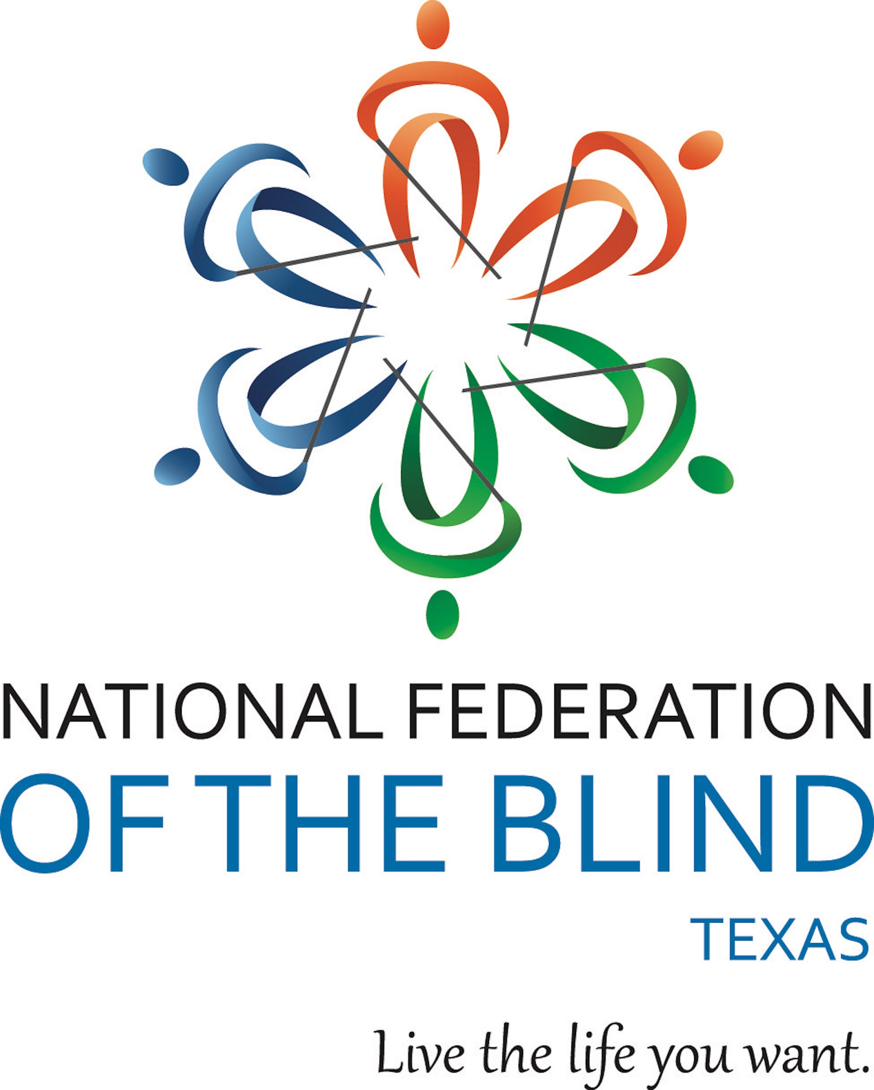

70TH ANNUAL CONVENTION
Anywhere in Texas that your heart may long to be
“CELEBRATING THE PAST & LOOKING TOWARD THE FUTURE”

National Federation of the Blind of Texas
1600 E Highway 6, Suite 215
Alvin, TX 77511-2595
(281) 968-7733 (Main)
(281) 968-7634 (Newsline)
(281) 968-7347 (Youth & Education Services)

Office Hours
9 AM to 5 PM
Monday-Friday

REGISTRATION
Everyone who plans to attend the convention is encouraged to register. There is no charge to register, but there are benefits. First, it helps us to plan for the appropriate Zoom meeting space. Second, it makes you eligible for some fabulous door prizes. Third, you cannot vote even if you are a member unless you registered with the convention. Registration will be open until 12:01 AM, November 5, 2021. If you are reading this and haven’t registered yet, you can do so by going to our event registration page.

DOOR PRIZES
Our members and local chapters have been busy gathering some great door prizes for this year’s convention. If you have registered, you will be eligible to win one or more of these fabulous gifts. Door Prizes will be awarded during general sessions and at the banquet. Some breakout sessions may also have goodies to award. You must be present to win. So, join us for every session for both the great content and the chance to go home a little richer.

Salvador Villa will serve as our door prize chairperson this year, and Emily Gibbs will serve as his assistant. Chapter presidents and anyone else who has door prizes to contribute should contact our office to discuss how we are dealing with door prizes during our virtual convention. Dial 281-968-7733, weekdays, from 9:00 AM to 5:00 PM. Please, provide us with information about door prize donations no later than Monday, November 1.

EXHIBITS
When we host in-person conventions, we always have an exhibit space. This year’s exhibits will be handled in a different way. On Friday, we will be inviting our exhibitors to make presentations about their new products and services in an Exhibitor Showcase. You can find information about that showcase in the body of our agenda. Everyone is invited, and we hope you will visit so you can learn about the latest and greatest products and services our vendors have to offer. We will allow questions if time permits, and our vendors have shared contact information that you will find in a separate document.

BANQUET
The annual banquet of the National Federation of the Blind of Texas will take place on Saturday, November 6, beginning at 6:15 PM. You’ll find the link to join us in the main part of our agenda. Kevan Worley, of the National Federation of the Blind of Colorado and blind merchant extraordinaire, will be our keynote speaker. Raul Gallegos will emcee the program, and scholarships will be awarded during the banquet.

SILVER BELLS TRAINING
On Friday, November 5, from 1:00 to 4:00 PM, NFB-NEWSLINE® TEXAS will host its Silver Bells Training Program. While the information presented will cater primarily to blind seniors, others are welcome to attend in order to get information they can share with seniors who may not be able to attend. Our program coordinator, Liz Wisecarver, will be overseeing this program, and you may call or email her with questions. Her phone number is 281-968-7634, and her email address is lwisecarver@nfbtx.org. Please, join us.

BIG BASKET BONANZA AUCTION
This year, we are auctioning off some spectacular baskets donated by some of our chapters, divisions, and the Newsline team. Proceeds from the auction will benefit programs of the National Federation of the Blind of Texas. You can bid on your favorite basket by going to the Big Basket Bonanza. The auction will remain online until the evening of our banquet. Then, Kevan Worley and Glenn Crosby will serve as our auctioneers for the final, live portion of the auction. So, if you forget to bid in advance, you’ll have a chance on the evening of November 6, at the end of the banquet. Even if you have already placed your bid, join us for the fun and to find out who will take home these fantastic prizes.

AGENDA

FRIDAY, NOVEMBER 5, 2021

10:00 AM-Noon Chapter Leadership Meeting: The Future of Our Affiliate
Norma Crosby, President, National Federation of the Blind of Texas
This meeting is intended for those who are current and future leaders. So, everyone is invited to attend.
Location: The Texas Room
Meeting ID: 852 7275 4719
One Tap Mobile: +13462487799,,85272754719#

11:00 AM-2:00 PM Access Technology Showcase
Representatives from HIMS, Humanware, and Vispero will join us to highlight their latest and greatest access technology products. Each product representative will take approximately an hour to discuss their products and respond to your questions. If you can’t join us for this showcase you’ll find contact information for the product representatives in a separate document online, but try to be there. Even if you are not currently in the market for any of these products, it is important to share information with your chapter members and with people who call your chapter for assistance.
Location: The Houston Room
Meeting ID: 831 6553 1036
One Tap Mobile: +13462487799,,83165531036#

1:00-4:00 PM Silver Bells Training: The Future for Blind Seniors
Hosted by NFB-NEWSLINE® TEXAS, this special training session will offer blind seniors, those who work with them, and others who are interested the opportunity to learn how to effectively use the service and other blindness skills to become more independent. Everyone is welcome to attend.
Location: The Coastal Bend Room
Meeting ID: 890 6021 4817
One Tap Mobile: +13462487799,,89060214817#

3:30-5:00 PM Fair Housing Law and the Disabled
Diego Demaya, Director of ADA Technical Assistance
Southwest ADA (SWADA) Center
If you need to learn more about fair housing for yourself or so you can advocate more effectively for others, this is the session for you.
Location: The Fort Worth Room
Meeting ID: 861 0958 4284
One Tap Mobile: +13462487799,,86109584284#

5:00-6:00 PM Building a Diverse Future: Getting to Know Our Diversity, Equity, and Inclusion Committee
Yolanda Shaw, Chairperson
Join Yolanda and our diversity team for a meeting designed to introduce you to the committee’s work and to invite you to help.
Location: The Austin Room
Meeting ID: 854 6121 7971
One Tap Mobile: +13462487799,,85461217971#

6:00-7:00 PM Board of Directors Meeting
The National Federation of the Blind of Texas Board of Directors invites you to join us for our annual meeting. This meeting is open to everyone.
Location: The Texas Room
Meeting ID: 852 7275 4719
One Tap Mobile: +13462487799,,85272754719#

7:00-7:45 PM Resolutions Committee Meeting
Glenn Crosby, Chairperson
Resolutions should be submitted no later than October 31, 2021. They can be sent to ncrosby@nfbtx.org. All resolutions must be submitted in finished form. If you have an idea and need some assistance in developing proper language, please contact our committee chair at
resolutions@nfbtx.org. That should be done in advance of the deadline for submission.
Location: The Texas Room
Meeting ID: 852 7275 4719
One Tap Mobile: +13462487799,,85272754719#

7:00-11:00 PM Texas Association of Blind Students: The Future of Our Movement
Salvador Villa, President
This meeting is intended primarily for blind high school and college students. The students will present a seminar, conduct their annual business meeting, and host an informal get together following the meeting. Informal festivities should begin at approximately 9:00 PM.
Location: The Dallas Room
Meeting ID: 872 6740 4865
One Tap Mobile: +13462487799,,87267404865#

9:00-10:00 PM Texas Parents of Blind Children: Growing Our Future Leaders
This is a business meeting for our parents division. We invite parents to attend and to jump right in to help with upcoming projects. A separate breakout session for parents needing more information than we can fit into this hour will be held on Saturday afternoon. You are invited to both meetings.
Location: The TPOBC Room
Meeting ID: 817 6592 8205
One Tap Mobile: +13462487799,,81765928205#

SATURDAY, NOVEMBER 6, 2021

7:30 AM-8:45 AM Coffee & Connections: Leading the Way With NFB-NEWSLINE TEXAS
Liz Wisecarver, Newsline Coordinator, NFBTX
Grab your breakfast tacos and coffee and join us to discuss the community outreach work our chapters have done to promote Newsline since our last convention. Announcements regarding our Community Outreach Grants will be made, and we’ll also talk about the coming year.
Location: The Arlington Room
Meeting ID: 843 3279 8967
One Tap Mobile: +13462487799,,84332798967#

GENERAL SESSION
Location: The Texas Room
Meeting ID: 852 7275 4719
One Tap Mobile: +13462487799,,85272754719#

9:00 AM Invocation

9:05 AM National Anthem

9:10 AM Welcome From Houston
Stacie Gallegos, President
NFBTX Houston Chapter

9:20 AM Meet the Future: The Scholarship Class of 2021
Lara Sowell, Chairperson NFBTX Scholarship Committee

9:35 AM Graduating to a Brighter Future: CAREER Mentoring Made a Difference
Emily Gibbs, Director of NFBTX Youth & Education Services (YES)

9:45 AM Building Relationships One Teacher at a Time
Dori Senatori, Instructor, Texas School for the Blind & Visually Impaired

10:00 AM The Future for Blind Students: A Message from TSBVI
Emily Coleman, Superintendent, Texas School for the Blind & Visually Impaired

10:25 AM The Future of Rehabilitation After COVID-19
Ed Serna, Executive Director, Texas Workforce Commission
Cheryl Fuller, Director of Texas Workforce Solutions Vocational Rehabilitation Services.

10:45 AM Driving the Future: A Report From Our National Organization
Kevan Worley, Director of Project Literacy, National Federation of the Blind of Colorado

11:15 AM The Blind Can Lead the FFA
Faith Snapp, Student, West Texas A&M University

11:35 AM The Blind History Lady Reminds Us of the Past
Peggy Chong, the Blind History Lady

12:00 PM Adjourn

BREAKOUT SESSIONS
From 1:30-3:00 PM, breakout sessions will be available for our attendees. All sessions will run concurrently, and everyone is invited to pick the one that speaks to them and jump in. Or, if you prefer, you can visit more than one session if you want to get a taste of all we have to offer. Once the breakouts are over, we will return to a general session before enjoying an evening of inspiration and fun at our annual banquet.

Here are the breakout sessions. Each one begins at 1:30 PM.

Tools for Success
Raul Gallegos and his intrepid team will give you a heads up about productivity apps that will help to make your work and school life more productive and accessible.
Location: The Houston Room
Meeting ID: 831 6553 1036
One Tap Mobile: +13462487799,,83165531036#

Employment Leads to Empowerment
Government benefits may help while you are a student, but they just won’t take you where you want to go for the long term. Dr. Kimberly Aguillard and Dr. Angela Frederick can help you learn how employment will empower you and allow you to live the life you want. They know what to do to get and keep a good job, and they know some of the pitfalls of the job search. So, if you are looking for work, have a job but are struggling, or hope to be ready for a job soon, this is the seminar for you.
Location: The Permian Basin Room
Meeting ID: 898 1484 2704
One Tap Mobile: +13462487799,,89814842704#

Knowing When an Employer Is and Isn’t Following the Law
Attorney Diego Demaya, from the Southwest ADA (SWADA) Center will give you the lowdown on employment law as it relates to people with disabilities, and he’ll answer your questions as well. So, whether you are a blind person who is having an issue with your employer or just someone who wants to learn how to advocate more effectively, this is a great learning opportunity.
Location: The Texas Room
Meeting ID: 852 7275 4719
One Tap Mobile: +13462487799,,85272754719#

Texas Parents of Blind Children
Are you the parent or guardian of a blind child? Do you have questions about what to expect as your child grows up? Are you intimidated by the IEP/ARD process? Do you just need some support? Well, the Texas Parents of Blind Children is here to help with a session designed to talk to parents about the basics and to allow you to get to know about the positive philosophy of the National Federation of the Blind. Join Emily Gibbs and our Youth & Education Services (YES) team as they offer encouragement and concrete answers about how you can navigate the education and rehabilitation system.
Location: The TPOBC Room
Meeting ID: 817 6592 8205
One Tap Mobile: +13462487799,,81765928205#

iBug Teaches Tech: I Get Around
Are you new to the world of Apple products? Do you just need some tips and tricks to become a more proficient iPhone or iPad user? Then, this session might be what you are looking for. Michael McCulloch and his iBUG Today team are here to teach you how to use your iOS devices to navigate indoors and to share how you can get ongoing free support from the iBUG organization.
Location: The Big Country Room
Meeting ID: 826 0604 1443
One Tap Mobile: +13462487799,,82606041443#

The Future of Parenting as a Blind Person
Daniel Martinez, a blind parent and a member of the Board of Directors of the National Federation of the Blind of Texas, is working to develop a group to offer support, training opportunities, and encouragement to blind parents. If you are a blind parent who wants to help support other people who are parents or who plan to become parents, join Daniel for this empowering session that will help to organize a dynamic team of blind parents who want to learn and share what they already know about parenting as a blind person.
Location: The Golden Triangle Room
Meeting ID: 974 7443 8357
One Tap Mobile: +13462487799,,97474438357#,,,,*70#

The Psychology of Working With a Guide Dog
Elizabeth Campbell, president of the Texas Association of Guide Dog Users will lead a discussion about behaviors and the psychology of working with a guide dog. TXAGDU will also hold its annual business meeting during this session. Join this lively discussion and find out more about being a successful dog handler.
Location: The TXAGDU Room
Meeting ID: 650 593 045
One Tap Mobile: +13462487799,,650593045#

A Seminar for Spanish Speaking Members and Friends
The title says it all. This seminar is intended to share information about the Federation’s positive philosophy of blindness with our members and friends who prefer to communicate in Spanish. Jose Marquez, Rolando Hernandez, and other Federation leaders will help teach everyone that blindness is just a characteristic and does not keep us from reaching our full potential as human beings.
Location: The Rio Grande Valley Room
Meeting ID: 867 4314 2604
One Tap Mobile: +13462487799,,86743142604#

Introducing Louie Voice Control
Imagine being able to fully control popular Apps and phone functionality with just voice commands! Presenting to you – Louie Voice Control – A voice assistant that enables users to voice control key phone features and apps with just voice commands. Pramit Bhargava, founder of Visionapps Technology will join us for a demonstration of this technology.
Location: The Dallas Room
Meeting ID: 872 6740 4865
One Tap Mobile: +13462487799,,87267404865#

GENERAL SESSION
Location: The Texas Room
Meeting ID: 852 7275 4719
One Tap Mobile: +13462487799,,85272754719#

3:15 PM Embracing the Future: A Message from the Criss Cole Rehabilitation Center
Diane Yoder, Director, Criss Cole Rehabilitation Center
Diane has a long career in the blindness field and has spent her life raising expectations for blind people. Today, she will share some of her plans for the future of CCRC.

3:30 PM Understanding the Specialized Telecommunications Assistance Program
Carolyn McMahon, STAP Specialist, Specialized Telecommunications Assistance Program (STAP)

3:45 PM Making Life More Accessible for DeafBlind Texans
Marcia Brooks, ICanConnect

4:00 PM Welcoming Everyone: A Message About Diversity
Yolanda Shaw, Chairperson, NFBTX Diversity, Equity & Inclusion Committee

4:15 PM Chapter Reports Part One
Reports from Arlington, Austin, Big Country, Coastal Bend, Dallas, Fort Worth, Golden Triangle

4:35 PM Presidential Report
Norma Crosby, President, NFBTX

5:00 PM Adjourn

BANQUET
Location: The Texas Room
Meeting ID: 852 7275 4719
One Tap Mobile: +13462487799,,85272754719#

6:15 PM Invocation

6:20 PM Raffles & Drawings

6:35 PM Keynote Address
Kevan Worley, Director, Project Literacy, NFBCO

6:57 PM Scholarship Awards
Lara Sowell, Chairperson, NFBTX Scholarship Committee

7:17 PM PAC Plan Pledge Drive
Norma Crosby, President, NFBTX

7:30 PM Big Basket Bonanza Auction
Glenn Crosby & Kevan Worley Auctioneers

The banquet will adjourn upon completion of the auction.

SUNDAY, NOVEMBER 7, 2021

GENERAL SESSION
Location: The Texas Room
Meeting ID: 852 7275 4719
One Tap Mobile: +13462487799,,85272754719#

9:30 AM Invocation

9:35 AM Elections

9:55 AM Secretary’s Report
Louis Maher, Secretary, NFBTX

10:00 AM Treasurer’s Report
Lara Sowell, Treasurer, NFBTX

10:20 AM Chapter Reports Part Two
Reports from Houston, Lone Star, Rio Grande Valley, San Antonio, TABS, TPOBC, TXAGDU

10:45 AM A Report From NFB-NEWSLINE TEXAS
Liz Wisecarver, Newsline Coordinator, NFBTX

11:00 AM A Message From NABS
Elizabeth Rouse, NABS Liason for NFBTX

11:10 AM Resolutions

11:40 AM Closing Remarks & Announcements

12:00 PM Adjourn

