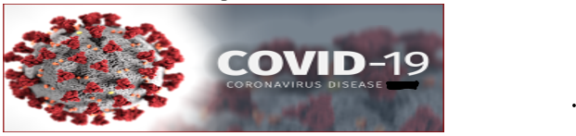

**FREE COVID-19 Vaccine / Booster Clinic**



**FRIDAY APRIL 7, 2023**

**10:00AM TO 12:00PM**

**HOLY CROSS BAPTIST CHURCH**

**1900 N 63RD ST, PHILADELPHIA, PA 19151**

**Reverend Dr. Vincent Stokes Sr., Senior Pastor**

**Broad & Snyder Pharmacy**

**2108 S. Broad St., Phila., PA**

**Pharmacist: Kevin L, PharmD**