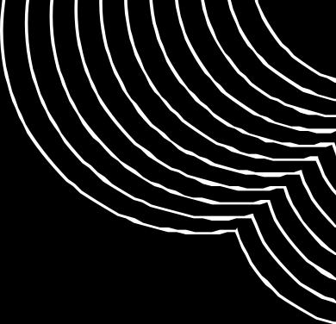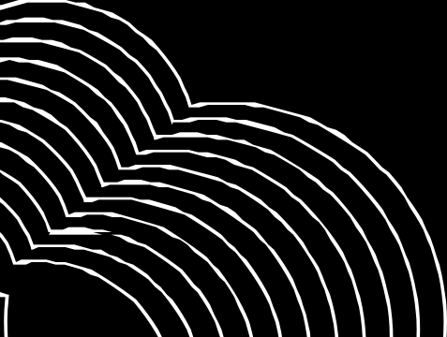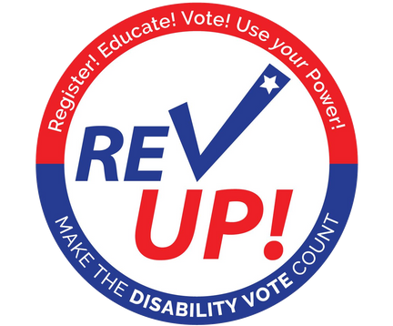

Please Join Us For

E D U C A T I O N A N D A D V O C A C Y

F O R V O T E R S W I T H D I S A B I L I T I E S

**SEPTEMBER 12**

**11AM-12PM**

[**CLICK HERE TO JOIN THE MEETING**](https://teams.microsoft.com/l/meetup-join/19%3ameeting_MmM3MWRiOTQtYTZlYS00YTU1LWE2N2EtMmRkMTNjN2JkZTEw%40thread.v2/0?context=%7b%22Tid%22%3a%22c6f12f47-2e66-413b-8d09-9682f7734ecd%22%2c%22Oid%22%3a%220083e177-aa28-43bf-aace-fe7c29a6bba6%22%7d)