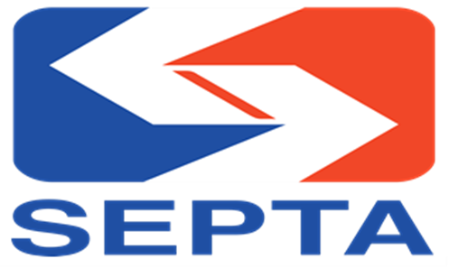

SAC Meeting Agenda: March 10th, 2026, 2pm-4pm
Microsoft Teams meeting
Join: https://teams.microsoft.com/meet/23750121128440?p=ZYKZocJcFlccogo3P9
Meeting ID: 237 501 211 284 40
Passcode: W29L26z9
Dial in by phone
+1 312-593-1554,,899291435# United States, Chicago
Phone conference ID: 899 291 435#

2:00pm-2:05pm: Welcome, guidelines for this call
mute, raise virtual hand, or shout
out (name put me in the cue)
when you want to speak.
Topics:
Open Forum: 2:05pm-2:35 {Vice-Chair Cole Holmes leads}

2:35pm-3:05pm New Bus Network {Dan Nemiroff & Tammy Leigh}

2:35pm-2:45pm: Q&A

3:05pm-3:35pm-The City of Philadelphia’s Zero Fare Team {Nicola Mammes & Ruby Glenn}
3:35pm-3:45pm: Q&A

3:45pm-3:50pm- 5 Year Strategic Plan Update {Joseph Clemens}

Close & Adjourn: 3:55pm-4pm (Next meeting to be determined on leadership availability).

