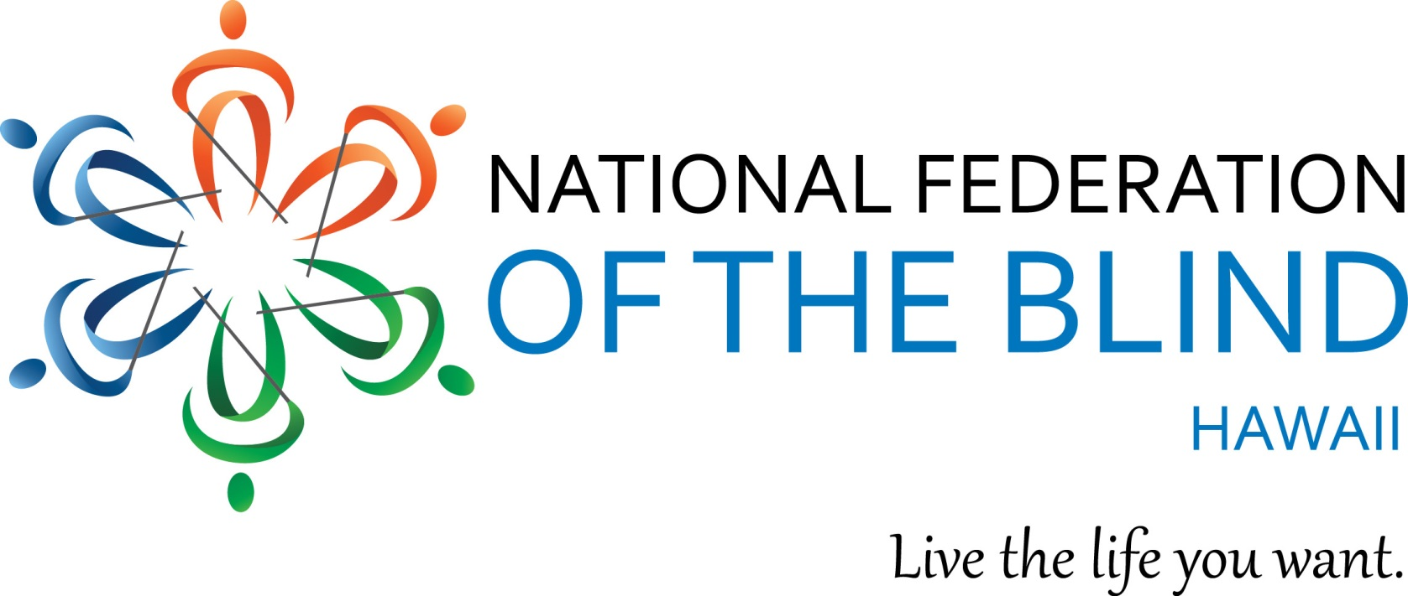

P. O. Box 4605
Honolulu, HI 96812
Phone: (808) 595-6123

National Federation of the Blind of Hawaii Scholarship Application Form

Please read all pages of the program rules and instruction. This form may be photocopied but only if accompanying pages of the program rules and instructions are also included.

To apply for a scholarship, complete this application form and email attachments to NFBH secretary and convention coordinator, Katie Keim at 808keim@gmail.com

Or you may mail to the attention of: National Federation of the Blind of Hawaii Scholarship Committee, P.O. Box 4605, Honolulu, Hawaii, 96812.

Form must be received by Monday September 24, 2018

Name (please include any maiden or other names by which you have been known):

______________________________________________________________________

Date of birth: ___________________________

School address: ________________________________________________________

School phone number: ___________________________

Home address: _________________________________________________________

Phone number: ___________________________

Email address: ___________________________

Institution being attended currently, or in 2019; with class standing (freshman, senior, etc.):

______________________________________________________________________

Cumulative grade point at this institution: ___________________________

Institution to be attended in 2019; with class standing. (Send by separate letter if admitted to school after submitting completed application.): _____________________

______________________________________________________________________

List all postsecondary institutions attended with highest class standing attained and cumulative GPA: ______________________________________________________________________

______________________________________________________________________

High school attended and cumulative grade point:

______________________________________________________________________

For High School Seniors Only: College Admission Composite Test Scores

SAT _________________ ACT ___________________

Note: Please attach copies of all score reports as requested in number five of the list of attachments.

Vocational goal: __________________________________________________________

State your major: __________________________________________________________

Awards and honors (attach list if necessary):
______________________________________________________________________

______________________________________________________________________

Community service (attach list if necessary):

______________________________________________________________________

______________________________________________________________________

Please see the following list of required attachments. Fill out the application and attach the following documents or arrange to have them sent to the Scholarship Committee:

1. Personal Letter from Applicant. NFB scholarships are awarded on the basis of scholastic excellence, financial need, and community service. In preparing your personal letter, keep in mind that the committee members are all successful blind college graduates. Consider how you can most effectively convey your best qualities. Since the awards are restricted to blind people, the committee will be interested in the techniques and approaches you use. Almost all blind students have financial need. Committee members will assume basic need, so you may choose merely to refer to this topic unless your need is unusual.

2. Two letters of recommendation.

3. Current transcript from institution now attending and transcripts from all other post-secondary institutions attended. If you have not yet attended such an institution or have not completed one year of study, send high school transcript.

4. Letter from a NFB Federation State President or Officer. Federationists are volunteers. Many take messages and then return calls in evenings or on weekends. They will wish to speak with applicants personally; parents or school officials may help set up appointments but cannot participate in the actual interviews.

5. Score Reports (for high school seniors only). Please attach a copy of your score reports for all standardized tests taken for college admission. Copies are acceptable; there is no need to attach official reports.

NATIONAL FEDERATION OF THE BLIND of Hawaii 2018 SCHOLARSHIP PROGRAM

