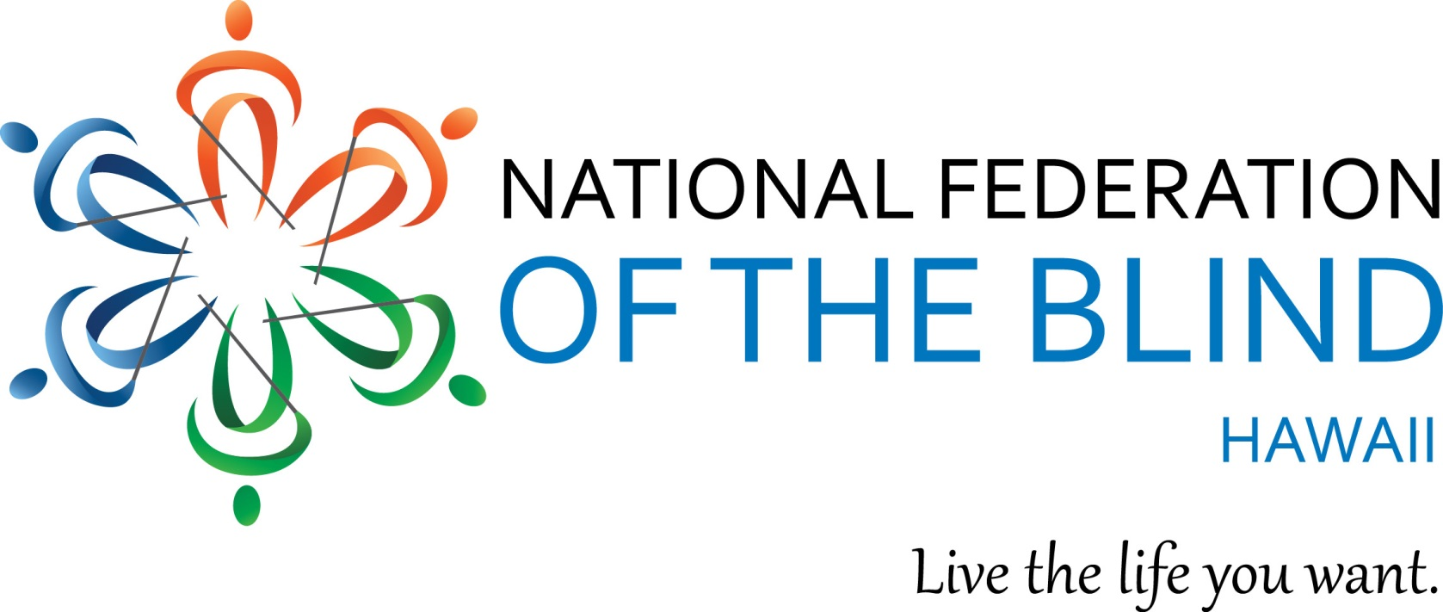

You are cordially invited to the
National Federation of the Blind of Hawaii
2018 Annual State Convention"

"Raising Expectations, Building our Federation"

Friday September 28 – Sunday September 30, 2018

Friday - 2943 Kalakaua Avenue, Honolulu, Hawaii Tropic Seas

Saturday and Sunday - 1901 Bachelot Street, Honolulu, Hawaii, Auditorium

Our National NFB Representative Jeannie Massay, President NFB of Oklahoma will be speaking at this year’s convention. Read Jeannie's biography and learn about her own life as a blind college student at https://nfb.org/jeannie-massay-bio#main-content

Join us for our 2018 state convention, with Hope, Love and Determination!

During the Convention, Scholarships will be awarded
to help some blind students to further their education.
Apply for your scholarship today! Deadline for submittal of your application is no later than Monday September 24, 2018.

For Further Information, call: Katie Keim (808) 722-4242
Email: 808keim@gmail.com
NFBH Voicemail: (808) 595-6123
Toll Free Neighbor Islands: (866) 595-6123
Mail your application packets to PO BOX 4605 Honolulu, HI. 96812

