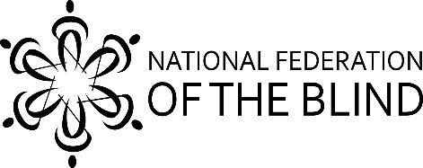
National Federation of the Blind of Hawaii Honolulu Chapter
Virgil Stinnett, President - 808-722-4243
2943 Kalakaua Ave. #304, Honolulu, Hawaii, 96815

Code #77247
The National Federation of the Blind of Hawaii Affiliate is participating in Give Aloha, Foodland’s Annual Community Matching Gifts Program. This program honors Foodland’s founder, Maurice J. "Sully" Sullivan, and continues his legacy of giving back to the community.

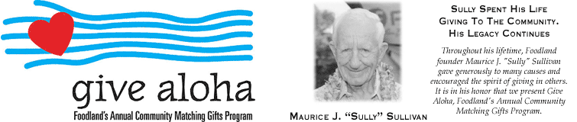

How It Works
From September 1-30, customers are invited to make donations up to $249 to participating Hawaii non-profit organizations at checkout. Donations can also be made when you place an online grocery order for curbside pickup or delivery.
Individuals must use their own Maika'i card to make a donation. Foodland will match a portion of each donation made with a Maika'i card. Donations made without a Maika'i card will not be matched.

Matching Gift

Foodland’s gift of $250,000 to Hawaii non-profit organizations participating in Give Aloha this year.

How to Donate
• At checkout, present your Maika'i card (or give your 10-digit number) and inform the cashier that you would like to make a donation to the National Federation of the Blind of Hawaii, code number 77247 . If you do not have a Maika'i account, you may establish one by telling the cashier you would like to do so; you will need to give a unique 10-digit number (such as your phone number).
• Tell the cashier how much you would like to donate. Your donation will be added to your grocery purchase total.
• You may donate up to $249 per organization (any amount in excess of $249 will not be matched).
• Be sure the cashier reaffirms our organization’s name and amount that you are donating.
• Any donation must be made payable to Foodland or Sack N Save.
• The name of our organization and the amount you donate will appear on your receipt.
• Donor names will not be released to our organization. If you would like us to know of your gift, please contact us directly so that we may properly acknowledge your gift.
Nfb.hawaii.org
Are These Donations Tax Deductible?
Give Aloha donations are tax deductible to the full extent of the law. Please save your store receipt for tax purposes since it will be the only record you will have of your donation. You may ask the cashier for a duplicate receipt.

How Matching Gifts Will Be Calculated
Every year, the matching gift percentage varies and cannot be pre-determined. For the past few years, the matching percentage has been between 20%-25%. Thus, if a customer donated $100 to an organization, Foodland’s matching gift was $20-$25. The actual matching gifts will be calculated at the end of the program. Organizations will receive 100% of all customer donations given to their organization, plus their % of Foodland’s 250,000 matching gift. The portion of the matching gift that each organization will receive will be based on the total dollar amount of customer donations designated to that organization as a % of all customer donations received for all organizations. For example, if total combined customer donations for all participating organizations equal $1,000,000, and $10,000 (1% of total) in donations are designated for organization XYZ, then organization XYZ will receive 1% of $250,000, or $2,500.
​

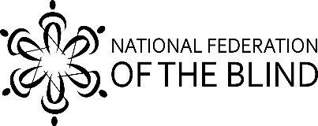
National Federation of the Blind of Hawaii Honolulu Chapter
Virgil Stinnett, President - 808-722-4243
2943 Kalakaua Ave. #304, Honolulu, Hawaii, 96815

Code # 77247

