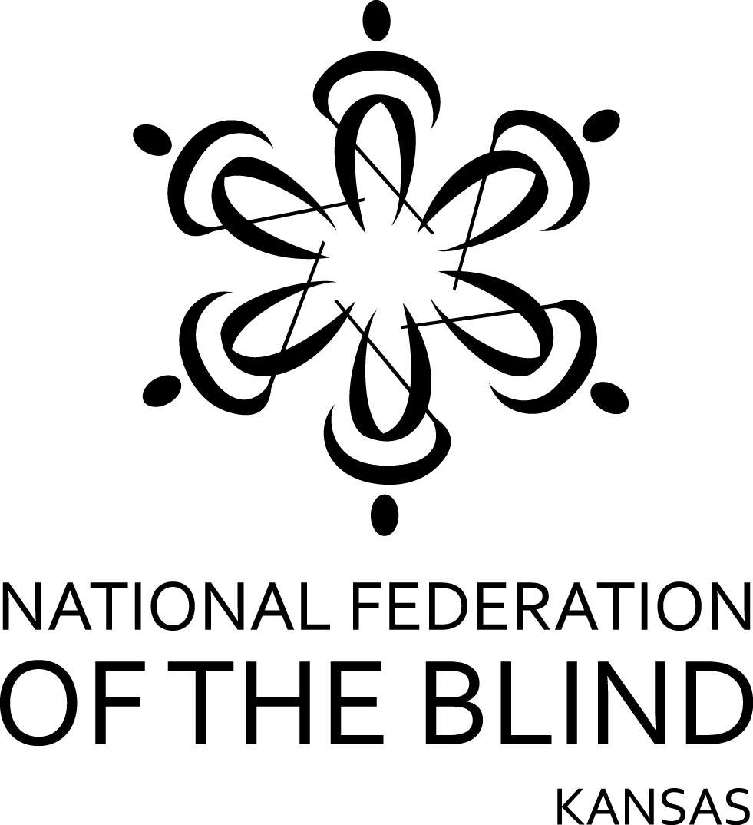

President Tom Page
120 E. 1st #3C Wichita KS 67202

2017 National Federation of the Blind of Kansas
Kenneth Tiede Memorial Scholarships
Information and Application

To be eligible you must be able to affirm the following three statements:

- I am legally blind in both eyes with best correction.
- I live in Kansas or will be attending a school in Kansas this (2017-2018) academic year.
- My GPA is 2.5 or better.

You must complete an interview with an NFB of KS designee and will contact Tom Anderson (303-842-9661NFB of KS scholarship Committee Chair, to make an appointment for this interview. (please make contact as early as possible to accommodate the October 31st deadline).

If you are chosen for a scholarship you must agree to the following to become a winner.

If chosen for a scholarship I:

- will attend the NFB of KS state convention to be held November 10-12 of 2017.in Lawrence KS (at the expense of the NFB of KS).
- agree to participate in the NFB of KS mentoring program during the scholarship year.

I will provide:

- my completed NFB of KS scholarship application
- a physician's signed eye report
- certified transcripts from the current and last school(s) that I have attended
- a letter of recommendation, and
- my essay

by October 31st 2017.

Please provide complete information for each of the following:

Name:___________________________________________

Address:_________________________________________

Best phone contact:________________________________

E-mail:__________________________________________

Date of birth (mm/dd/yy):____________________________

High School graduated from and year
______________________________:__________________

GPA:__________

What school will you attend in 2017-2018?:___________________________________________

What profession or field of employment do you wish to enter when your schooling is completed?:

________________________________________________

List all post secondary institutions you have attended your final GPA at that institution and with complete name and address: if more than one list on separate sheet and attach.

________________________________________________

________________________________________________

The essay! Please answer this question:

What would you like the scholarship committee to know about you?

Please keep your essay between 600 and 1,000 words.

Letter of recommendation:
You must submit one letter in support of your scholarship application from someone who knows you and who is familiar with your academic performance.

Certification Statement:

By signing my name below, I confirm that all of the information provided above and in the accompanying documents is true and correct to the best of my knowledge.

Signed_________________________________________

Date___________________________________________

Please mail or E-Mail a completed application form and all required supporting documents to:

attn: scholarship
Robert Fuller
1812 Mississippi
Lawrence KS, 66044

E-mail applications should be submitted in Microsoft Word format and sent to

robertfuller584@gmail.com

If you are chosen to become a scholarship finalist you will be notified of the award no later than November 3rd 2017.

This form is for NFB of KS scholarships only and may not be used to apply for an NFB national scholarship.

for information on the 2018 NFB national scholarship program please visit www.nfb.org/scholarships.

for more information on the many programs of the NFB please visit www.nfb.org

