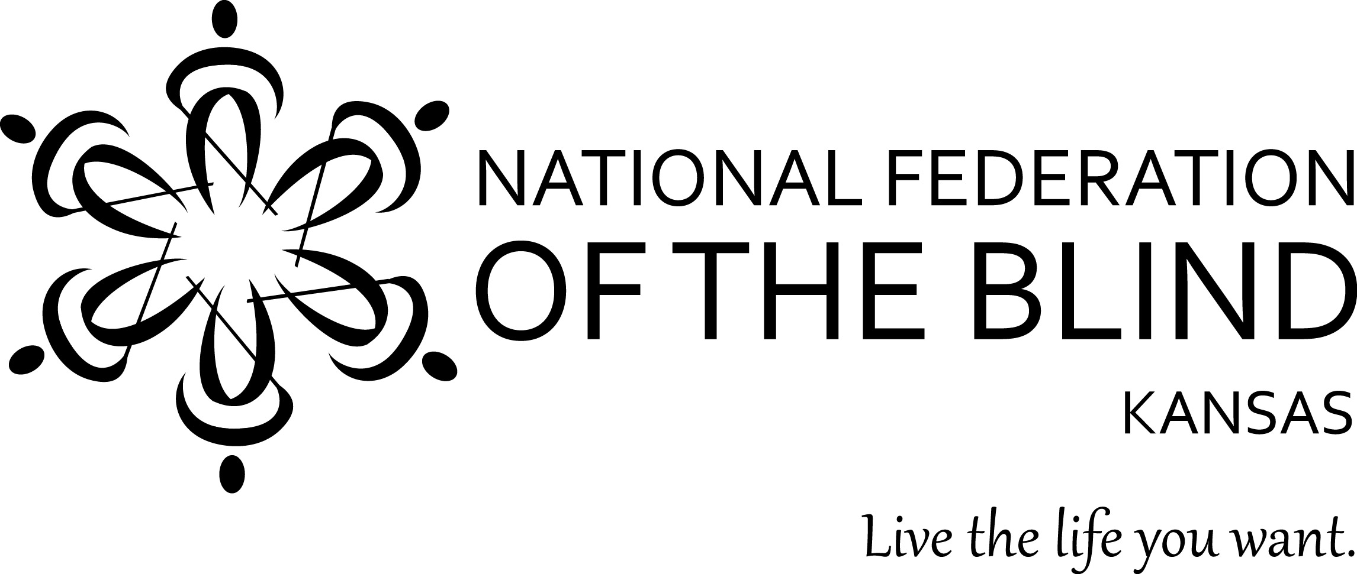

National Federation of the Blind of Kansas
48th Annual State Convention
November 10, 11 and 12, 2017

Doubletree by Hilton Hotel Lawrence
200 McDonald Drive, Lawrence, KS, 66044,
785-841-7077

National Representative: Carla McQuillan, Member of the NFB National Board, Executive Director of Main Street Montessori Association

Friday, November 10, 2017

2:00 PM -- ‘iPhone for Beginners’, Rob Tabor
& Tamara Kearney (Brazilian A)
2:00 PM -- ‘Tap that App’ – iPhone for advanced
users, Anna Dressner (Brazilian B)
6:00 PM -- Registration (Brazilian rooms atrium)
6:00 PM -- Exhibit Hall (Brazilian C & D)
6:00 PM -- Hospitality -- Warm Appetizers, cash bar
(Regency D2 & D3 )
7:00 PM -- Resolutions Committee, Chair: Rob Tabor
(Brazilian A)
9:00 PM -- Nominating Committee, Chair: Donna Wood,
2nd Vice President (Brazilian A)

Saturday, November 11, 2017 (Brazilian A & B)

9:00 AM -- Welcome, invocation and opening remarks
9:15 AM -- Welcome to Lawrence, Mayor of Lawrence KS,
9:30 AM -- National Report, Carla McQuillan,
National Representative
10:15 AM -- State Report, Tom Page
10:40 AM -- Creative Collaborations, Newsline Report,
Heather Hogan, Senior Vice President Envision
Foundation and Mission Services
10:50 AM -- ‘Blindness Skills for Pre-school Children’,
Teresa Houston Director Envision ECDC,
10:55 AM -- Kansas Talking Books Update, Michael Lang,
Interim Director KS Talking Books
11:05 AM -- Audio Reader Update, Lori Kesinger,
Outreach Coordinator Audio Reader
11:10 AM -- Report on the Kansas State School for
the Blind and Visually Impaired, John Harding, Superintendent
11:20 AM -- ‘Higher Education for the disabled? : Getting
it done at KU’, Andrew Shoemaker Director of
Academic Achievement and Access Center University of Kansas
11:30 AM -- ‘The Braille Crisis in KS: One
Families Struggle’, Lyn Petro
11:40 AM -- ‘Gaining Access to Higher Education’,
Emily Schlenker
11:50 AM -- Nominating Committee Report and
Resolutions
12:00 Noon -- Lunch (Brazilian C & D)
12:00 Noon -- Senior Division Lunch Meeting (Hospitality
Room Hotel Atrium)
1:00 PM -- The Helen Keller School experience,
Ellen Foshag
1:10 PM -- From the Colorado Center to Chemistry
Education, Ashley Neybert
1:20 PM -- ‘Progress on the Road to Compliance: Course
and Materials Access for Blind Students at WSU’,
Grady Landrum, Director Disability Services
Wichita State University
1:30 PM -- Kansas Rehabilitations Services: Pre-ETS
report, Michael Donnelly, Director KRS
1:35 PM -- ‘Progress on the Road to Compliance:
University Wide Systems’, John Jones, Media
Resources, Wichita State University
1:45 PM -- Panel: ‘Raising Educational Expectation for
Blind Kansans’, John Harding, Michael Donnelly, Andrew Shoemaker, John Jones, Grady Landrum
2:00 PM -- Programs for Blind Seniors in
Colorado and Minnesota’, Dianne Hemphill
2:05 PM -- ‘Blindness Rehabilitation: The BLIND Inc.
Approach’, Anya Fuller
2:15 PM -- ‘A Seat at the Table’: NFB of KS on
Advisory Committees, Rob Tabor,
Tom Anderson, Tom Page
2:25 PM -- Braille Enrichment for Literacy and Learning:
2017 Kansas BELL Academy Report, Tom Anderson,
Nicole Taylor, Sharon Luka, Dianne Hemphill,
Cayte Mendez
2:40 PM -- ‘832 UEB and You’, Sharon Luka
3:00 PM -- Break
3:20 PM -- ‘One Touch Self Defense’, How a Blind person
can learn and short demo, Amy Wilson
4:00 PM -- Resolutions
4:15 PM -- Tech Updates:
BARD Mobile, Tom Anderson
AIRa Glass, Susie Stanzel
K-NFB Reader, Tom Page
ALEXA, Ken Ruda
4:35 PM -- ‘Tech Directions’, Greg Kearney
4:45 PM -- Resolutions
5:00 PM -- Adjourn

Saturday Evening, November 11, 2017
(Brazilian C & D)

6:00 PM -- Happy Hour
7:00 PM -- Banquet
Invocation
Key note speaker, Carla McQuillan
Awarding Tiede Memorial Scholarships
Entertainment to follow banquet: ‘5 Easy Pieces’

Sunday, November 12, 2017

9:00 AM-- Invocation and remarks
9:15 AM-- Business meeting
Secretaries report
Treasurers report
Elections
Resolutions
Legislative Report
Washington Seminar Report
Chapter / Division Reports
12:00 Noon -- Adjourn

NFB Pledge

I pledge to participate actively in the effort of the National Federation of the Blind to achieve equality, opportunity, and security for the blind; to support the policies and programs of the Federation; and to abide by its constitution

