National Federation of the Blind  www.nfb.org  National Federation of the Blind of Kansas  www.nfbks.org | National Federation of the Blind of Kansas  120 E. 1st St. #3C  Wichita, KS 67202 | Recipient Name  Address  City, ST ZIP Code | 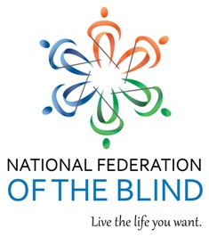

Introduction to Blindness Skills Workshop  in correlation with the  50th Annual State Convention of the National Federation of the Blind of Kansas | Put the GOLD into your Golden Years!  Are you interested in learning a few good skills used by other independent blind and low vision people? This short workshop may be just the thing for you!  This year’s convention will be held:  November 1-4, 2018  Hotel at Old Town  830 E. 1st St. N.  Wichita, KS 67202 | Key Offerings  The National Federation of the Blind of Kansas in partnership with professionals from BLIND Inc., Minneapolis, MN will be providing the valuable workshop.  In addition, there will be a separate opportunity for your significant other to learn in your adjustment to vision loss.  Key Clients  - Most expenses will be covered by the NFBKS  - You must attend both the workshop and State convention (November 1-4, 2018)  - You must be able to do all self-care  - You must be available for a short telephone interview  - Space is limited so please enroll as soon as possible  Contact Us  Dianne Hemphill,  President, NFBKS Seniors Division  316-201-1323  Email: diannehemphill@cox.net

