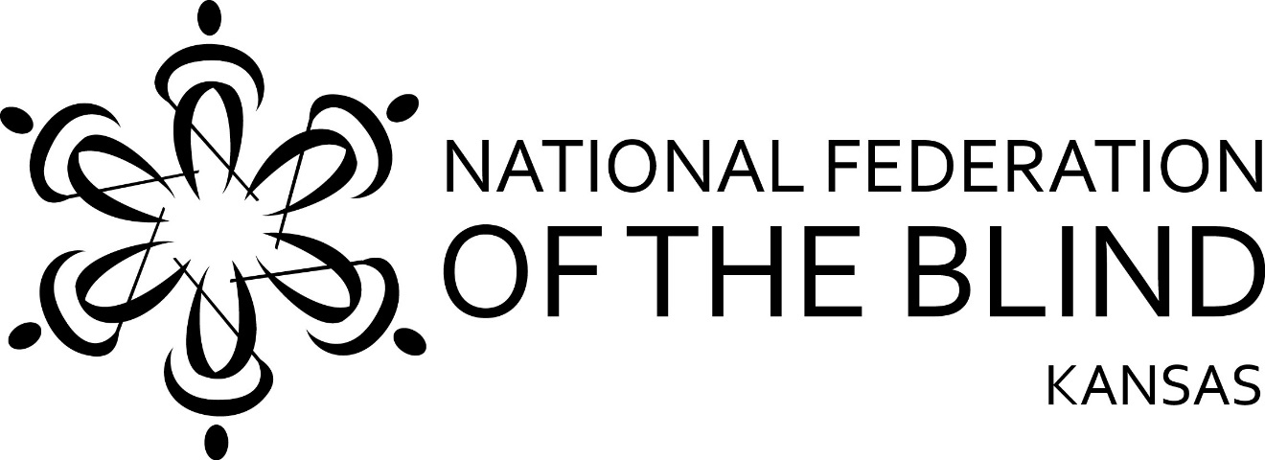

National Federation of the Blind of Kansas
State Convention 2019
Agenda
November 1, 2 and 3, 2019

NFB Pledge
I pledge to participate actively in the effort of the National Federation of the Blind to achieve equality, opportunity, and security for the blind; to support the policies and programs of the Federation; and to abide by its constitution.

Friday, November 1, 2019

Noon--Registration (Pre-Function Area)
1:00 PM--Access Technology Extravaganza, Rob Tabor, Mika Pyyhkala and Alison Roets (Flint Hills)
4:00 PM--Legislative workshop, John Fritz and Tom Page (Flint Hills)
5:00 PM--Registration (Pre-Function Area)
5:00 PM--Hospitality (Pre-Function Area)
6:00-10:00 PM--Vendors (Graves)
7:00 PM--Resolutions, Chair Rob Tabor (Flint Hills)
9:00 PM--Nominating committee, Chair Rob Tabor (Flint Hills)

Saturday, November 2, 2019
(General Session, Graves and Earhart)

8:00 AM--Registration (Pre-Function Area)
9:00 AM--Invocation, Welcome from Mayor Trent Davis and opening announcements
9:15 AM--National report, John Fritz
10:00 AM--State report, Tom Page,
10:30 AM-- Project Search: What it does in the community, Ardis Bryan, Instructor and Austin Meyer
10:45 AM--Envision: Updates and future directions, Michael Monteferrante, CEO
10:55 AM--Envision Research Institute Jared Reyes, Research Program Manager and Marco Tarantino, Research Fellow
11:15 AM--Kansas Talking Books update, Michael Lang
11:30 AM--Audio Reader, Lori Kessinger
11:45 AM--Directing NFBKS Social Media, Alison Roets
11:50 AM--Nominating committee report and Resolutions
Noon--Lunch (Eisenhower)
Senior lunch (Flint Hills)
1:15 PM--Kansas School for the Blind update, John Harding
1:25 PM—Kansas Rehabilitation Services update, ?
1:35 PM--Building the capacity to accommodate blind students, John Jones, Director Wichita State University Media Resources Center
1:45 PM--My life as a blind student, Alison Roets, Brittany Myrie and Emily Schlenker
2:00 PM--Education panel, John Harding, John Jones and KRS?
2:15 PM--My journey to employment, Renee Morgan
2:25 PM--Braille Transcription and Proof Reading, Rob Tabor
2:35 PM--Braille Technology, Mika Pyyhkala
2:45 PM--832: UEB and You, Sharon Luka
3:00 PM--What is Alpha Pointe, Cheryl Rayburn, Low Vision Manager
3:15 PM--Break
3:30 PM--SILCK, KAC, and Rehab. Council Updates, Tom Anderson
3:45 PM--Salina Arts and Humanities, Brad Anderson
4:00 PM—Kansas Affiliate building, John Fritz
4:15 PM--The long road to the Marrakesh Treaty books for the world, Nick Hoekstra
4:25 PM--Newsline, Rob Tabor
4:30 PM--Representative J. R. Claeys
4:40 PM--NFBKS new member welcome and coin presentation, Tom Page
5:00 PM--Adjourn

Saturday Evening November 2, 2019

6:00 PM--Happy Hour (cash bar) Pre-Function Area
7:00 PM--Banquet (Eisenhower) Keynote address, John Fritz
Awarding Tede memorial scholarships
9:00 PM--Entertainment by: Don Wagner, Sylvia Kvacikand, & Amos Vega

Sunday, November 3, 2019
(Business Meeting, Graves and Earhart)

7:00 AM--NFBKS in Communities of Faith breakfast (Flint Hills)
9:00 AM--Invocation
Business meeting
Noon--Adjourn

