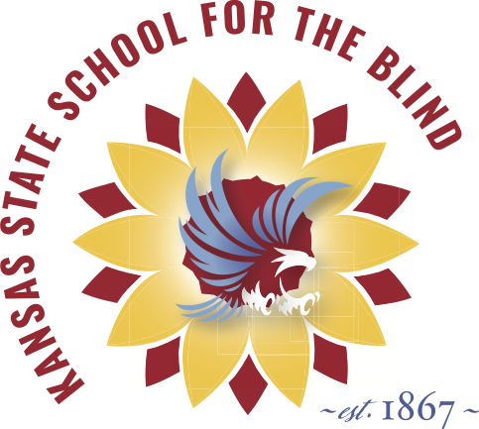
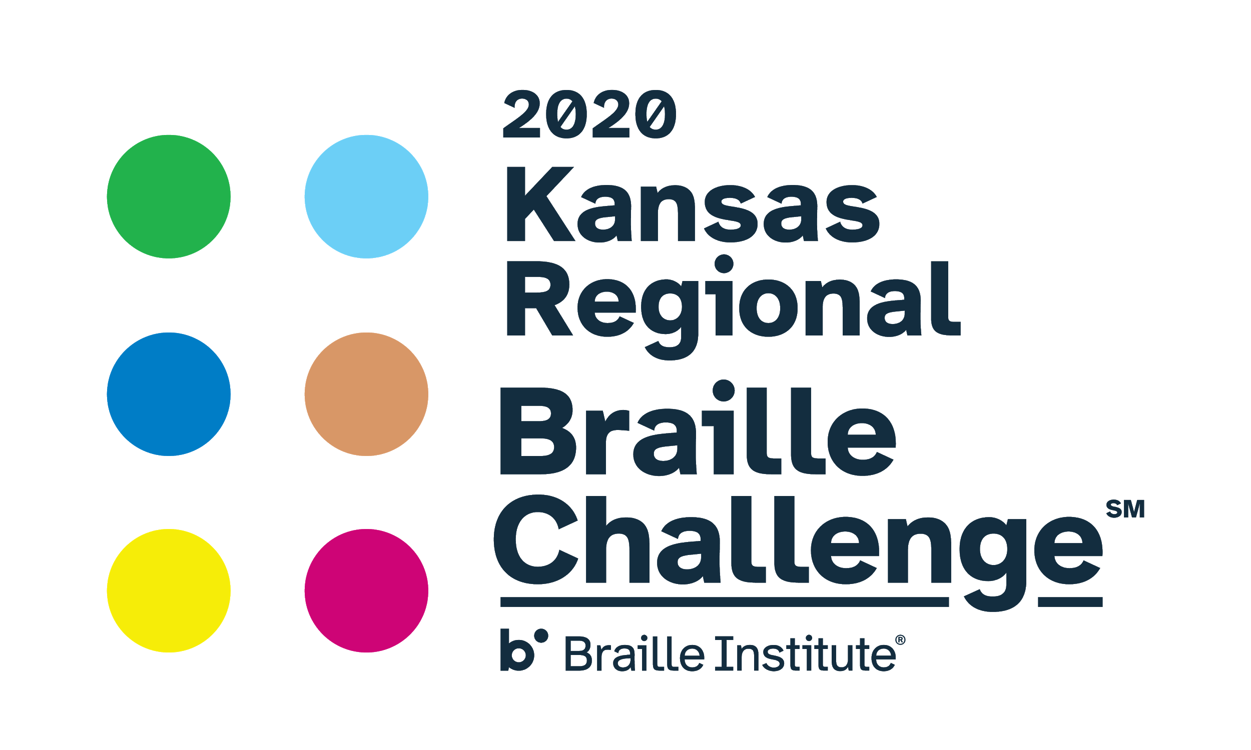
Leap For Braille
2020!!!

Derby Event Schedule

DERBY MIDDLE SCHOOL: 801 E Madison Ave, Derby, KS 67037

Saturday, February 29, 2020
8:30 am Registration (cafeteria)
9:00 am Opening Ceremony (library)
9:30 am Student Session 1 *Parent Session: NanoPac AT
10:15 am Snack Break (Proctors bring students to the cafeteria)
10:30 am Student Session 2 *Parent Session: O&M/Dog Guide
11:30 am Student Session 3 *Parent Session: ADL Demonstration
12:15 pm LUNCH - service and seating in the cafeteria.
(Please remain with your participant in cafeteria until next activity)
1:00 pm Entertainment - Jenny Eichner (Apprentice and Freshman Only)
Student Session 4 (Sophomore, Junior Varsity and Varsity Only)
2:00 pm Closing Ceremony (library)

A warm and grateful thank you to our 2020 sponsors!

Humanware
Seedlings Braille Books for Children
KC Blind All-Stars
Derby Middle School, Derby, KS
Kansas Lions Sight Foundation
Hallmark
UMB
Bank of Labor
Garden City Noon Lions Club
Garden City Optometrists
Garden City Vision Source
Alphapointe
Envision, Inc. Wichita, KS
Drum Safari

