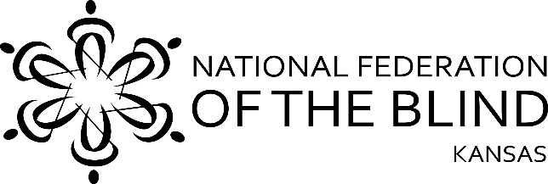
From: Tom Page, President, National Federation of the Blind of Kansas
To: Scott Schwab, Secretary of State of Kansas
CC: Governor Laura Kelly, Derek Schmidt Attorney General of Kansas, Vicki Hiatt, Chair, Kansas Democratic Party, Mike Kuckelman, Chair, Kansas Republican Party
Greetings,
I write today in my capacity as President of the National Federation of the Blind of Kansas to bring your attention to the failure of the Kansas Secretary of State and the Kansas Democratic Party to ensure that the voting rights of blind Kansans were protected during the recent mail-in primary. Unfortunately, the combination of already insufficient and poorly implemented voting systems in our state and the COVID virus threat created a situation in which the decision was made to go ahead with the election even though there were no mechanism in place to allow blind and print disabled voters to privately and independently cast their ballots. These decisions, long and short term, have placed blind Kansans in an intolerable position.
The current system relies entirely upon county election offices to be open so that those wishing to vote accessibly can go in person to a physical voting machine. This has also applied to absentee balloting and early voting. Although the impact of the COVID virus threat has highlighted the inadequate nature of the current systems, these problems are not new to blind Kansans. We have long lamented the Secretary of State’s unwillingness to implement accessible absentee voting, early voting, and voting registration mechanisms. These concerns have been repeatedly voiced at local and state levels. Mark Riccobono, President of the National Federation of the Blind, wrote to the Secretary of State last fall urging his office to comply with the appropriate federal laws including the Rehabilitation Act, the American’s with Disabilities Act and the Help America Vote Act. This letter detailed the insufficiency of the voting systems in our state and drew attention to caselaw underscoring the incorrect assumption that the “one accessible ballot marking device” model constitutes an “equal voting experience”.
The Secretary of State’s office did not reply and their continuing lack of attention to this issue has led to the current deplorable disenfranchisement of blind Kansans. We are extremely concerned that these same problems will continue as the demand for mail-in balloting rises. Sadly, nothing can be done to restore the loss of access to the recent primary. These systems problems however, can and should be fixed now before more damage is done to blind Kansans.
We call upon the Secretary, the Governor, and the chair of both parties to take the necessary steps to bring our voting mechanisms up to par and in all future elections ensure that the voting rights of blind and print disabled Kansans are protected. We would appreciate the opportunity to be involved in the solution process. We offer our expertise to make the voting systems in Kansas something we can all be proud of. The NFB of Kansas will put forth every effort and resource to help solve these problems. I look forward to working together with you. Please contact me at the below phone or email as soon as possible.
Respectfully,

Tom Page
President, National Federation of the Blind of Kansas
316-734-4839
topage@swbell.net

