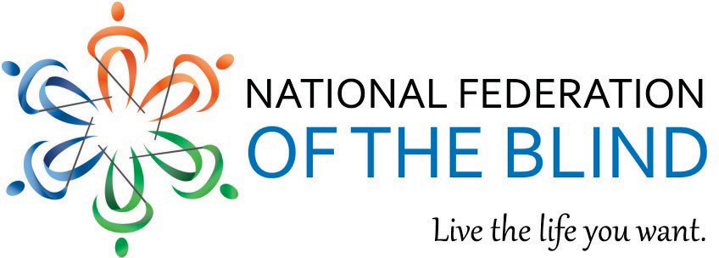

MEDICAL DEVICE NONVISUAL ACCESSIBILITY ACT

Issue--Advanced digital interfaces create barriers that prevent blind individuals from independently and safely operating home-use medical devices that are essential to their daily healthcare needs.

Home-use medical devices are becoming more prevalent and less accessible for blind Americans. The rapid proliferation of advanced technology is undeniable. Most newer models of home-use medical devices, such as glucose and blood pressure monitors, along with the emergence of in-home devices that offer medical care options, such as chemotherapy treatments and dialysis, require that consumers interact with a digital display or other interfaces. This new technology has been and continues to be developed and deployed without nonvisual accessibility as an integral part of the design phase, which creates a modern-day barrier. The inaccessibility of home-use medical devices is not a mere inconvenience; if accessibility for blind consumers is omitted from the medical technology landscape, the health, safety, and independence of blind Americans will be in imminent danger.

Advancements in home-use medical devices have the potential to transform how people live in society but are currently designed for those with no functional limitations.1 This flaw in product design limits options for blind Americans who need nonvisual access to critically important devices that help them to maintain their health and are available to people without disabilities.2

Nonvisual access is achievable, as demonstrated by a number of mainstream products. Apple has incorporated VoiceOver (a text-to-speech function) into all of their products, making iPhones, Macbooks and Mac desktops, and iPads fully accessible to blind people right out of the box. Virtually all ATMs manufactured in the United States are accessible, and every polling place is required to have a nonvisually accessible voting machine. Frequently, a simple audio output or vibrotactile feature can make a product fully accessible at little to no additional cost for manufacturers.

Current disability laws are not able to keep up with advancements due to the expeditious evolution of medical technology and its incorporation into home-use medical devices. Although the Americans with Disabilities Act and other laws require physical accessibility for people with disabilities (e.g., wheelchair ramps, Braille in public buildings), no laws protect the blind consumer’s right to technology such as home-use medical devices. The National Council on Disability concluded that accessibility standards lag behind the rapid pace of technology, which can interfere with technology access.3 This trend of inaccessibility will continue if accessibility solutions are ignored. Only a fraction of medical device manufacturers have incorporated nonvisual access standards into their product design, while others continue to resist these solutions.

Solution--Medical Device Nonvisual Accessibility Act:

Calls on the Food and Drug Administration (FDA) to promulgate nonvisual accessibility standards for home-use medical devices. The FDA will consult with stakeholders with disabilities and manufacturers and issue a notice of proposed rulemaking no later than twelve months after the date of enactment of the act. No later than 24 months after the date of enactment of the act, the FDA will publish the final rule including the nonvisual accessibility standards.

Requires manufacturers of home-use medical devices to make their products nonvisually accessible. Manufacturers will have twelve months following the publication of the final rule to ensure that all of the home-use medical devices they produce are nonvisually accessible.

Authorizes the FDA to enforce the nonvisual access standards for home-use medical devices. Any manufactured device found to be out of compliance, whether by a public complaint to the FDA or by an independent FDA investigation, will incur the same penalties as failing to meet the same safety standards as other home-use medical devices.

GOAL--END UNEQUAL ACCESS TO HOME-USE MEDICAL DEVICES FOR BLIND AMERICANS.

Cosponsor the Medical Device Nonvisual Accessibility Act when introduced.

For more information, contact:
Stephanie Flynt, Government Affairs Specialist, National Federation of the Blind Phone: 410-659-9314, extension 2210
Email: sflynt@nfb.org

For more information visit www.nfb.org.

1 See NATIONAL COUNCIL ON DISABILITIES, National Disability Policy Progress Report: Technology that enables access to the full opportunities of citizenship under the Constitution is a right at 19 (October 7, 2016), available at https://ncd.gov/progressreport/2016/progress-report-october-2016.
2 See Id.
3 See Id.

National Federation of the Blind

