BVI Sights Unseen Group Cruise
Hi everyone. Here is the information about our first group trip.
We will cruise to the Caribbean. General details are below. See group website for more information. The link is below.

All are welcome to come and enjoy an adventure at sea. Singles, couples, friends, family - together we will travel as a group, BVI Sights Unseen. Get ready for a literal “boat load” of fun. There will be activities and interests to suit individual needs and/or group excursions and adventures, if so desired. You choose. Whatever activities you decide to participate in, you will have a support system around you – from the cruise line staff to your fellow travelers, we support each other.

Cruise Information
Royal Caribbean International: Symphony of the Seas
Departing Miami on Sunday, March 9 – 15, 2025
7-night trip going to Caribbean - Western (Caribbean)
Visiting: Miami, CocoCay, Nassau, Falmouth, Labadee

Cabin Information:
All cabins are double occupancy.*
- Each guest would pay for ½ cabin price – per guest amount listed below.
  - Total cabin price: per guest price x 2
*If a person opts for their own cabin, must pay for total cabin price*
Staterooms
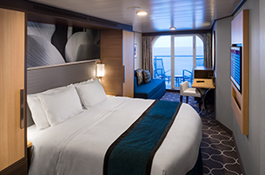
Ocean View Balcony: 4D
Stateroom Type: Balcony
Two twin beds that convert to Royal King, sitting area with sofa, full bathroom and private balcony.
Per Guest Rates:
Guests 1-2: $1,373.29/per person

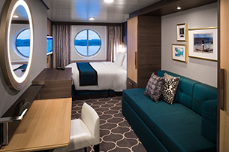
Ocean View: 3N
Stateroom Type: Ocean View
Per Guest
Guests 1-2: $1,136.29/per person

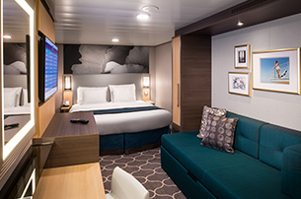
Interior: 4V
Stateroom Type: Inside Cabin
Interior Two twin beds that convert to Royal King, private bathroom and sitting area. Up to 4 guests. Stateroom: 149 sq. ft.
Per Guest
Guests 1-2: $1,054.29/per person
** If a cabinmate is needed to share a room, and keep costs down, let us know. We will do our best to facilitate.**

Additional Details:
- Cabin Hold Fee of $50 per person is due March 25, 2024
- This fee is nonrefundable.
- Full Deposit - $250 per person due May 24, 2024
- Payments in any amount can be made incrementally up until the Final Payment date.
- Final Payment Due Date: Dec 6, 2024

Additional Details can be found on the group website:
https://www.ebycruising.com/GroupRegistrations/view/120378

Other Important Information

- Hotel** - See details below and on link
SPRINGHILL SUITES BY MARRIOTT MIAMI AIRPORT SOUTH BLUE LAGOON AREA
- Shuttle Service
- Free Full American and Hot Breakfast
  - Monday-Friday 6:30 - 9:30 AM
  - Saturday-Sunday 6:30 - 10:00 AM

https://www.marriott.com/en-us/hotels/mialg-springhill-suites-miami-airport-south-blue-lagoon-area/overview/?scid=f2ae0541-1279-4f24-b197-a979c79310b0

- Airline**
  - Details after May 24, 2024
  - Travel: KCI – Miami - March 8
  - Travel: Miami to KCI - March 16, 2025
- Transportation**
  - From Miami airport to Marriot Hotel
  - From Marriot hotel to Miami airport
    - Hotel shuttle- Springhill Suites by Marriott Miami Airport South -Blue Lagoon Area
  - To/from hotel to Ship – Symphony of the Seas
    - Cruise Port Shuttle $ 15/per person
- Travel insurance
- Booking/Registration
  - Registration Help/Assistance - options
    - Audio registration guide will help assist, *posted soon
    - Ask a family/friend to help
    - Contact Renita Claud, t. 757-472-5076; renita.claud@cruiseplanners.com
- Payment
  - Cabin rate is based on 2 person occupancy
  - Rates provided are per person rates
- Cruise information and specifics
Royal Caribbean Cruise: Symphony of the Seas

- Short video;
https://youtu.be/vyZ5oLa4TgE?si=ZTwJOIK_4kdwXSmu

- Long video;
https://youtu.be/rFpcDuYKcBk?si=HmZbtraj_q-RL4tE
- Have questions
- Send email to bvisightsunseen@gmail.com
- Ask questions on FAQ page
  - 24-48 hour response time
**Additional Services at a Group Rate - hotel, airfare, and transportation will be determined after May 24, 2024. These rates will be based on a minimum number of travelers.

Note: When registering, be specific to indicate, IN THE COMMENTS section, if you are interested in any additional services: hotel, airfare, transportation, travel insurance. Specifics related to each will be provided based on your selection.

A cruise informational meeting will be scheduled in April. Details will follow in a later email. Our Travel Agent, Renita Claud, will talk with the group and answer any questions or concerns. If you have accessibility issues, or immediate questions, please let us know.
Travel Agent: Renita Claud - ACC
A Cruise Planners® Independent Franchise Owner
t. 757-472-5076
e. renita.claud@cruiseplanners.com
w. www.ebycruising.com

We look forward to sailing with you.

Bon voyage,
Patricia
BVI Sights Unseen
bvisightsunseen@gmail.com

