**Sponsor Sheet**

|  |  |  |
| --- | --- | --- |
| # | Name | Amount |
| 1 |  |  |
| 2 |  |  |
| 3 |  |  |
| 4 |  |  |
| 5 |  |  |
| 6 |  |  |
| 7 |  |  |
| 8 |  |  |
| 9 |  |  |
| 10  Total |  |  |

If you have more sponsors, please use an additional sheet.

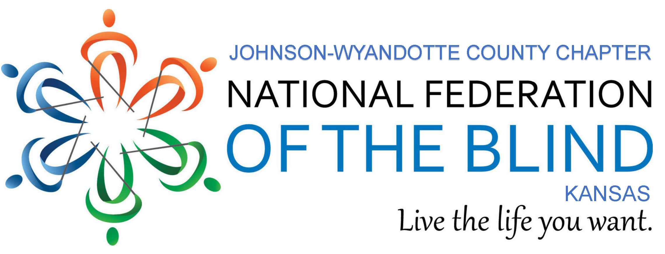

WALK FOR INDEPENDENCE

**Saturday, May 11, 2024**

**Loose Park Pavilion**

**REGISTRATION**

Name:____________________________________

Address:__________________________________

_________________________________________

Phone: ___________________________________

Emergency Contact Information:

Name: ___________________________________

Phone: ___________________________________

**WAIVER**

I hereby waive all claims against the National Federation of the Blind, State affiliates, chapters,

and any personnel for any injury I might suffer in

this event.

Signature: _________________________________

If the walker is under the age of **18**, signature of parent or guardian is required below.

Signature: _________________________________

**ABOUT THE WALK FOR INDEPENDENCE**

You can help by obtaining sponsors and joining us for our 2024 walk on Saturday, May 11.

Registration begins at 9:00 a.m. at the Loose Park Pavilion at 5200 Wornall Road, Kansas City, MO. The park entrance is between 51st and 55th Streets. **There is no registration fee.**

You must turn in your registration form and signed waiver to the Walk Coordinator at registration on the day of the walk. Your donations should be turned in as soon as possible after completing the walk. Checks should be made payable to **NFB of Kansas.**

The walk will begin at 10:00 a.m. (rain or shine). You choose how far you walk! The perimeter around the park is equivalent to one mile.

To obtain more information about this event or the National Federation of the Blind, you may contact us at 913-339-9114.

The National Federation of the Blind knows that blindness is not the characteristic that defines you or your future. Every day we raise the expectations of blind people, because low expectations create obstacles between blind people and our dreams. You can live the life you want; blindness is not what holds you back.