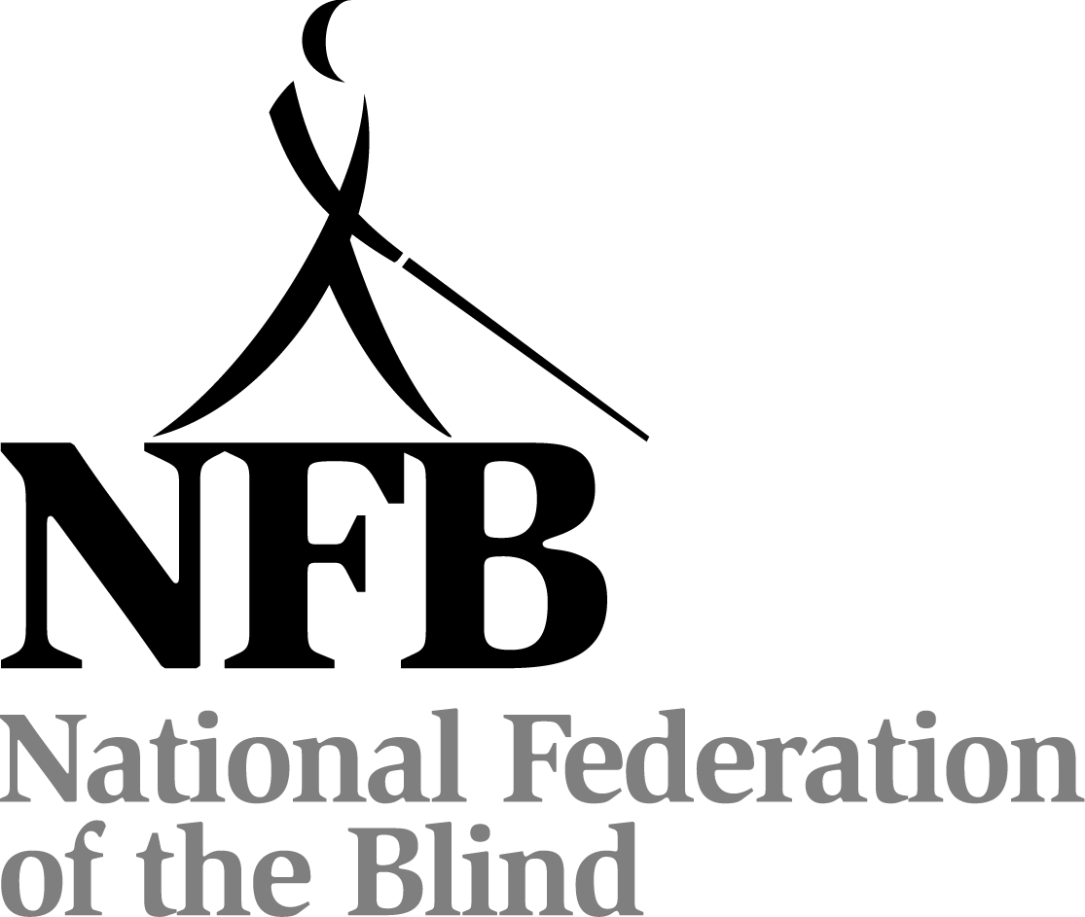

The Campaign Guide for October 2009 Meet the Blind Month

Meet the Blind Month, held during October, is our nationwide campaign to increase awareness of and support for the National Federation of the Blind (NFB). This person-to-person awareness campaign is designed to increase the understanding that the National Federation of the Blind is the country’s prominent membership organization of blind people and that we, the NFB, are the recognized resource when it comes to vision loss, blindness, and rehabilitation.

During Meet the Blind Month, chapters throughout the country are encouraged to conduct a variety of activities to spread this message to their local communities. NFB members are asked to interact with the public in a number of venues while providing outreach to individuals, including spreading the word to those who are losing or have lost vision. The National Center for the Blind will support these grassroots activities with a nationwide public awareness campaign that will include access to video and other specialized materials.

Two thousand nine marks a very special year as the two hundredth anniversary of the birth of the inventor of the Braille code, Louis Braille. To help celebrate this historic moment in history, we are launching a new Meet the Blind Month initiative, Who's Whozit. This initiative will serve to generate excitement around one of our organization's most important efforts--public education. The primary focus in 2009 is to promote Braille, a better understanding of what it is, and the positive affect it offers the blind here in the United States and around the world.

Here's what we are asking you to do:
1. In August, contact at least one elementary, middle, and high school in your area.
2. Arrange to present the Who's Whozit campaign to a class (or classes) during the month of October. The earlier in October the better.
3. Order your Who's Whozit materials by September 14.

Each package of Who's Whozit materials will include:
1. A program guide tailored to your target audience (elementary school, middle school, high school, or the general public.)
2. Braille alphabet cards
3. Whozit Die Cuts
4. Who IS Whozit and Whatzit all about?

What is Who's Whozit?

A die cut Whozit and five alphabet cards will be given to each student who attends the Meet the Blind Month presentation (teachers are welcome to participate as well.) Participants will then be instructed to bring their Whozit and alphabet cards with them everywhere they go during October. Each week they should introduce Whozit to at least one new person. They will give this person an alphabet card and tell them about the Who's Whozit campaign. Here's the fun part—students will be asked to photograph folks meeting Whozit and receiving their alphabet cards. They will then log onto our NFB Web site to submit their photos. This site will be password protected and access will only be granted to those who have deciphered the Braille on the bottom of their alphabet card. Each student may submit one photo, which will be entered by staff into one of three prize categories. Examples of possible categories are: Whozit meeting the largest group of people, Whozit meeting people in the most unusual place, Whozit meeting the most influential person, etc. So, it is suggested that students be as creative as possible when introducing their Whozit to new people and places. Our ultimate goal is for Whozit to meet one million people during the month of October. We know that NFB members can make anything happen, and we're counting on you to help us meet this goal.

The winner in each of the categories will receive a Louis Braille Bicentennial Uncirculated Silver Dollar.

Why the focus on schools?

One of our biggest obstacles to attaining equal status in society has been shattering the misconceptions about blindness. If we are able to shatter these misconceptions before they are introduced or take hold, we will slowly, but surely, begin to eradicate them completely.

Does this mean that you should stop doing traditional Meet the Blind Month activities? NO! It just means that you need to incorporate the Who's Whozit initiative into your event planning. For example:

Story time at the library—give all of the kids a Whozit and supply of alphabet cards

Proclamation signing—ask your government official if he or she would pose with Whozit for a picture

White Cane walk—bring Whozit along. Introduce him to folks you meet while on your walk.

There is one more big change to Meet the Blind Month this year. If your chapter is primarily into raising funds, go for it. But, fundraising should never be your only goal during Meet the Blind Month. Education of our nation’s youth about Braille, using the Who’s Whozit materials, is critically important in busting the myths about Braille and blindness. Remember… it really is about Braille.
Once you have shared the importance of Braille with your audience, be sure to encourage them to purchase a Louis Braille Bicentennial Silver Dollar by visiting www.usmint.gov or calling 1-800-USA-MINT (872-6468). The matching funds available through the sale of these coins will make a huge difference in the future for blind children and adults.

Finally, take this time to get out into your community and show folks that it is respectable to be blind! Teach a yoga class, build a house with Habitat for Humanity, serve in a soup kitchen—the sky is the limit. In addition, wherever you go, bring Whozit with you!

Public Speaking Engagements

In the event that there is no opportunity to present the Who’s Whozit program to school children, remember that many civic and community groups are looking for interesting speakers for their luncheon or dinner meetings. Groups that could be contacted include: Elks, Kiwanis, Lions, Masons, Rotary, garden clubs, neighborhood associations, church groups, low vision support groups, senior centers, companies hosting brown bag information luncheon meetings for employees, labor unions, PTAs, and any other such groups you have in your neighborhood.
Choose some of these points to emphasize when meeting the public, interacting with the media, and giving presentations:
- With a membership of over 50,000 Americans, The National Federation of the Blind is the largest membership organization of blind people in this country with more than 700 local affiliates and chapters as well as many divisions and interest groups.
- The mission of the National Federation of the Blind is to achieve widespread emotional acceptance and intellectual understanding that the real problem of blindness is not the loss of eyesight but the misconceptions and lack of information which exist. We do this by bringing blind people together to share successes, to support each other in times of failure, and to create imaginative solutions.
- An organization of blind people is the best resource for individuals facing vision loss, their families, professionals who work with blind individuals, and governmental officials who deal with issues of importance to the blind.
- The National Federation of the Blind Jernigan Institute, the first of its kind developed and operated by an organization of blind people. The programs, services, research, and technology of the Institute reflect, first and always, the consumer perspective and are responsive to the pragmatic needs of the blind in a way unique to an organization of blind persons.
- We are leading the way in the promotion of access to technology for the blind by advocating for the implementation of national technology access standards, conducting educational activities to inform technology developers and others of the importance of access design, and assisting technology companies in their efforts to market helpful nonvisual access technology applications.
- The National Federation of the Blind has established a comprehensive initiative in Braille literacy in honor of Louis Braille’s two hundredth birthday. The initiative will be marked by the most significant investment in literacy for the blind ever—raising $8 million for Braille literacy programs into the future—and an innovative network of programs that dramatically enhance opportunities and education for the blind.

For more information, to coordinate local affiliate and chapter activities with the national office, or to order materials and have your local activities posted on the NFB Web site, go to www.nfb.org, and then click on Meet the Blind Month.

Or contact: Jerry L. Lazarus

Director of Special Projects
National Federation of the Blind Jernigan Institute
1800 Johnson Street
Baltimore, Maryland 21230-4998
(410) 659-9314, extension 2297
E-mail: jlazarus@nfb.org

