PACE is Sticking Paratransit Riders with the Bill
$$ Fare Increase
Can You Afford to Pay $5.00 Every Time You Ride???
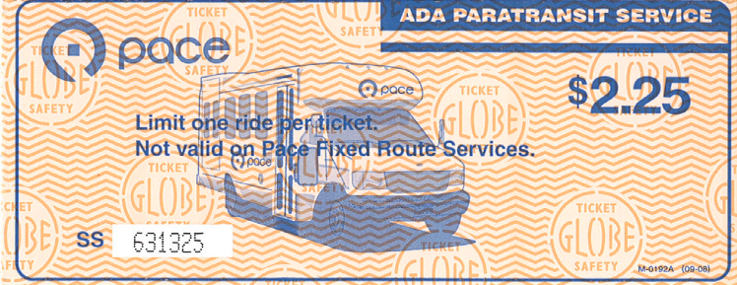
Join us in a RALLY to express your disgust and outrage for the proposed fare increase. Afterwards stick around for the public hearing meeting from
$$ Fare Increase
3-5pm.

When: Monday October 26, 2009
Where: Westside Technical Institute
Address: 2800 S. Western Ave
Time: 1:00pm-2:00pm

Questions or Concerns please contact Carleda Johnson Independent Living Skills Coordinator for Access Living
312-640-2159 or cjohnson@accessliving.org

