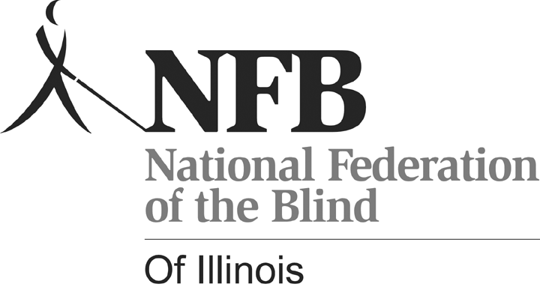
Kelly Doty, Chairperson
NFBI Senior Fair
1433 Ashland Street, #403
Des Plaines, Illinois 60016
(847) 390-1738
kelly@dls.net

Dear Exhibitor:

The members of the National Federation of the Blind of Illinois (NFBI) invite you to participate as an exhibitor at our second annual Senior Fair - Senior-bilities: Embrace the Possibilities. Our Senior Fair aims to provide seniors losing vision the opportunity to be exposed to all kinds of services and products that they may not know exist. I am sure that your product or service will be of interest to them and extremely important in helping them maintain an independent lifestyle.

The fair will take place on Friday, October 9, 2009 from 11:00 a.m. to 2:30 p.m. at the Holiday Inn O’Hare, 5615 N. Cumberland Avenue, Chicago, Illinois. Senior participants will have an hour before lunch begins to browse the different demonstration areas. After lunch, seniors will have a more lengthy time to visit exhibits and get a hands-on opportunity to learn about techniques and equipment that can improve the quality of their lives.

An exhibitor registration form is attached. Please let us know of your intentions to exhibit at Senior-bilities: Embrace the Possibilities by returning the enclosed form and payment by July 31, 2009. We look forward to working with you to provide attendees with the best experience possible. If you have any questions, please do not hesitate to contact me.

Sincerely,

Kelly Doty, Chairperson
Senior-bilities: Embrace the Possibilities

