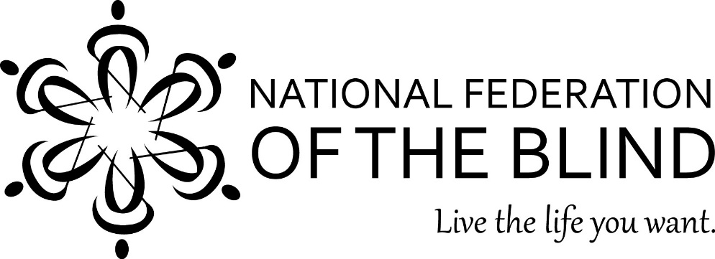
The National Federation of the Blind of Illinois Presents ___

“Picnic in the Park Fund Raiser”
Your participation will help the NFBI support the good work we do

June 6, 2015

11am-4pm
Everyone is encouraged to attend, invite your family, friends, co-workers and employees
On June 6, 2015 the National Federation of the Blind of Illinois will host a picnic at Tom Madonia Park East; Lake Springfield, Springfield, IL
Menu: Hamburgers, Brats; grilled on site, Mostaccioli, Baked Beans, Macaroni Salad, Tea and Lemonade. BYOB
Boat rides provided by the Rogers on their 24’ pontoon boat.
Door prizes; 50/50 drawing
Anyone who plays a musical instrument is encouraged to bring it along.

The Chang’s and the Reif’s will operate a shuttle service from the Amtrak station in Springfield to the park. The train leaves Chicago at 7am arrives in Springfield around 10:30am. Leaves Springfield at 4:56 arrives back in Chicago around 8:30pm. Anyone interested should contact Bill Reif 217-801-2996.
Cost: $30.00 per person
Deadline: June 1, 2015; Please make checks payable to NFBI and send To: Treasurer Patti S Chang, 6919 W Berwyn Av, Chicago, IL 60656
Contact: Jess Rogers……217-629-7023 Bill Rief 217-801-2996

The National Federation of the Blind (NFB) is a 50,000-member organization that works to insure the full participation of blind people in all aspects of society.
For more information on NFB go to www.nfb.org. For more information on our Illinois Affiliate of NFB, go to www.nfbofillinois.org.

