FOR IMMEDIATE RELEASE
Blind Royal Navy Veteran Penny Melville-Brown Wins International Award to Share the Joys of Baking Blind Around the World
The LightHouse for the Blind announces Penny Melville-Brown of “Baking Blind” as one of the first-ever winners of the Holman Prize.
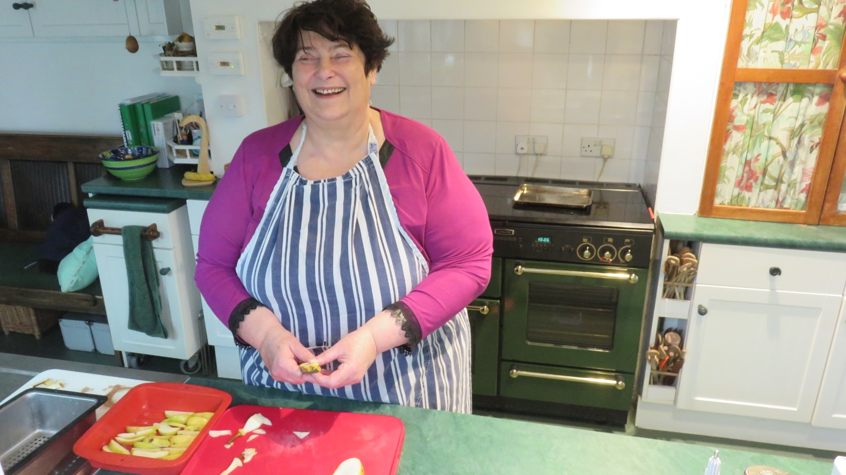
Image: Blind baker Penny Melville-Brown chops apples in her kitchen.
FAREHAM, HAMPSHIRE, UK – June 29, 2017 – British Royal Navy Veteran Penny Melville-Brown is not your average chef. First of all, she is, in fact, blind. But beyond that, Penny has a deep and unique understanding of food’s ability to break down cultural barriers and to connect people – blind and sighted alike – across the globe.
Today, LightHouse for the Blind and Visually Impaired in San Francisco announces Penny as one of three winners of the 2017 Holman Prize for Blind Ambition, a brand-new award for blind adventurers of all kinds.
“While food is a mainstay across the media and popular culture, it is almost impossible to find any inclusion of visually impaired people,” Penny says. With her Holman Prize project, Penny hopes to change that.
With the $25,000 Holman Prize, Penny will travel to Costa Rica, Malawi, Australia, China and the United States, all over the course of a year. Along the way, she will meet chefs, teach blind people and community leaders the techniques and panache of blind baking, and film these encounters to ensure that people change their assumptions about the capabilities of blind chefs.
Equal parts travelogue and instructional video series, Penny’s video blog will teach all of us, sighted or otherwise, something new about the art of cooking.
Penny also has a special connection with the namesake of the Holman Prize, James Holman, a 19th Century world traveler known as the first blind man to circumnavigate the globe. Both became blind while serving in the British Royal Navy (albeit nearly 200 years apart). Now, like Holman, Penny will take off around the world, crossing multiple continents to teach others about the capabilities of those with disabilities.
Penny is one of three inaugural winners of the Holman Prize. Her fellow prizewinners, Ahmet Ustunel and Ojok Simon, hail from the US and Uganda respectively, and also have ambitious adventures planned over a range of geographies and subjects. Ustunel is planning a solo kayak journey from Europe to Asia, while Simon is planning to build out a blind-led social enterprise for beekeepers in Uganda.
They will all meet at the Lighthouse in San Francisco in September.
Penny began hosting and producing regular video segments this year for a program she calls “Baking Blind”. She takes pride in her collaborations, which will only grow with the help of The Holman Prize. A YouTube original, she can be seen in her videos making everything from apple tarts to lamb tajines and quail eggs in soy sauce.

Interviews and images available upon request.

Read about all three Holman Prize winners in-depth.
Holman Honorees: Meet this year’s finalists.
Meet the blind judges who picked the winners.

Support The Holman Prize
The LightHouse for the Blind and Visually Impaired, which is a 501(c)(3) nonprofit organization based in San Francisco, is actively seeking sponsorships and support for the 2018 Holman Prize, including donations of equipment for the winner’s projects. To offer your support, contact holman@lighthouse-sf.org. Individuals may donate any amount using LightHouse’s secure form. For sponsorship inquiries, email us or call +1 (415) 694-7333.

About LightHouse for the Blind and Visually Impaired
Founded in 1902, San Francisco’s LightHouse for the Blind and Visually Impaired promotes the independence, equality and self-reliance of people who are blind or have low vision. LightHouse offers blindness skills training and relevant services such as access to employment, education, government, information, recreation, transportation and the environment. LightHouse also pursues the development of new technology, encourages innovation, and amplifies the voices of blind individuals around the world. To receive services, volunteer or make a donation, visit lighthouse-sf.org.

Press contact:

Will Butler, Director of Communications
+1 (415) 694-7309
press@lighthouse-sf.org

