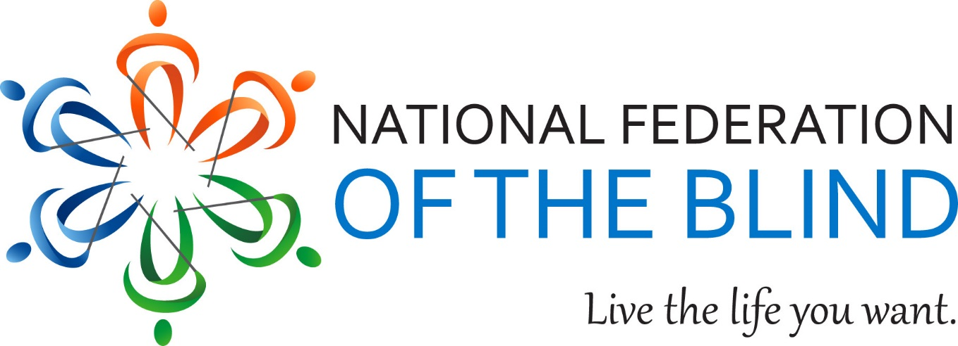

Dear Friend,

I invite you to support the fine programs and activities of the National Federation of the Blind of Illinois (NFBI) through your donation of a door prize to be used at our state convention. This year our convention will be held October 27th through 29th in Naperville, Illinois. Our convention kicks off with informative seminars and resolutions. It continues throughout the weekend with a myriad of programs related to low vision and blindness.

During our convention blind people and their families can gather information both formally and informally. People learn about summer programs, youth opportunities, rehabilitation centers, technology, employment, and other programs as well as services for the blind and visually impaired. Workshops, seminars, and general sessions as well as networking opportunities are afforded.

NFBI awards grants which help recipients gain the adaptive techniques so essential to success as a blind person. We award academic scholarships. We advocate on behalf of individuals and for better legislation.

I speak for the bearer of this letter when I say that the National Federation of the Blind has done more to assist the blind in its seventy plus years of existence than any other organization of or for the blind. NFB is the largest group of the blind speaking for ourselves and we change what it means to be blind.

Your tax-deductible contribution of $25 or greater value can help. We are a not-for-profit corporation supported by members and nonmembers alike. Thank you for your assistance. It is greatly appreciated.

Cordially,
Denise R. Avant
President, NFBI