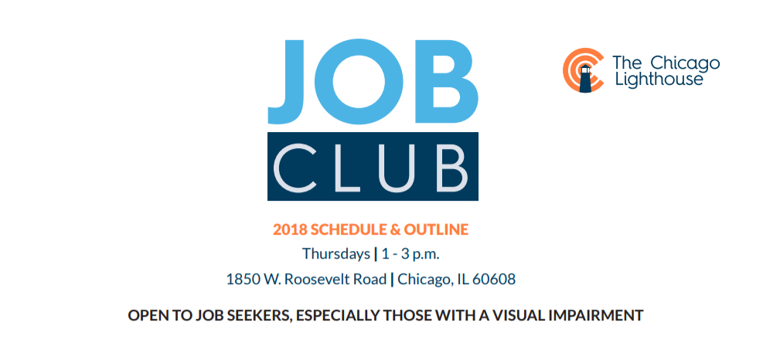

DATE | TASK

9/20 | Knowing yourself and focusing your employment goals
9/27 | Marketing yourself- your presentation and the tools you have to use
10/4 | Social Security Benefits - how will returning to work impact your benefits

10/11 | Financial Literacy - Ensuring you have full access to your accounts,  the National ABLE Act, understanding a credit score, and addressing student loans
10/18 | Developing your resume, crafting cover letters, and on-line job application
10/25 | Interviewing from the employers perspective
11/1 | Mock interviews and computer assessments

11/8 | Federal and State Employment opportunities for people with disabilities
11/15 | Getting around-O&M and transportation choices
11/29 | Disability disclosure and discrimination rights and responsibilities
12/6 | Assistive/adaptive technology in the workplace, and requesting  reasonable accommodations

12/13 | Keeping the job once you have it!
Please Contact Maureen Reid, Job Placement Counselor/Scholarship Coordinator
AT 312-997-3665 or maureen.reid@chicagolighthouse.org with any questions!

