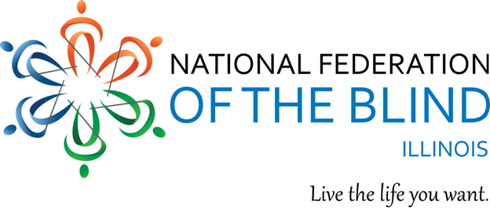
Illinois Association of Blind Students
Virtual Cooking Course
April 3, 2022.

Interested in attending a cooking class? You can give the class as a gift, or take it yourself. The Illinois Association of Blind Students will be administering a virtual cooking course via the Zoom platform on April 3, 2022, from 5-6 P.M. central standard time. This course offers people the opportunity to learn basic cutting skills as they prepare guacamole. The course objective for guacamole to be covered during this course can be found below:

COURSE OBJECTIVE:
✓ Demonstrate basic knife skills while chopping vegetables.

DISH TO BE COVERED:

Guacamole:
This will not be the classic guac recipe, but it might be the best one you ever had. The classic recipe may only incorporate 4 ingredients, but this one will be enriched to be extra creamy and to hold better and longer, without the avocado turning dark.

REGISTRATION:
People who wish to participate in the IABS Virtual Cooking Course will be expected to pay an admission fee of $10, as well as purchase materials and ingredients that will be utilized during the course. A full list of materials and ingredients will be sent to all students by March 27, 2022. Spots for the IABS Virtual Cooking course are limited, and only the first fifteen people who register will be accepted. To register for this course, please reach out to Glenn Moore at gmoore3rd@gmail.com for more information regarding registration and payment for the course.

