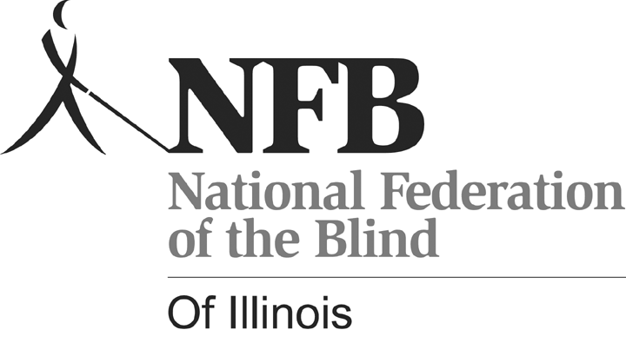
Senior-bilities: Embrace the Possibilities
Holiday Inn O’Hare – Chicago, Illinois

Friday, October 9, 2009 11:00 a.m. – 2:30 p.m.

Registration Form

Name:

Address:

Telephone Number:

E-mail Address (If available)

Choice of sandwich:
Turkey ___ Ham

The first 100 people who register will receive ‘goody bags’. Before September 18th, the registration fee, which includes admission and lunch, is $10. IF tickets are available after September 18th, the cost is $15. Please make checks payable to National Federation of the Blind of Illinois (NFBI).

Note: This form may be copied. Please submit an individual form for each person who will attend, although one check may cover multiple registrations.
---------------------------------------------------------------------------------------
Mail to: Kelly Doty
1433 Ashland St. #403
Des Plaines, Illinois 60016

If you have questions, please call Kelly Doty at (847) 390-1738 or
e-mail kelly@dls.net. Information about the National Federation of the Blind of Illinois and its other programs and scheduled events can be found at www.nfbofillinois.org.

