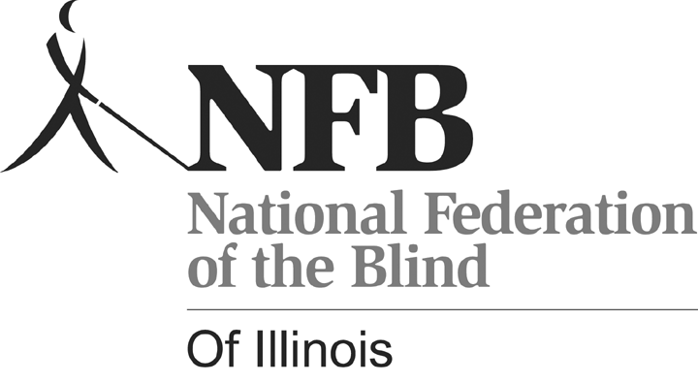
NFBI Senior Fair: Senior-bilities: Embrace the Possibilities

Friday, October 9, 2009
11:00 a.m. – 2:30 p.m.
Holiday Inn O’Hare
5615 N. Cumberland Avenue
Chicago, Illinois 60631

Cost (includes lunch): $10, before September 18
$15, after September 18(if space is available)
The first 100 people to register will receive ‘goody bags’.

The NFBI Senior Fair for those who are losing vision will provide a hands-on opportunity to learn about newspapers over the telephone, books on tape, magnification devices, talking computers, accessible voting machines, and more. Members of the NFBI will be demonstrating alternative techniques for the kitchen and handling finances, as well as some helpful aids and appliances which can make life more accessible. Resources and information about services for seniors losing vision will be plentiful.

For additional information or to register contact Kelly Doty at 847.390.1738, kelly@dls.net or visit www.nfbofillinois.org.

