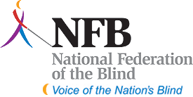
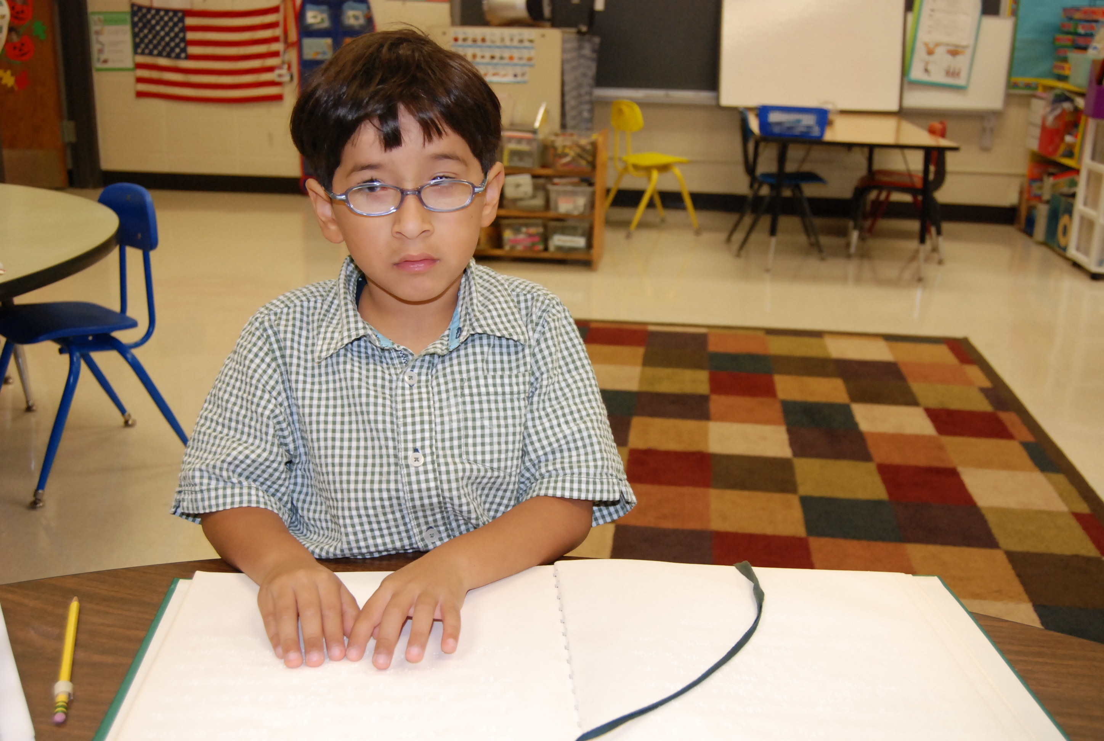

The National Federation of the Blind of Illinois Presents a Parents Seminar

“ABC’s of IEP’s – IEP’s and more…”

Saturday, April 10, 2010

A daylong seminar for parents and teachers of visually impaired and blind children will be held on Saturday, April 10, 2010, at the O'Hare Holiday Inn, Chicago, 5615 North Cumberland Avenue. Families and teachers from throughout Illinois are invited to share in an empowering day of discussions and activities. Topics will include the IEP process, education of children with multiple disabilities, technology, opportunities in sports and recreation, and much more. Blind adults and students will share their life experiences, explaining what worked for them when they were growing up and what could be improved for the upcoming generation. Spanish interpreting will be available.

Interesting activities will be provided for children and teens. Kids under twelve will enjoy arts and crafts, music, and mobility activities. In The Teen Scene, older kids will explore the hotel on a scavenger hunt, learn a few dance steps, experiment with self-advocacy techniques, and engage in discussions about school, and socialization.

Cost: $25 adults, $15 ages 12-18, and $10 for ages 11 and under, including a box lunch. Overnight accommodations are available for $77 at the O'Hare Holiday Inn by calling (773) 693-5800. Indicate that you are asking for the National Federation of the Blind group rate. For those traveling from outside the Chicago-metro area, financial assistance may be available. Please apply for a James Chappell Memorial Award by going to www.nfbofillinois.org.

The National Federation of the Blind (NFB) is a 50,000-member organization that works to insure the full participation of blind people in all aspects of society. The National Organization of Parents of Blind Children (NOPBC) is a division of NFB that has been helping to spread a positive message about vision loss to parents for more than twenty-five years. "The more I educate myself, the more I find I am widening opportunities for my son," says Beth Sturman, the mother of a blind thirteen-year-old.

Information and applications can be found at www.nfbofillinois.org.

For more information, please contact Debbie Kent Stein at dkent5817@worldnet.att.net (773) 631-1093), or Beth Sturman at beth.sturman@gcsd9.net (618) 345-3105.

Vision impairment can be reduced to a nuisance with proper training. Please come and see how.

