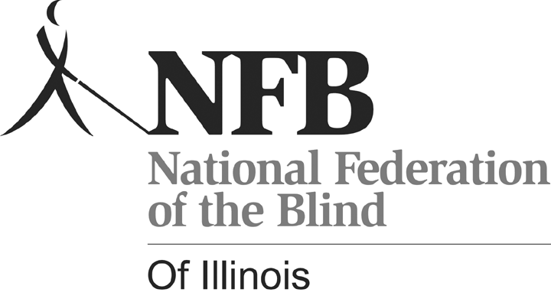
NFBI Parents Seminar: ABC’s of IEP’s-IEP’s and more…
Holiday Inn O’Hare–Chicago, Illinois

Saturday, April 10, 2010 9:00 a.m. – 5:00 p.m.

Registration Form and Release Form

Name:

Address:

__________________________________________________
City State Zip Code

PH#: ________________________ Cell#___________________________

E-mail Address (If available)

Enclosed is a check in the amount of :

___ $25 (adult), ___ $15 (12-18 years old), ___ $10 (under 12), which covers admission to the seminar, and lunch. Please make checks payable to National Federation of the Blind of Illinois (NFBI). Registration deadline is April 1, 2010.

Note: This form may be copied. Please submit an individual application and RELEASE form for each person even children and teens who will attend, although one check may cover multiple registrations.
---------------------------------------------------------------------------------------
Mail to: Kelly Doty
1433 Ashland St. #403
Des Plaines, Illinois 60016

If you have questions, please call Debbie Stein at (773) 631-1093,
dkent5817@att.net, or contact Beth Sturman at (618)345-3105, beth.sturman@gcsd9.net. Information about the National Federation of the Blind of Illinois and its other programs and scheduled events can be obtained at www.nfbofillinois.org.

Teens and Children:
Activities for children and teens are planned. Siblings of your visually impaired or blind child are welcome. So that activities can best suit your children, please let us know the following:

Age:_________________________________________________

Dietary restrictions:_____________________________________

Does your child have any disability / special needs (e.g., hearing, physical, psychological, unable to climb stairs without assistance) which requires special attention or special accommodation? If yes, please explain.

If your child needs to take medication during the event, we will expect you or your child to administer all medications. Parents/guardians agree to remain at the Holiday Inn O’Hare during the time that their children or teens are attending activities sponsored by NFBI on April 10, 2010.

______________________________
Signature of parent/Guardian

RELEASE FROM ALL LIABILITY AND CONSENT FORM
National Federation of the Blind of Illinois
2010 Parents Seminar

By signing my name below, I agree to assume all risks and to release, hold harmless, and covenant not to sue the National Federation of the Blind or any designated beneficiaries, sponsors, officers, officials, affiliates, chapters, communities, organizations, friends of the event, and all other government or public entities and all their respective directors, officers, agents, employees, and members for any claim, loss, or liability that I may have arising out of my
participation in the event.

Program: Parents Seminar
Event Date: April 10, 2010

I / My child will participate in the 2010 Parents Seminar facilitated by the National Federation of the Blind of Illinois. I / My child will adhere to any and all rules and policies of the Program. I agree / My child has permission to participate in all activities of the Program.

________________________________________
Print Name of Participant

________________________________________
Signature of Participant

________________________________________
Print Name of Parent / Guardian (if participant is under 18 years of age)

________________________________________
Signature of Parent / Guardian (if participant is under 18 years old)

