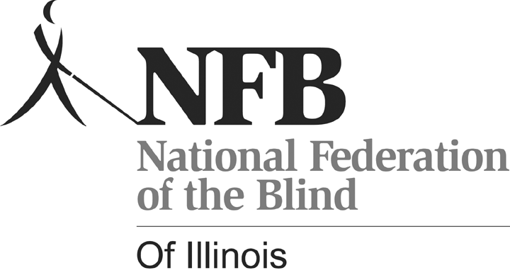
2010 NFBI SCHOLARSHIP APPLICATION

Each year the National Federation of the Blind of Illinois (NFBI) awards scholarships to qualified blind students. The scholarships are awarded at the annual convention of the NFBI. The following scholarships are currently available:

PETER GRUNWALD SCHOLARSHIP: A scholarship in the amount of $2,000 was established by the NFBI as a memorial to Peter Grunwald, whose work with members of the Illinois General Assembly resulted in implementation of several statutes that have changed what it means to be blind in Illinois.
NATIONAL FEDERATION OF THE BLIND OF ILLINOIS SCHOLARSHIPS: Two scholarships in the amount of $1,500 will be awarded.
KENNETH JERNIGAN SCHOLARSHIPS: Two scholarships in the amount of $1,250 were established in tribute to Dr. Kenneth Jernigan, former President of the Federation, whose extraordinary leadership has improved the quality of life for blind people both here and abroad.

Criteria: All scholarships are awarded on the basis of academic excellence and service to the community. Financial need is considered. To be eligible for any NFBI scholarship, an applicant must be a legally blind resident of, or student in Illinois, who is enrolled full-time in an accredited two-year, four-year or graduate college or university program.

To apply: Complete an application. Electronic application forms can be downloaded from www.nfbofillinois.org. Send your application and supporting documents via e-mail in an easily accessible format to:

Deborah Kent Stein, Chairman, NFBI Scholarship Committee
dkent5817@worldnet.att.net

If e-mail is not possible to:
Deborah Kent Stein
5817 N. Nina, Chicago, IL 60631
Direct questions to: (773) 631-1093

Deadline: All application materials must be received by March 31, 2010.

General Information: Persons who have previously applied for NFBI scholarships are encouraged to apply again. The Scholarship Committee reviews all applications and selects the scholarship winners, who will be notified of their selection by June 15, and will be brought to the NFBI convention in the fall.

On a separate sheet please provide the following information:
- All post-secondary institutions you have attended with highest class standing attained and cumulative grade point average,
- High school attended and cumulative grade point average, and
- Community Service.

Please include the following documents with your completed application:
1) Personal Essay: Along with your application, introduce yourself to the scholarship committee in a brief essay or self-portrait. Consider the essay an opportunity to tell the committee who you are. Describe your strengths, achievements, and aspirations. What is important to you? Who do you hope to become? Has a particular person or experience changed your life? How has your blindness affected you? How do you handle it at school, on the job, and in interpersonal relationships?
2) Two current letters of recommendation.
3) Transcripts: Provide a current transcript from the institution you are attending as well as transcripts from all post-secondary institutions you have attended. If you have not attended an institution of higher learning or have not completed one year of study at such an institution, provide a high school transcript. This form may be photocopied.

NFBI 2010 SCHOLARSHIP APPLICATION FORM

Name: ____________________________________________________
(Please include any maiden or other names.)

Date of Birth: _________________

School Address:

School Phone:

Home Address:

Home Phone:

Cell phone:

___________________________________________________________

E-Mail Address:

Institution attended and class standing, i.e. Freshman, Sophomore.

Spring 2010 Standing

___________________________________________________________

Fall 2010 Standing

