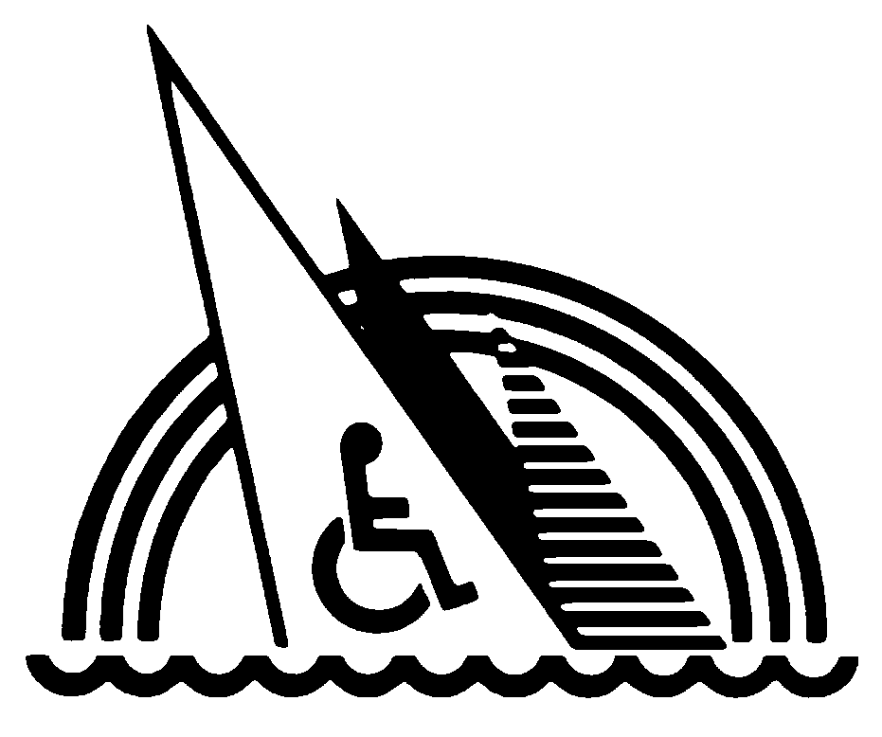
JUDD GOLDMAN ADAPTIVE SAILING FOUNDATION

You’re Invited to an Open House and Lunch!

Judd Goldman Adaptive Sailing Program offers sailing opportunities for all,
from the weekend sailor to the competitive racer

“Twenty years from now you will be more disappointed by the things
that you didn’t do than by the ones you did do.
Explore. Dream. Discover.”
- Mark Twain

Since the Judd Goldman Adaptive Sailing Program (JGASP) was founded in 1990, over 12,000 individuals have experienced the thrill of sailing on Lake Michigan. The goal of the program is to offer persons with disabilities the opportunity to "take the helm" on boats specifically designed for crews with disabilities.

Come to Our Open House!
Saturday, June 1, 2013 • 10 a.m. – 4 p.m. • Judd Goldman Sailing Center at
Burnham Park Harbor, 1362 Linn White Drive, Chicago, IL 60605 (one block west of the Adler Planetarium)
Go for a sail on one of our 20 boats. Enjoy a great lunch. Meet new friends in a laid-back atmosphere along Chicago’s beautiful lakefront. See the christening of a new boat!

Check out our classes and schedules, our leisure cruises and fleet of accessible boats. Find out about getting involved in racing. If you sign up for lessons at the Open House, you'll receive a free JGASP t-shirt.

The Open House and Lunch is free (aide included). For all others, the cost for lunch is $6/person. The Burnham Park Harbor facility features fully accessible docks, classrooms and restroom facilities.

The cost is free. Just bring yourself (and friends, if you like). And keep in mind the Burnham Park Harbor facility features fully accessible classrooms and restroom facilities.

What we offer…
And if you just can’t make it on June 1, we still want you to be involved. Consider this:

- Boats---Well-maintained, safe and designed especially for those with disabilities. We have eight, two-man Independence 20-foot sailboats; eight, three-man Sonars; and four one-man 2.4 meter sailboats. Two of the three classes of boats are used in the Paralympics.
- Lessons--- Our program consists of 15 hours of instruction (six, 2 1/2-hour lessons) for $100. Individual lessons are scheduled Wednesday through Sunday.
- Racing---We have an active racing program with races throughout the summer. This July will mark the 21st year for the North American Challenge Cup and the 24th year for the Goldman Cup.
- Cruises---We have scheduled several fun cruises throughout the summer.
- Scholarships--- Scholarships available
- Free Lesson---Enclosed is a coupon for a 2 ½ hour free lesson!

For more information visit www.juddgoldmansailing.org
or to schedule a lesson call 312-747-7684
875 N. MICHIGAN AVENUE, SUITE 3718 • CHICAGO, ILLINOIS 60611 • (312) 644-3200
www.juddgoldmansailing.org

