Davis Square Park
Baseball for individuals with a visual disability
4430 S. Marshfield Chicago, IL 60609

Beep Baseball

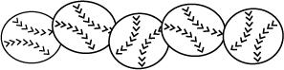

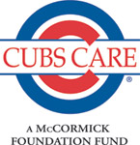
July 2 ---August 8

FREE – funded through

Registration begins April 8th

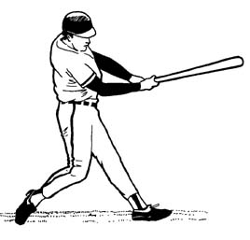
Tuesday Practices:

2:30pm- 4:30 pm at Davis Square

Game’s scheduled tentatively Thursdays from 11am- 5pm
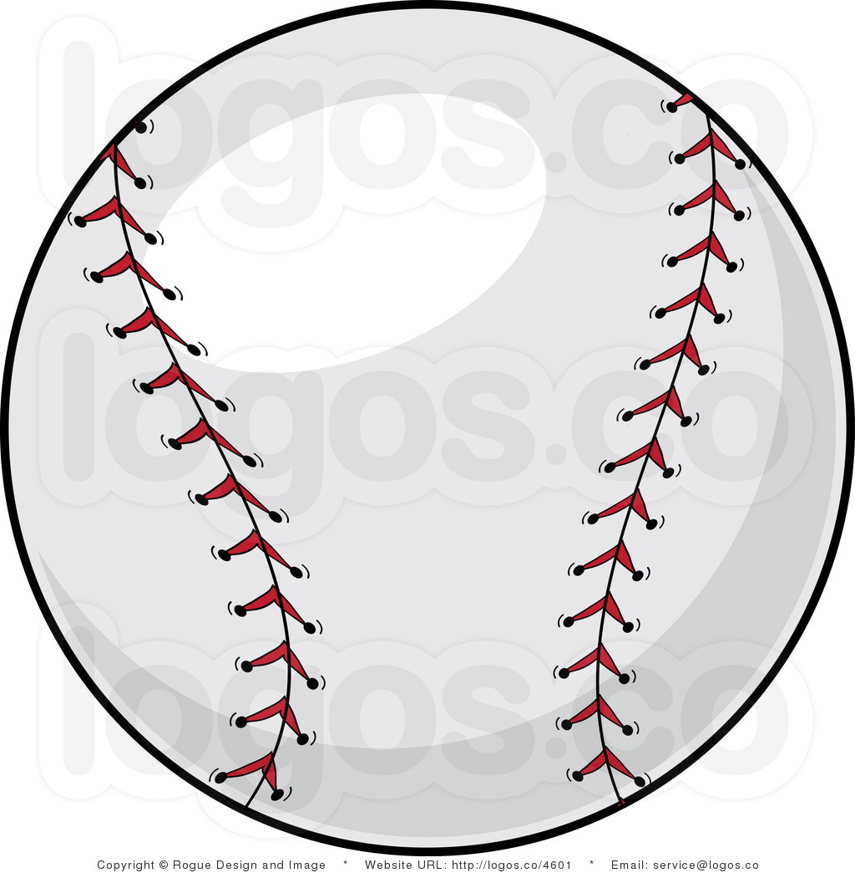

Uniforms and schedules will be passed out at the 1st practice on July 2nd. Please wear athletic attire (no jeans, no sandals) and bring water to every practice and game. On game days, please bring a lunch.

For registration and questions contact:
Christina Moy, Special Recreation Coordinator
312 747 6107
Christina.Moy@chicagoparkdistrict.com
www.chicagoparkdistrict.com (312) 742-PLAY (312) 747-2001 (TTY)

