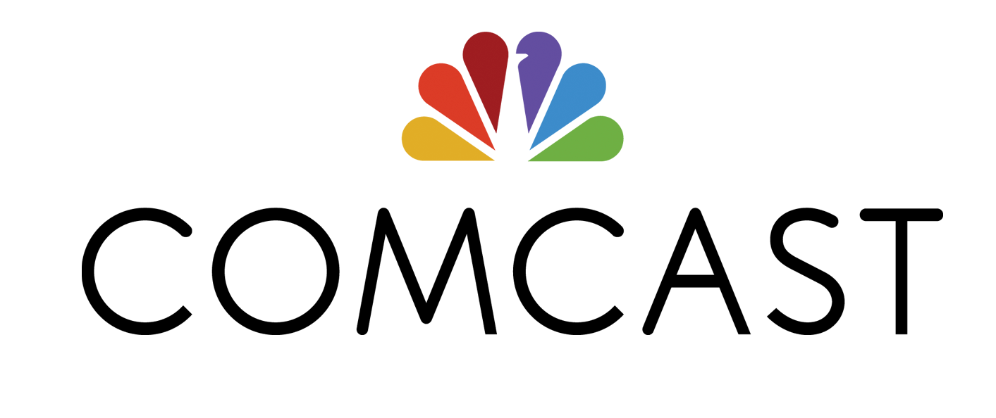_____________________________________________________________________________

PRESS RELEASE
Comcast
One Comcast Center
Philadelphia, PA 19103
http://www.comcastcorporation.com
COMCAST DEBUTS NEW ACCESSIBILITY OFFERINGS
DURING NATIONAL DISABILTY AWARENESS MONTH

Launches Dedicated Support for Customers with Disabilities and Opens New Accessibility Lab

Also Offers Special Xfinity On Demand Collection of Disability-Themed Programming

PHILADELPHIA, PA – October 28, 2013 –According to the U.S. Census, approximately one-third of American households have a member who has a disability. To better serve its customers, Comcast today announced it has created a dedicated accessibility customer support team and opened an accessibility product and development lab. These two key initiatives are examples of Comcast’s commitment to meet the needs of customers with disabilities.

“Accessibility is the measure of how effectively people with disabilities can use and enjoy the programming, products and services we deliver and how successful we are at making these solutions available to the widest possible audience,” said Tom Wlodkowski, Vice President of Accessibility for Comcast. “Comcast and my team are laser focused on developing new innovative solutions that enhance the user experience for these customers as well as utilizing these same technologies to ultimately enhance and improve how all of our customers interact with our services.”

In addition to launching these initiatives, Comcast is making a collection of programming featuring disability related themes available to all Xfinity TV customers on Xfinity On Demand, Xfinity.com/TV and the Xfinity TV Player app through November 8th.

Dedicated Customer Support for People with Disabilities
Closed captioning, video description, accessible billing services and operating web and mobile interfaces with screen reader software are especially important for people with disabilities. Now, customers can contact a dedicated support team of 22 agents specially trained on all things related to Comcast accessibility, in the new Comcast Accessibility Center of Excellence for help with these and other general support issues.

Customers can access the center directly by calling 855-270-0379 seven days a week between the hours of
9 a.m. and 10 p.m. (EST). Customers can also contact an Accessibility Center of Excellence representative via chat (https://www.comcastsupport.com/ChatEntry/Default.aspx?Trouble.Accessibility%7Cform).

National Disability Awareness Xfinity On Demand Collection
Comcast has gathered a collection of programming including award-winning movies, biographical films, documentaries, TV shows and interviews across Xfinity On Demand, Xfinity.com/TV and on the Xfinity TV Player app that positively portray people living with disabilities.

Programming highlights include movies like Children of a Lesser God, High Ground, I Am Sam, Mr. Holland's Opus and Radio; TV shows including CSI (CBS), Friday Night Lights (Xfinity Streampix), Glee (FOX), Grey's Anatomy (ABC), The Michael J Fox Show (NBC), Parenthood (NBC), Project Runway (Lifetime), Push Girls (Sundance) and Switched at Birth (Xfinity Streampix); as well as specials including Bio: Heather Mills (Bio Channel), Lives Worth Living (PBS), Moto X (ESPN) and multiple interviews with Paralympic athletes (NBC Sports) and interviews conducted by Xfinity TV with blind adventurer Erik Weihenmeyer (http://www.touchthetop.com) and more.

Additional programming content can be found at http://xfinitytv.comcast.net/microsites/disabilities.

The Comcast Accessibility Product and Development Lab
The Comcast Accessibility Lab is both a working lab for the development of accessible products and features and a showcase of assistive technologies used by people with disabilities to interact with mainstream mobile, online and desktop user interfaces. Comcast is also using the lab for focus groups and usability testing with key communities of people with disabilities to learn more about how customers can use its services as well as to help educate its employees about accessibility. Co-located with Comcast Labs in Philadelphia, the space brings together cutting-edge solutions such as cable TV’s first talking program guide (http://corporate.comcast.com/comcast-voices/a-pictures-worth-a-thousand-words) that the Company plans to launch in 2014. .

For more information and an overview of Comcast’s accessible products and services please visit http://customer.comcast.com/help-and-support/account/accessibility-services.

About Comcast Cable:
Comcast Cable is the nation's largest video, high-speed Internet and phone provider to residential customers under the XFINITY brand and also provides these services to businesses. Comcast has invested in technology to build an advanced network that delivers among the fastest broadband speeds, and brings customers personalized video, communications and home management offerings. Comcast Corporation (Nasdaq: CMCSA, CMCSK) is a global media and technology company. Visit http://www.comcastcorporation.com for more information.
# # #

Press Contact:
Jenni Moyer
(215) 286-3311
jenni_moyer@comcast.com

