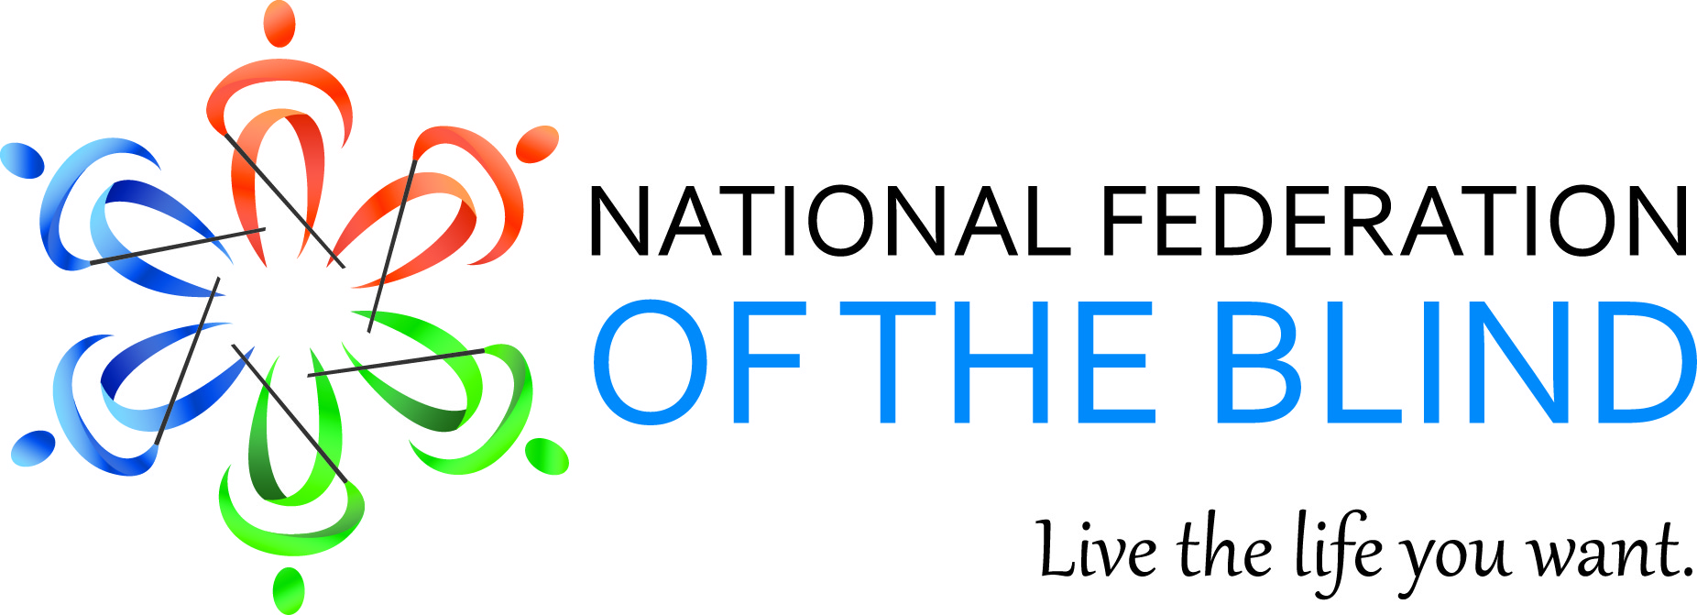

THE NATIONAL FEDERATION OF THE BLIND OF ILLINOIS PRESENTS

RAISING THE BAR

A SEMINAR FOR TEACHERS AND PARENTS OF BLIND
AND VISUALLY IMPAIRED CHILDREN

April 17-18, 2015
Marriott Midway Hotel, Chicago

FRIDAY, APRIL 17, 2015
Teachers of the Visually Impaired

8:00-9:00, Registration

9:00-9:10, Opening remarks, Denise Avant, President, NFB of Illinois

9:10-10:00, "Without Exception: Strategies for Today's Classroom and Tomorrow's World," Natalie Shaheen, Director of Education Programs, NFB Jernigan Institute, Baltimore, MD

10:00-11:00, "Introducing Beep Kickball,”
Judy Byrd, Director, Beep Kickball Association, Atlanta, GA

11:00-11:45, "Nods, Handshakes, and Waves Good-bye: Revealing the Mysteries of Nonverbal Communication," Panel Discussion

11:45-12:00, "Could Your Student Use a Guide Dog?"
Pam Berman, Guide Dogs for the Blind, San Rafael, CA

12:00-12:45, Lunch and Introductions

12:45-1:30, "Getting the Edge on Technology,"
Jordyn Castor, Technology major, Michigan State University, East Lansing, MI

1:30-2:15, "How Should Jimmy Read? Making the Most of the National Reading Media Assessment," Amy Lund, Teacher of the Visually Impaired, Springfield, IL

2:15-3:00, "Hadley Opportunities: Courses to Empower Teachers and Parents," Debbie Siegel, Hadley School for the Blind, Winnetka, IL

3:00-3:30, "Programs and Progress: What the NFB Can Offer Your Students," Denise Avant and Natalie Shaheen

3:00-4:15, "Sorting Out the Glitches: What Technology to Use and How to Get Help When All Else Fails," Peter Tucic, Technology Hotline, Chicago Lighthouse for the Blind, Chicago, IL

4:15-4:30, Evaluations and Networking

SATURDAY, APRIL 18, 2015
Parents of Blind/Visually Impaired Children
Raising The Bar

8:00-9:00, Registration

9:00-9:10, Welcoming Remarks, Denise Avant, President, NFB of Illinois

9:10-9:35, Introductions

9:35-10:30, "Without Exception: Preparing Today's Kids for Tomorrow's World," Natalie Shaheen, Director of Education Programs, NFB Jernigan Institute, Baltimore, MD

10:30-11:30, "Introducing Beep Kickball,"
Judy Byrd, Director, Beep Kickball Association, Atlanta, GA

11:30-12:00, "Programs and Progress: What the NFB Can Offer You and Your Child," Denise Avant and Natalie Shaheen

12:00-12:30, Lunch

12:30-12:45, "Could Your Child Use a Guide Dog?"
Pam Berman, Guide Dogs for the Blind, San Rafael, CA

12:45-1:30, "Getting the Edge on Technology,"
Jordyn Castor, technology major, Michigan State University, East Lansing, MI

1:30-2:15, "From Disaster to Triumph: How to Get What Your Child Needs at Your IEP Meeting," Presented by a Cast of Thousands

2:15-3:00, "Nods, Handshakes, and Waving Goodbye: Revealing the Mysteries of Nonverbal Communication," Panel and Discussion

3:15-4:00, "Sorting out the Glitches: What Technology to Use and Where to Turn for Help When All Else Fails,"
Peter Tucic, Technology Hotline, Chicago Lighthouse for the Blind, Chicago, IL

4:00-4:15, "Let's Hear It from the Kids!"

4:15-4:30, Evaluations and Networking

Saturday, April 18, 2015
Blind and Visually Impaired Students
Raising The Bar

*Don’t miss our Friday Night, “Extra Curricular” Networking event.

8:00-9am, Registration

9:00-9:30, Welcome, and Intro. to the NFB, and our speakers
Debbie Stein, NFBI 1st VP, & Katie Leinum, IABS 1st VP.

9:30-10:15, Accessing Distance Learning Glenn Moore, Columbia College, MO, Business Administration Undergraduate

10:15 11:15, Paralympic Judo
Brett Wolf of the Paralympic National Training Center

11:15-Noon, Technologies That Work for You
Jordyn Castor, technology major, Michigan State University

Noon-12:30, Lunch

12:30-1:15, Keynote Q & A
Keynote Speaker, Natalie Shaheen, Director of Education Programs, NFB Jernigan Institute, Baltimore, MD.

1:15-2:00, The New College Try - Student Panel (What to know to make it in college).
Candice Chapman, NABS Rep, University of MN.
James Hunt, Purdue University - Calumet, IN.
Nadia Montinez, Walter Payton College Prep.
Sara Luna, Walter Payton College Prep.
Sarah Meyer, IN Wesleyan University, CCB and (to be) Ball State University
Michal Nowicki, University of Illinois, Chicago, IL

2:00-3:00, Beep-Kickball
Judy Byrd, Director, Beep Kickball Association, Atlanta, GA.

3:00–3:30, You’ve Got Your Degree, Now What?
Sarah Meyer, Colorado Center for the Blind.

3:30-4:00, A Guide to Grad School
Candice Chapman, NABS Rep., U of MN: Twin Cities, Counseling Psychology (CSPP)

4:00-4:15, Join the Parents’ Seminar for "Let's Hear It from the Kids!" performance from Kid Kamp.

4:15-4:30, Evaluations and Networking

Saturday, April 18, 2015
Kids Camp
Kids Camp Coordinators: Paul Shepardson and Janna Stein

8:30-9:00, registration, with introductions and free play

9:00-10:15, "All Around the Hotel": Accompanied by Kids Camp staff, children will explore the Marriott Midway on a scavenger hunt.

10:15-11:15, "Twists and Tumbles," a taste of Paralympic judo, Bret Wolf, Great Lakes Adaptive Sports Association (GLASA), Lake Forest, IL

11:15-12:00, "Paper, Glue, and Imagination," arts and crafts for everyone

12:00-12:45, Lunch

12:45-2:00, "Hooray for Hollywood!" time for a kids' movie with audio description.

2:00-3:00, "Beep Kickball Comes to Illinois!" Illinois' first ever experience of Beep Kickball, led by Judy Byrd, Beep Kickball Aassociation, Atlanta, GA

3:00-3:15, "Listen to a Story," Bill Reif, NFBI, Springfield, IL

3:15-4:00, "Music, Music, Music!" Dave Meyer, Forest Par, IL

4:00-4:15, "Let's Hear It from the Kids!"

The National Federation of the Blind knows that blindness is not the characteristic that defines you or your future. Every day we raise the expectations of blind people, because low expectations create obstacles between blind people and our dreams. You can live the life you want; blindness is not what holds you back.

