Logo: National Federation of the Blind
Illinois
"Live the life you want."ILLINOIS INDEPENDENT

(SUMMER 2015)

Editors: Deborah Kent-Stein and Robert Gardner

National Federation of the Blind of Illinois

President: Denise R. Avant, (773) 991-8050 Davant1958@gmail.com

Deborah Kent Stein: (773) 2030-1394 Dkent5817@att.net

Robert Gardner: (309) 236-6606 rgardner@gmail.com

Formatting: Glenn Moore and Janna Harvey

Newsline Edition: David Meyer: (708) 209-1767 datemeyer@sbcglobal.net

Print and Braille Editions: Bill Reif: (217) 801-2996 billreif@ameritech.net

Website: Byron Lee: (773) 633-4799 byron@byronlee.com

TABLE OF CONTENTS

A Report from the President, by Denise R. Avant

Ringing the BELLs in Illinois, by Amy Lund

The Naperville Marriott Hotel, Convention Information, by Patti Gregory-Chang

Get Ready, Get Set, Go UEB, by Robert Gardner

Memories of My Father, Part II, by Dutch tenBroek

The Business of People, by Chris Jeckel

Me and Michael Jordan, by Deborah Kent Stein

My Adventurous Commute to Work, by Syed Yousufuddin

Harold Palash: In Memoriam, by Robert Gardner

* * * * * *

A REPORT FROM THE PRESIDENT

By Denise R. Avant

Ten months have passed since I was elected to serve as president of the National Federation of the Blind of Illinois. I want to begin my report by thanking our immediate past president, Patti Chang, for all of her advice and support prior to and following my election to the presidency. I know I have big shoes to fill, but I also know that I am very fortunate to be part of an affiliate with experienced leadership and deeply committed members. A lot has happened during my first ten months in office, and there is still much work to come.

Washington Seminar

At the beginning of 2015, nine people from Illinois joined Federationists from across the country for the annual Washington Seminar. We spoke with our representatives in Congress, advocating for legislation critical to blind people. The TIME Act (Transitioning to Integrated and Meaningful Employment), H.R. 188; and the TEACH Act (Technology, Education and Accessibility in College and Higher Education) were the key pieces of legislation we worked to promote. The TIME Act is designed to phase out Section 14(c) of the Fair Labor Standards Act, which allows certain employers to pay below (sometimes far below) the minimum wage to workers with disabilities. Passage of the TEACH Act would enable the development of accessibility guidelines for instructional materials used in postsecondary institutions.

Christina Kuckie, the parent of a blind child, was our parent representative and a member of the Parent Leadership Program sponsored by the National Organization of Parents of Blind Children (NOPBC). She carefully researched the issues, and she was a zealous advocate for us on the Hill. She understood that her son might be paid subminimum wages some day unless the TIME Act is passed. Christina so appreciated our efforts that she made a number of thoughtful suggestions on ways we might enhance our fundraising. She went still further by asking her company, Invesco, to sponsor our 2015 state convention. Invesco responded by awarding the NFBI a generous grant of five thousand dollars.

Raising the Bar

On November 5, 2014, we started to plan "Raising the Bar," our spring seminar for teachers, parents, and students. The seminar took place on April 17 and 18 at the Chicago Marriott Midway. Our keynote speaker for both days was Natalie Shaheen, director of education at the NFB Jernigan Institute in Baltimore. Judy Byrd, president of the Beep Kickball Association, showed everyone how to play this new accessible sport.

The first day of the seminar was geared toward teachers of the visually impaired. Most of the teachers came from the Chicago Public Schools, and a few from suburban schools attended as well. We are a provider of continuing education credits, so the teachers earned credits. A highlight of the teacher seminar was a presentation on the National Reading Media Assessment (NRMA), which is designed to aid teachers in determining whether a student will be best served by being taught print, Braille, or both media. This topic was presented by Amy Lund, a highly respected TVI in Illinois. For the past three summers Amy has been the lead teacher for our BELL (Braille Enrichment for Literacy and Learning) program.

On April 18 the seminar presentations were directed toward parents of blind children. One of the highlights was a skit on handling a child's Individualized Educational Program (IEP) meeting. The IEP meeting is critical because it establishes which services a child will receive from the school district in the course of the year. On the same day, students from Illinois, Minnesota, Michigan, Indiana, and Colorado put on their own seminar. One of the topics was how to handle the online college education option.

National Convention

Many of us from the NFBI went to the seventy-fifth anniversary convention of the National Federation of the Blind, which was held in Orlando, Florida, in July. We had seven first-time attendees, three of whom were students. One of our students, Michal Nowicki, who will enter law school in the fall, was awarded a Jernigan Fund scholarship to attend convention.

Drone photograph of historic NFB Guinness World Record
umbrella mosaic in Orlando, FL, July 8, 2015,
spelling out
"LIVE THE LIFE YOU WANT" The national convention was a great celebration. Since Illinois was one of the original seven affiliates, we were a host affiliate, along with California, Pennsylvania, Ohio, Minnesota, Wisconsin, and Missouri.

On the morning of July 8, 2015, the NFB set a Guinness World Record by creating the largest umbrella mosaic in history. Altogether 2,480 people took part, far exceeding the previous record of 2,170. Our upraised umbrellas, photographed from a circling drone, formed our logo and the words “LIVE THE LIFE YOU WANT.”

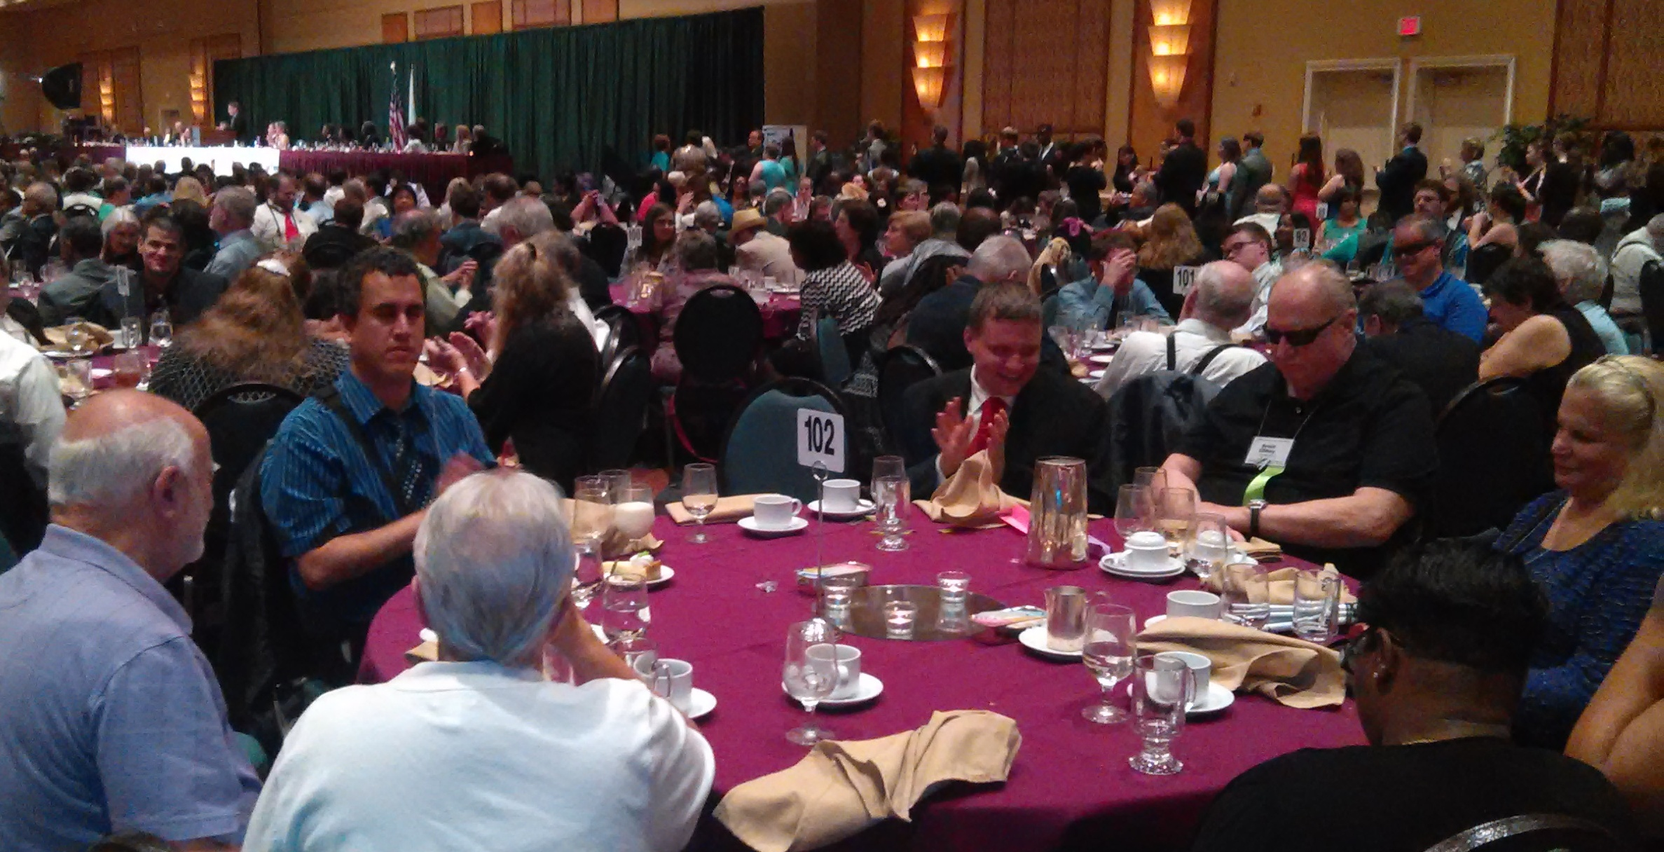 During the opening ceremony, we heard recordings of Dr. Jacobus tenBroek, Dr. Kenneth Jernigan, and Dr. Maurer. The program left me with an appreciation of how far the Federation has come and the work each of those leaders played in the development of the blindness movement. Our new president, Mark Riccobono, gave a superb banquet address that left me and everyone in the banquet hall filled with energy, hope, and love.

Programs and Activities

For the first time the NFBI hosted not one, but two BELL programs. We held our third Chicago BELL and our first BELL program in Springfield. You can read more about our 2015 BELL programs in Amy Lund's article elsewhere in this issue.

We continued to run our annual internship and scholarship programs in 2015. Four NFBI Scholarship finalists will attend our state convention: Jhaliyah Anderson, Barb Feltz, Alexandra Futty, and Marina Salman. They will compete for scholarship awards ranging from $1,250 to $2,000. Our NFBI Internship Program gives blind students the opportunity to gain hands-on work experience. Interns find full-time volunteer work that they can do for four to six weeks, and they receive a stipend from the Nfbi. This year's intern was Sumaya Hussein, who volunteered for four weeks at the Arab American Family Institute of Illinois.

For the past several years we have held Oktoberfest, a major fundraiser, every September. We will do so again on September 19 at the home of Patti and Francisco Chang. In June we held our first Picnic in the Park fundraiser in Springfield. Members from the Four Rivers, Bloomington, and Chicago Chapters joined the Ferris Wheel Chapter for food, fellowship, fun, and boat rides on the lake. In the process of raising money, we met a new family of a blind child. We also met a young blind boy, a student of Samantha Voll, the assistant teacher in our BELL programs.

Last winter President Riccobono invited all of the new state presidents, then fifteen in number, to a New State Presidents Forum in Baltimore. At the forum I learned that Illinois is well known among our state affiliates for two reasons. First, we are admired for our committee structure, which ensures that all of our members have opportunities to participate in the organization. Second, we are recognized for the number and content of our programs. State presidents often visit our website to get ideas for programs they may want to try. I appreciate the countless hours that our members spend throughout the year to maintain and expand our activities.

Right now we are getting ready to hold our state convention, which will take place in Naperville, Illinois, on the weekend of October 30 to November 1, 2015. We are planning many exciting presentations for parents, students, and our members in general. Our national representative will be James Gashel, who has been active in the realms of governmental affairs and technology development since the 1970s. At convention, as in all of our programs and events, our goal is to help blind children and adults live the lives they want.

* * * * * *

RINGING THE BELLS IN 2015

By Amy Lund

This summer the National Federation of the Blind of Illinois sponsored two BELL programs for blind students in the state. BELL stands for Braille Enrichment for Literacy and Learning. The Chicago BELL program ran from June 18 to July 1. Our Springfield program ran for one week, from July 20 to July 24.

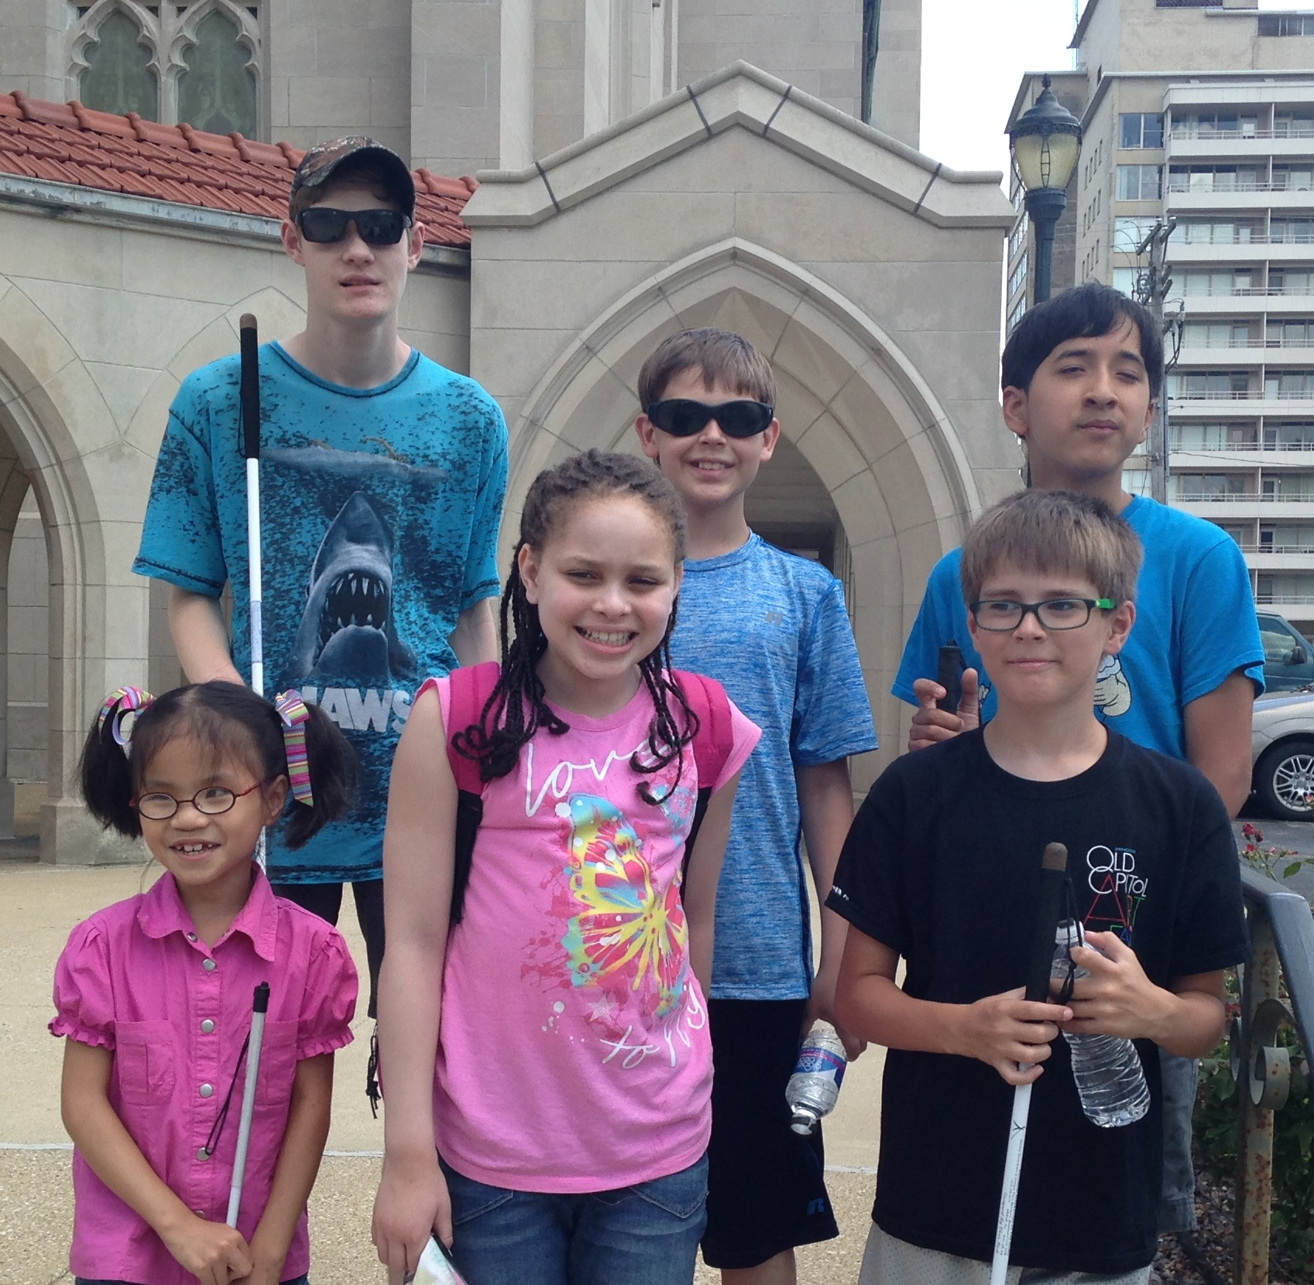 The National Federation of the Blind has developed an amazing curriculum that enhances Braille literacy. It is a core belief that literacy means reading, not listening, and Braille allows full interaction with text. On June 18 ten children, ranging in age from four to thirteen, started a Braille adventure. The children were given instruction and enrichment opportunities to improve their Braille reading and writing skills. Safe travel skills and excursions were also included in our two-week adventure. Our oldest student, thirteen-year-old Alex, was a veteran of two previous BELL programs. This year he helped out as a junior volunteer.

In our first few days, assistant teacher Samantha Voll and I got to know our new participants. It is so nice to see kids returning to the BELL program and having them welcome the new students! Knowing where the participants were starting with their Braille skills was essential as we planned the rest of their program. Braille lessons were specifically chosen to help the children improve their tracking, discrimination, letter identification, and reading skills.

We also explored some physical activities, such as Beep Kickball. The children learned some of the basic rules and techniques of the sport. Everyone had a great time hearing the beeper in the ball and seeing if they could locate it using their auditory skills.

On Saturday, June 20, several of our students and their families turned out for a trip to the Lincoln Park Zoo. This was a great way for the families to meet each other, and we were joined by some of the teens and mentors from the NFBI's Freedom Link program. We gave a few pointers on walking with the long white cane, letting the kids shoreline along the edge of a path. We then had a great multisensory experience through the African Journey exhibit, led by Mark, an enthusiastic staff member. We finished with a delicious lunch at the zoo's Landmark Café.

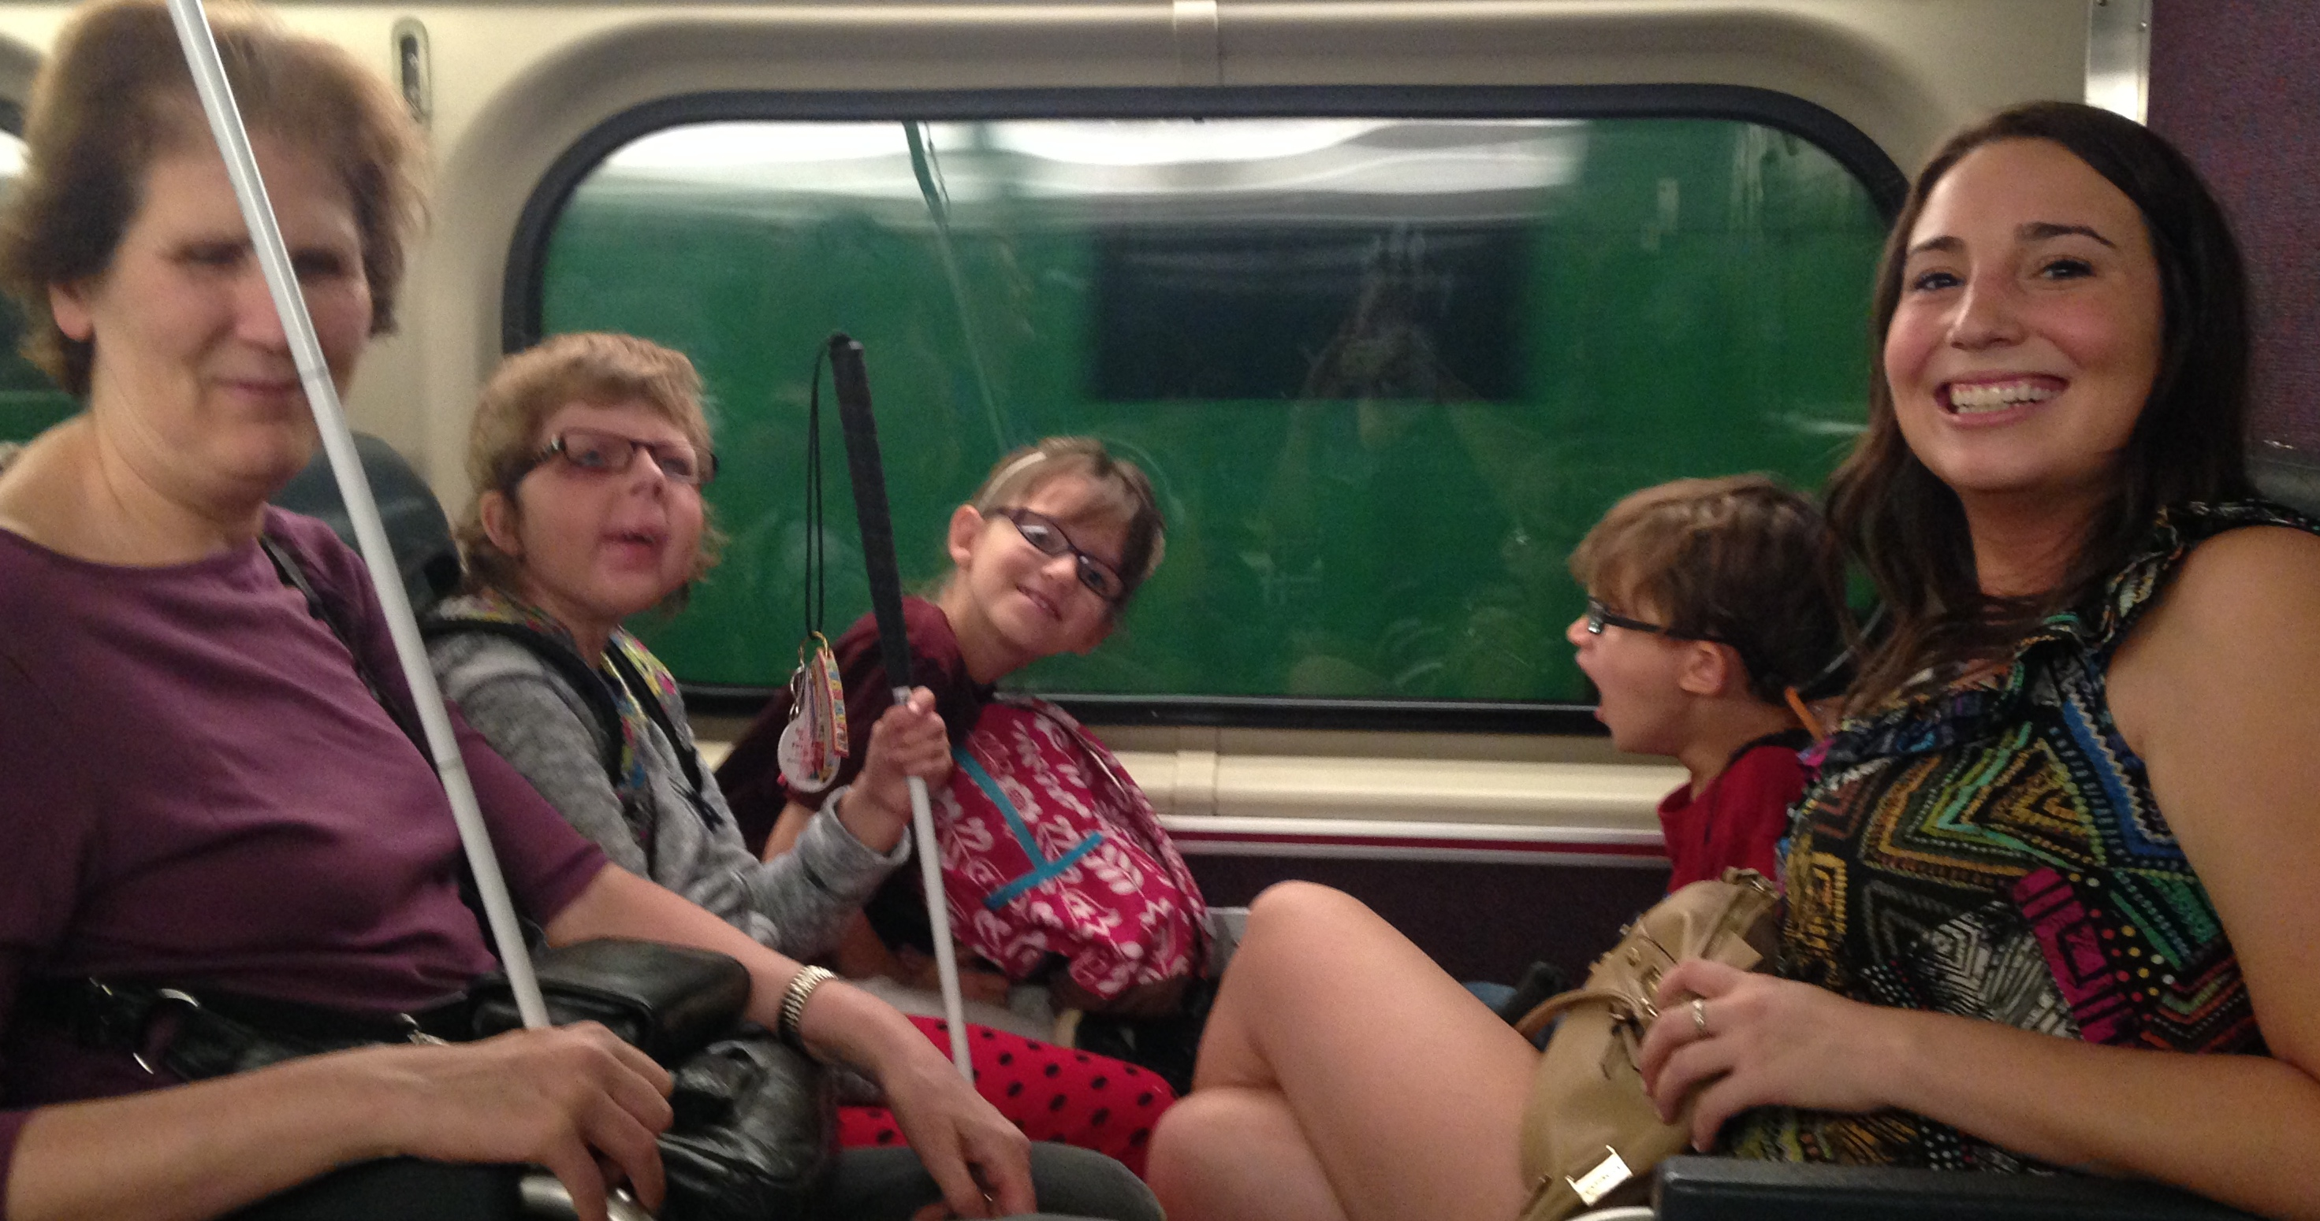 This year our Chicago BELL program traveled to many different parts of the city. Our trips included going to a local park, taking a Metra train to a suburb for ice cream, riding on the El for a family-style lunch at the Olive Garden, and transferring on buses to Navy Pier's Children's Museum. All of our trips combined a fun experience with specific travel skills.

Working on kitchen tasks such as spreading peanut butter, placing meat on bread, and completing a sandwich was very important this year, as we made several of our lunches. Some of our participants even made sandwiches for the teachers and mentors. We also used money skills to "buy" items for a delicious snack mix. The group's favorite snacks were the smoothies! Measuring was simple, and we all used the blender.

We have been so lucky to have incredible volunteers and blind mentors. I would like to thank our Chicago volunteeers: Chaquita, Brianna, Sara, Debbie P., Debbie S., Marco, Janna, Dave, Robert, and Mary Kate. I also want to thank the volunteers in our Springfield program: Bill, Katie, Alyssa, and Nelly. Each of them contributed in very special ways to make the programs successful.

We were very fortunate to have money donated for the Chicago BELL program through the generosity of the Naperville Noon Lions Club. The participants Brailled letters and tactile bells that we sent off to the Lions to thank them.

The Springfield BELL program was quite different from Chicago BELL, but it, too, was a wonderful experience. With only one week to work on many possible skills, Samantha and I had to pick and choose carefully. I think everyone learned and had a great time.

We had six participants in the Springfield BELL program, ranging in age from nine to thirteen. Some of the students had had zero exposure to Braille before the program. Again Alex served as a junior volunteer.

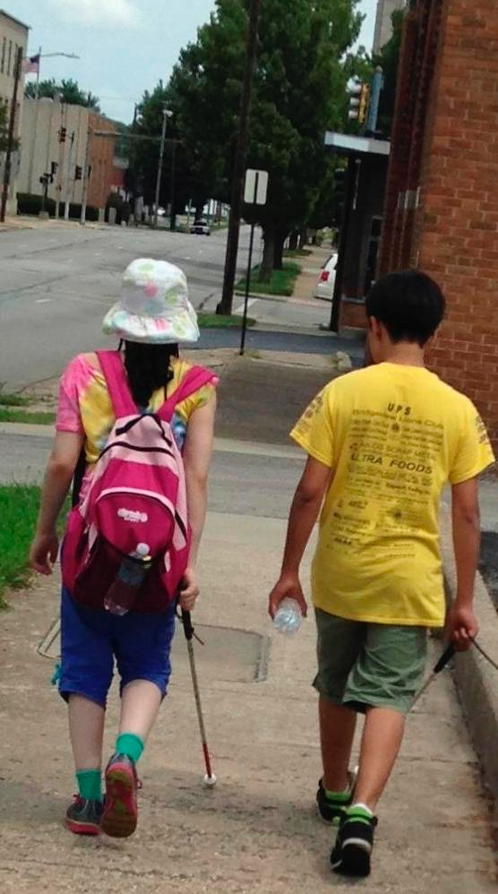 As in the Chicago program, we began each morning with Braille yoga and a question of the day. This allowed everyone to get to know each other. The kids worked on specific lessons as they made sandwiches for themselves and their mentors. The lessons focused on simple Braille knowledge acquisition. Later on in the day, we worked specifically on tracking/reading skills. On Monday, Tuesday, and Thursday we walked to the YMCA three blocks away and enjoyed some gross motor skills time, including Beep Kickball and red light/green light. We also played with a parachute and enjoyed time running around.

On Wednesday the parents and the kids and mentors took a city bus to the Olive Garden, where we had a similar experience to the one in Chicago. We ate delicious food, and some even tried new dishes. The trip gave us the chance to utilize the public transit system in Springfield.

On Friday we caravanned out to a park in Springfield where we enjoyed a pizza picnic. Families, mentors, and kids had a beautiful lunch and learned more about Braille. Each of the participants hosted a station for the parents/mentors to go through. The kids talked about the Braille cell, how to Braille their names, the rules of Beep Kickball, how to use a slate and stylus, and how to track a line of Braille. The kids did a great job presenting their stations. Then the whole group played two innings of Beep Kickball. We all agreed that it's harder than it looks, and we could use some more practice sessions.

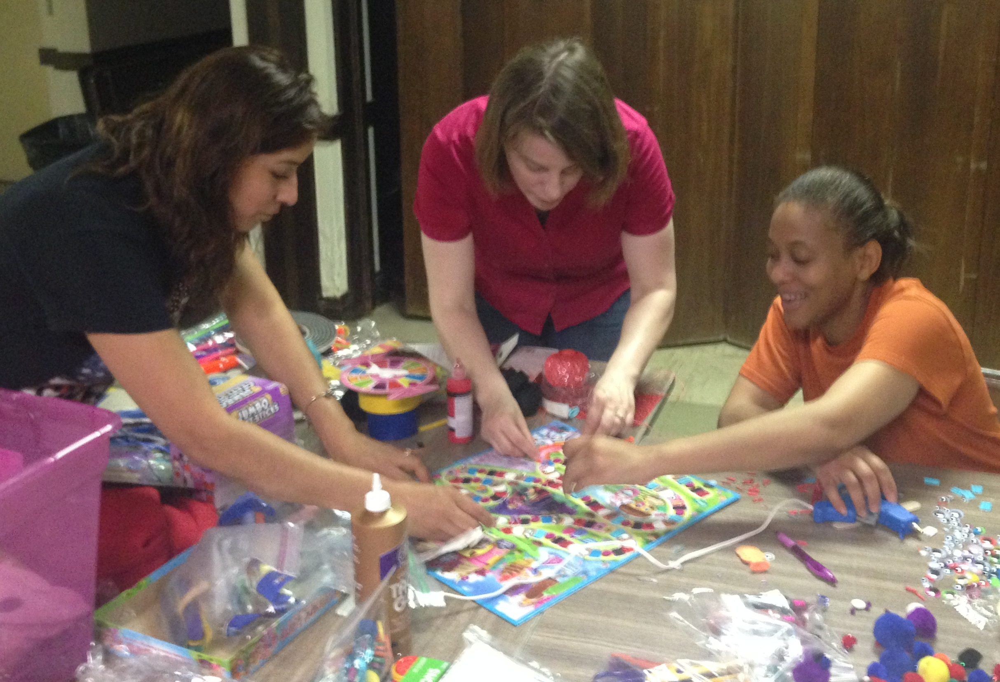 During the week, the parents who chose to attend had a learning session each day. They took a tour of the IATP (Illinois Assistive Technology Project), and Samantha spoke with them on how to adapt board games for home use (and they adapted two games for our programs!) They enjoyed observing O&M techniques during our field trip to the Olive Garden. They spoke with volunteer Bill Reif about job potential and encouragement of dreams, and they talked with Nelly Gamino about her experiences and philosophy as a parent.

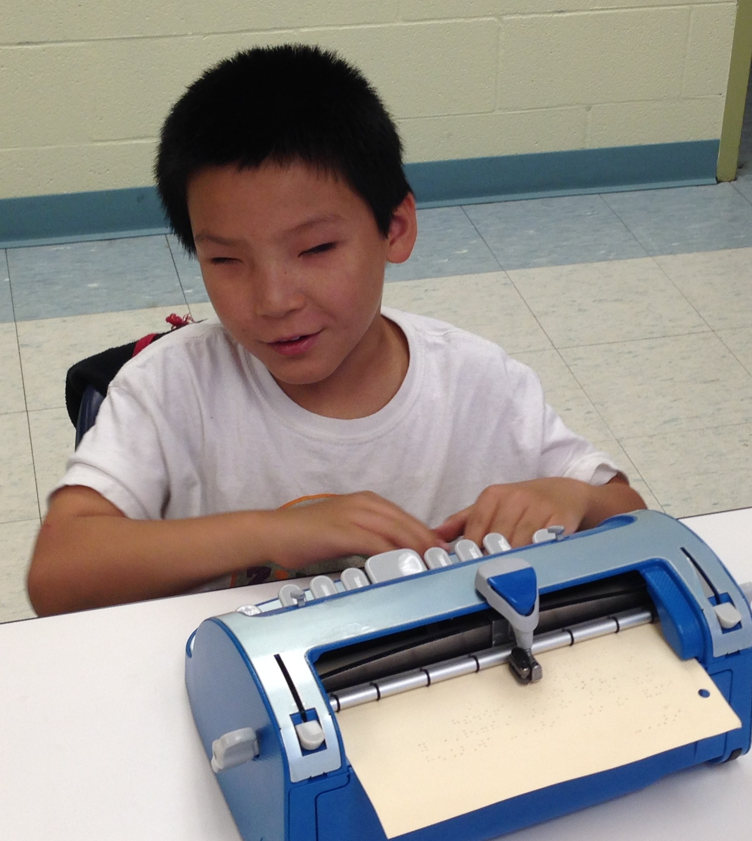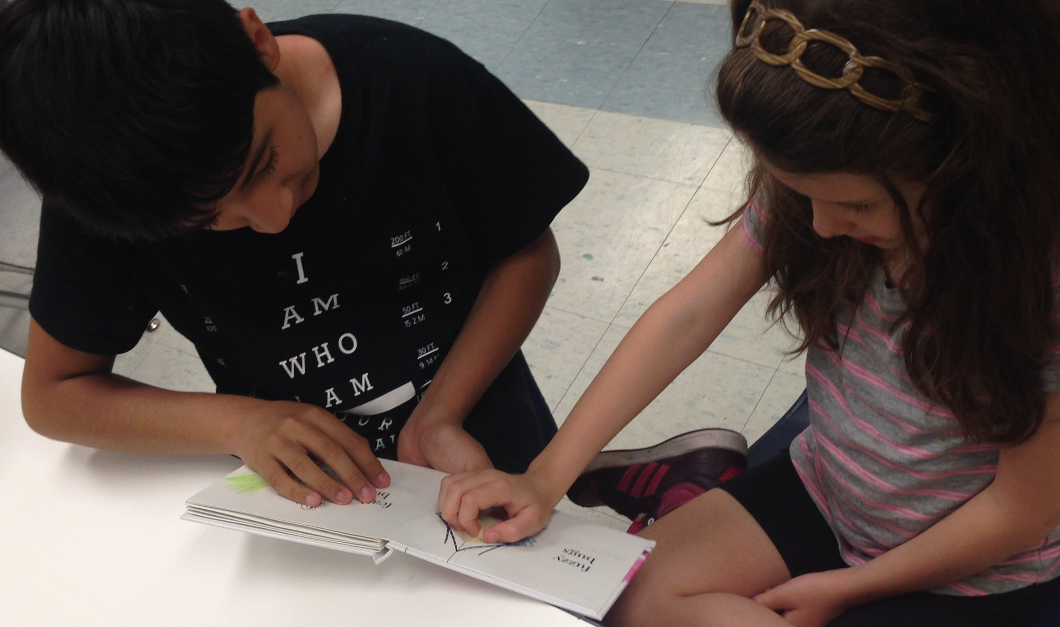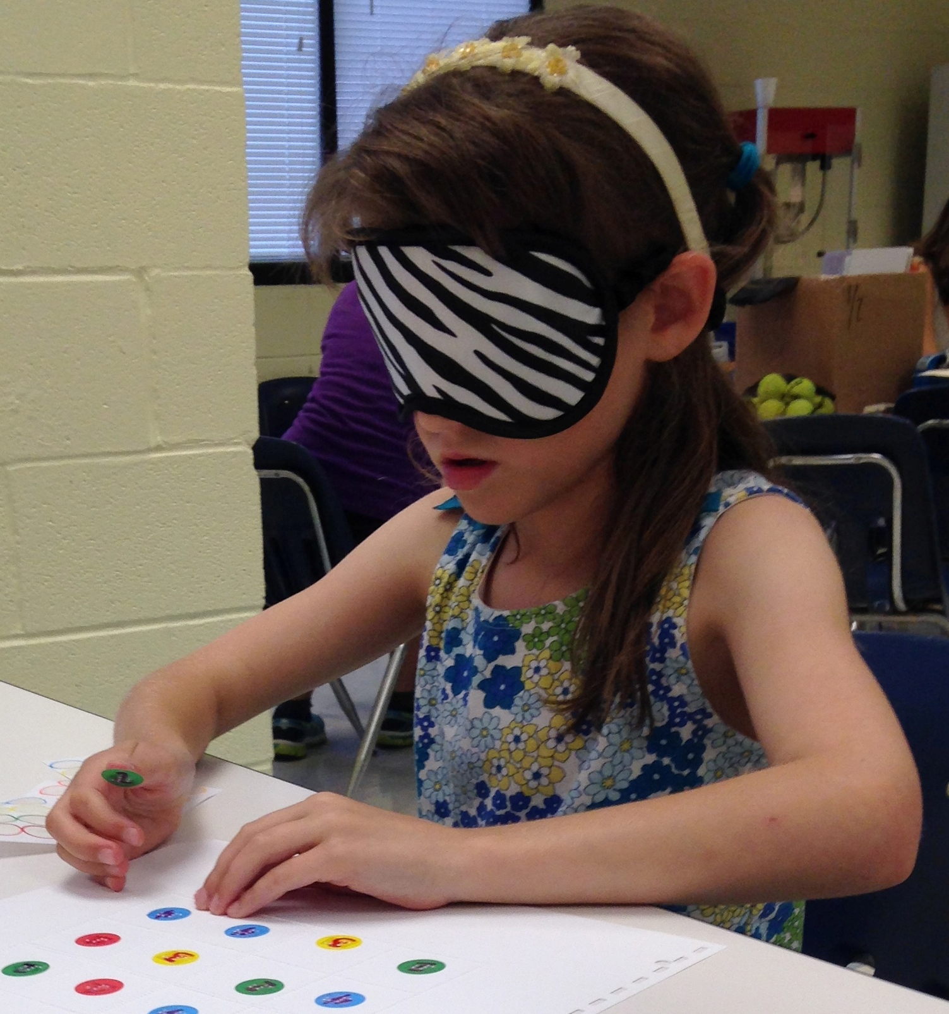 In both of the programs, we ended each day by ringing bells to celebrate the children's new achievements. Each child was invited to tell the group about something he or she wanted to celebrate. At bell-ringing time, the volunteers also expressed their excitement about the work the children were doing and the growth they made that day. The ringing of the bells was a wonderful symbol of the excitement we all felt about the learning that took place.

* * * * * * *

THE NAPERVILLE MARRIOTT HOTEL, Convention Information

By Patti Gregory-Chang

This quick article explains the layout of the Naperville Marriott, our hotel for the 2015 NFBI convention. It also gives you basic information about the facilities and amenities.

Address and Phone:

The hotel is located at 1801 N. Naper Blvd, Naperville, IL 60563. The phone is: (630) 505-4900.

Sleeping Room Types:

There are two types of rooms, Suites and Standard Rooms. The suites have a parlor with a sleeper sofa, two easy chairs, and a coffee table. The room rate for standards is $89. The rate for suites is $129. All rooms have hair driers and coffee makers. Connecting rooms are available upon request.

Keycards and Electrical Power:

This hotel is modernized. You need to insert your keycard in a slot inside your room to the side of the door to turn your power on. Leave it in the slot until you exit your room. When you remove it, the power goes off again.

Check-out:

Check-in time is three p.m. Check-out time is 12:00 p.m.

Wi FI:

There is free Wi Fi in all lobby and common areas. This includes our meeting rooms.

Facilities:

The hotel offers an indoor pool, fitness room, and Jacuzzi. There is lots of parking, especially by the side door.

Shuttles:

The hotel runs free shuttles within a five mile radius. Since there are trains scheduled to leave for downtown Chicago at 12:30, 2:30, and 4:30, we will shorten our general sessions agenda on Sunday or we will start earlier.

The hotel also has a contract with a limo company which provides discounted service to and from each airport. The cost is under forty dollars, which compares favorably to a cab, which would cost approximately sixty-five dollars.

Layout:

If you enter the hotel through the main doors, the layout is as follows: The Starbucks is to the left. You should walk ahead to where the tiled flooring forms a cross. If you turn left at the “lobby cross,” with the doors at your back, you can enter Starbucks by taking the first left. If you take a right, you can go to the elevator bank. If you pass the elevators, you head toward the meeting rooms.

From the front door, if you simply bypass the crossing of the tiled portions of the lobby and keep going straight, you will find our information desk on your left and the hotel desk on your right. If you pass both, there is a restaurant directly ahead. You can find the bar, which also serves food from the restaurant, by turning left after passing the hotel desk. The bar will be on your right, although people can also sit on the left side at this point in the lobby.

If you reorient to the lobby desk, at this point it is easier. If you are standing facing the hotel front desk, the elevator bank is down the tiled hall to the right of the front desk. There are three elevators on your left side down that hall a short way. They are fast.

Our meting rooms are laid out past the elevator bank. Right after the elevators there is a cash machine on your left, and there are restrooms on your right. Past those, first you come to a hallway where conference rooms A, B, and C are on your left headed away from the lobby. Conference rooms D, E, and F are on your right. Past that Hall the hall divides at a Y. There is another set of restrooms down by the other conference rooms near Bailey. If you go left, you come to Bailey-Hobson and if you go Right you will get to the Naper room which is where general sessions will be held. Outside of the Naper room we will have exhibits and we will have our registration.

There is a dog relief area outside of the Naper room. Exit and walk a short way, then make a forty-five-degree left turn. There is a cement patio area on the left about thirty feet up. At the end of the patio, you will find a grassy area with trees which will work well for dog relief. There is even a hydrant.

Both breakfasts and our lunch are scheduled to be in Conference Room A. Hospitality before and after the banquet will be offered in the banquet room, Bailey/Hobson . The parents meeting will be held in Conference Room C. Kids Camp is planned for Conference Room F. The Scholarship dinner will be held in Conference Room E. IABS Idol and General Sessions for Friday and Saturday will be in Naper 2 and 3. The banquet and the Sunday General Sessions are in Bailey Hobson. Registration is outside of the Naper room.

Set-up for Naper:

When you enter the Naper Room it is wider left to right and shorter going ahead from the doors. You enter at the back of the room. We will have info and IABS tables in the back of the room, and the head table/stage wil be furthest from the doors by the windows. If you face the head table, audio will be on your right and door prizes on the left.

* * * * * *

GET READY, GET SET, GO UEB!

By Robert Gardner

Don't panic, but the Braille code we use in the US is about to change. That is, there will be changes in contracted Braille (Grade 2) punctuation and contractions, and also in the rules that govern how those contractions are used. The new Braille code is called Unified English Braille, or UEB. This article will introduce UEB, with an emphasis on its effects on literary Braille.

So, what happened? In 2012 the United States members of the Braille Authority of North America (BANA) voted to adopt UEB to replace English Braille American Edition in the US. Working with stakeholders, BANA established January 4, 2016, as the date when the United States will implement UEB. I assume that the January 4th date was chosen because it's Louis Braille's birthday.

Although we may have forgotten, the Braille code we use has changed many times since its creation in the nineteenth century. Modern examples of change are the introduction of the Nemeth Code for mathematics in the 1960s and the computer Braille code in the 1980s. Developers of the new code advertise that UEB is going "to result in less ambiguity and fewer exceptions to Braille rules, to have the ability to show more symbols in Braille, and to make computer translation quicker and with less need for human intervention.”

Here are some basic facts about UEB.

1. The new code will still use the six-dot cell, and all symbols for the alphabet will remain the same, as well as the representation of numbers. Therefore, uncontracted (Grade 1) Braille in UEB would look identical to the code we are presently using.

2. The literary code used in contracted UEB will easily be read by those familiar with the current American Braille code. Only nine of the 189 contractions will be deleted to eliminate confusion with other symbols. Most of the punctuation will remain the same, but there will be a few changes. These changes will be discussed further in another article.

3. Some rules for when to use and when not to use contractions will be changed. More on this will be discussed in a future article.

4. The music code and the International Phonetic Alphabet code will not be affected. However, some questions remain about the retention of the Nemeth Code.

What about all those hardcopy Braille books out there? According to Jennifer Dunnam, a leading expert on Braille, hardcopy Braille books and other materials produced in the present code will remain in the National Library Service (NLS) system. Nothing will be removed from circulation in the foreseeable future. However, the NLS will produce new hardcopy Braille materials in the UEB code beginning in January 2016.

A talk with Joanne Sullivan of the National Braille Press (NBP) yielded an interesting fact: NBP is already producing some new Braille books and other materials in UEB. According to Joanne, NBP has jumped into the pool, not waiting for the January 2016 start date.

How will your BrailleNote or Braillesense handle UEB? UEB is already built into these devices, as well as other notetakers and refreshable Braille displays from such companies as Freedom Scientific and HumanWare. Those using iPhones or iPads with refreshable Braille displays can use UEB now, since it's built into the VoiceOver screen reader.

If you download Braille books electronically through BARD, be aware that NLS already has posted some UEB titles there and plans to add more in the rest of 2015. The subject heading "Unified English Braille" has been created in BARD to make these titles easier to find.

So what can we conclude from this quick overview of UEB? First of all, current Braille readers should have little problem adapting to the new code, as changes are not significant. Secondly, UEB is definitely coming, and it's coming soon. Get ready!

(Note: Portions of this article were extracted from the BANA website, [www.brailleauthority.org](http://www.brailleauthority.org). Those desiring more details about UEB should refer to that website).

* * * * * *

MEMORIES OF MY FATHER, PART II

by Dutch tenBroek

Editor's Note: This article is based upon a presentation given by Dutch tenBroek, the son of NFB founding president Jacobus tenBroek, at the 2013 NFBI convention. An article based on the first part of Dutch tenBroek's speech appeared in the Illinois Independent, Summer 2014.

Dad loved to surprise Mom with little presents. Many times he would announce, "We're going to Hinks [the local department store] to find something for Mom." I would describe the merchandise for Dad, although he always wanted to see things for himself. Lots of times he would hide the gift in my room until he was ready to give it to Mom. He would admonish me, "Don't clean up your room! Mom would get suspicious."

Dad was a music fan. He liked Ray Charles and The Kingston Trio. Often he would take Mom to concerts and movies. They would take long weekends away just to have time for them.

Summer Vacations

We spent our summers traveling, mostly to national conventions. The first car I remember was a 1954 Ford four-door sedan. It had a stick shift and no air-conditioning. I remember Dad crawling all over the car one day, and when I got in for our first trip, I discovered that he had cut a hole behind the center of the rear seat. I soon discovered that, as the oldest child, I was responsible for getting drinks out of the cooler that had been strategically placed in the trunk below the hole.

During the second or third year that we had the car, we were on our way to the convention in Santa Fe, New Mexico. Our mechanic had recommended to Mom a newfangled gadget called an air-conditioner. This device sat over the hump between the driver and the passenger in the front seat. It had legs that reached to the floor for stability, and it plugged into the cigarette lighter. There was a tray in front with four small fans. You put ice on the tray, and the breeze blew across the ice to cool the car. When you stopped for gas, there was a drain hose to let the water out of the bottom of the tray. The system actually worked quite well, given the alternative.

On our second or third day on the road, Mom had to make a hard left turn into a gas station, and the water spilled out of the tray all over Dad's feet. He bellowed in shock and surprise.

For a couple of years in the late 1950s, we did a lot of camping. We had a roof rack on the car, and we loaded it with our canvas tent, camp stove, and sleeping gear. Each of us had an assigned task. We got pretty good at setting up camp in “jig time,” as Dad used to put it.

My job was to help Dad put up the tent. It was a huge piece of canvass with poles that had to be put together. I had to put together the poles, help Dad spread out the canvas, and then assist him in putting the poles in place under the canvas. Then I had to go around the tent, connect tie lines to the outside of the poles, and drive tent stakes into the ground to keep tension on the poles.

One night in August we camped in Winnemucca, Nevada. The day had been cool, and the one piece of equipment we did not have was a tent heater. Dad said we would be fine once we crawled into the sack, which we did quickly after sundown, as the evening turned chilly.

Sometime in the early morning I woke up shivering. My brother's and sister's teeth were chattering as well. I lay still for a few minutes, when all of a sudden Dad announced, "Okay, I've had enough of this! Everyone up! Pack up!"

We broke camp faster than I ever remember. It was two-thirty in the morning when Mom started the car. The temperature was 28 degrees. As we drove off, occasional cars would pass us and honk or flash their lights. We figured we hadn't done a very good job of tying down the tent, that something was flapping around, but a quick check revealed nothing. When we stopped for breakfast, we discovered my sister's teddy bear flapping like a flag from the end of a tent pole on the top of the car.

Often we kids spent summer weekends with friends at Clear Lake in northern California. Mom and Dad's friend Steve would take us up on Fridays and bring us back on Sundays. One Sunday Dad and Mom came up with Steve, and he suggested Dad try waterskiing. Dad got up on only the third try. He spent most of the afternoon on skis.

Life at Home

Dad was very available for us kids when we were young. He would teach us how to repair our bikes and scooters. One day my sister Anna got a new bike for her birthday. It came in a box, unassembled. I got to help Dad put it together by reading the instructions and figuring out which part went where. At one point I suggested we get Mom to assist us. Dad informed me we would figure it out for ourselves.

Dad loved pizza of a particular kind. We would go as a family to a little place on Shattuck Avenue in Berkeley called Giovanni's. Dad would order a pitcher of beer. We kids fought over the toppings of our medium pizza. Dad would get pepperoni on French bread, which was a half loaf of San Francisco sourdough French bread as the pizza dough. The last time we ate there, I got the same thing as Dad. It quickly became my favorite, too.

When I was in the seventh grade, Dad asked if I would like to start walking with him on Sunday mornings. I jumped at the chance. I should have known by then to ask for details! Needless to say, I was a little surprised when Dad woke me at four in the morning. Three hours later, we had walked several miles up to the top of the hills behind the university. Even though we couldn't see it, Dad guessed we were behind the stadium. The quickest way to get back was down the hill. No street, no path--just eucalyptus trees and brush. After a while we found ourselves on top of a six-foot retaining wall. Of course we jumped down, and Dad broke his cane. The following week Dad had a six-foot wooden broom handle instead of his cane.

Dad was an intense person. He did whatever he did full out. He worked hard and played hard. In our china cabinet we have a twenty-ounce fog cutter glass from a restaurant called Trader Vic's. A fog cutter is a rum drink. Supposedly after two you can cut through a pea-soup fog just by opening your mouth. Mom had that glass and passed it on to me.

According to the family story, Mom and Dad went to Trader Vic's one night with several people who were leaders in the NFB at the time--Russ Kletzing, Muzzy Marcellino, Perry Sundquist, along with their wives and a few other people. After dinner they decided to continue with drinks and conversation outside, since the evening was delightful. However, Trader Vic's did not have outside facilities at the time. The gentlemen ordered two drinks apiece, placed the full drinks in their left and right suit-coat pockets, paid their bills, and left.

My wife and I have a large cedar chest in our house. In 1940 Mom and Dad moved from California to Chicago, where Dad had a teaching fellowship. Mom needed something to ship her things in. Dad went to Hinks Department Store with my Uncle Zivnuska. Dad found the chest and thought it would be perfect. It is solid cedar, five feet long, two feet wide, and two feet high, with metal casters on the bottom. He paid ten dollars for it, which was a lot of money back then. He and my uncle picked it up and carried it home, a mile and a half walk. Did I mention that the chest weighs close to a hundred pounds?

Mondays, Wednesdays, and Fridays, if the weather was good and sometimes even when it wasn't, Dad and I would walk to school together. Berkeley High was a mile south of the university campus, so Dad and I would go as far as the university together and I would continue on to school. I loved to stay for a minute or so and climb up onto a trash can to watch Dad walk away.

I have to digress here, and I'm probably the wrong person to be making these comments. Dad was six feet three, and Mom was five feet ten. For me when I was ten, Dad's normal pace was a fast trot. Eventually I grew into keeping up with his pace. I never understood how Mom did it, because Dad didn't slow down for her. He moved right along, whether we were with him or he was by himself. When he was by himself, his six-foot cane moved in a 180-degree arc with each step.

As I stood on the garbage can, I could see the crowd of students parting like the Red Sea to stay out of Dad's way. Occasionally there were stories of bruised ankles from a student who was not paying attention. I can only imagine what the stories would be today, with kids buried in their phones!

Air Travel

Dad used to travel a lot, mostly by plane. When I say airplane, you probably think of a plane with jet engines. Well, BJ, before jets, planes used to have real engines powered by gas and propellers. Dad told me the story of sitting on a DC3 on the runway in Sacramento at the end of a very long day. The plane was being held prior to take-off, and Dad nodded off. All of a sudden there was a horrific noise, and the plane started shaking. Dad awoke with a start, thinking the plane was coming apart. He discovered that two F4 jets were taking off next to the plane he was on.

As a youngster I thought San Francisco International Airport was our second home. It seems we spent a lot of time there, taking Dad and picking him up. Dad mostly flew on United Airlines. The counter and ground crews and many of the flight crews knew him. My sister, brother, and I were on a roster for taking Dad onto the plane and getting him off. This was before automated gangways at the airport. Dad always was boarded first, and we got to walk with him onto the plane and then get off so the rest of the passengers could board.

Getting Dad off the flight was the most fun. The ground crew would come and get us to help put the stairs in place, and we'd be there when the door opened. When the automated walkways were brought in, we were allowed to "drive" them up to the plane to meet Dad. As long as I can remember, Dad was always the first one off the plane, regardless of where he was sitting. Most of the time he was standing at the door when it was opened.

I was about ten when I took my first trip with Dad. We went to Los Angeles to the Biltmore Hotel, where Dad was going to give a speech. He was not the primary speaker that evening. I remember he had spoken for some time when the master of ceremonies, who was sitting next to where Dad was standing, looked at his watch. Dad said, "I see that Mr. X is checking the time, so I shall close." There were quick looks and murmurs in the audience. the emcee looked sheepish, and the person sitting next to me leaned over and whispered, "How did he do that?"

Europe

In 1964 I joined the US Army, and I was sent to Germany in January of 1965. The first week in November of 1965, Mom and Dad came to visit me in Nuremberg. They had been traveling in Europe to get the International Federation of the Blind off the ground. Since they were close by, they came to spend four days with me. They were at the end of a three-week overseas trek.

When I met Mom and Dad at the airport, Mom handed me a frozen homemade apple pie. She had asked every flight crew and every hotel they stayed in to put it in the freezer, and they did. I warmed it on the radiator in my barracks room, and my roommates and I enjoyed it.

While my parents were in town, we went sightseeing and enjoyed some really good food and beer. It is cold in Germany in November, so we found Dad a Russian-style fur hat. He wore that hat for a long time.

Dad also wanted to buy a Grundig portable radio. We found a shop in the middle of Old Nuremberg and went in. An older gentleman came out from the back of the shop to assist us. He spent about half an hour explaining different features of the radios and helping Dad pick the one he wanted. Dad finally made his choice, and the gentleman pulled out his sales pad to write up the sale. I gave him my name when he asked. He then asked my address. When I answered, he stepped back, muttered "SS!" under his breath, and disappeared into the rear of the shop.

A short time later his son came out to finish the transaction. Dad asked what was wrong. The young man explained that during the War, the place where I was stationed was used by the SS. His father assumed the Americans used it for the same purposes. Dad was taken aback. He said later that he had not considered that perspective, and he was surprised he did not encounter it more often.

Classroom Days

I know many of you have listened to Dad's speeches. He was a very good orator. One morning shortly after President Kennedy had been inaugurated, Mom told me that Uncle Len and Aunt Betty were coming to stay with us for a few days. Dad had been called to Washington to coach the president in speech making.

I'll conclude with a couple of stories of Dad in the classroom--the two most famous, if you will. Dad's first class was always at eight in the morning on Mondays, Wednesdays, and Fridays. It was a freshman/sophomore level class that was always booked full and wait-listed. One day Dad was in the middle of a lecture, and two students in the back of the room were passing a paper back and forth. Dad stopped his lecture and asked if tic-tac-toe was more important than the information he was presenting. There was silence in the back of the room as the student with the paper held it up for everyone to see. They were indeed playing tic-tac-toe.

According to the second story, Dad was teaching when a student walked in late. The student apologized for the interruption and headed to his seat. Dad resumed, but a moment later he stopped to ask the student when he started walking on four feet. A second student was walking right behind the first one, mimicking his steps--but apparently not well enough.

Dad was indeed a man of vision. All of you are proof of that. Dad brought passion to everything he did. From teaching classes to eating pizza, he challenged us to be all we could be, to push our limits every day. Frequently he told me he did not care what I became when I grew up, as long as I was the best at everything I did. His challenge lives on today as you reach out for improved lives and opportunities. I appreciate having the chance to share a few of my memories with you. Thank you!

* * * * * *

THE BUSINESS OF PEOPLE

By Chris Jeckel

Fellow Federationists, I want to write a short summary of the events that have, regrettably, moved me across the country from Illinois to Washington State. Although I was sorry to leave my friends in Illinois, the message here is one of hope and encouragement. My optimism stems from my unlikely new career path, which is the profession of labor and employment relations.

Labor and employment relations is basically human resources (HR) and union relations. Put more simply, it's the business of people. Most public and private organizations have an HR function. If the organization is unionized, it usually has a labor relations function. The field is broad. For example, the HR world includes diversity compliance, compensation, alternative dispute resolution, and other practices that require both hard and soft skills.

I never expected to fall into this area of work, but life sort of pushed me in that direction. I received my undergraduate degree in psychology from the University of Illinois at Chicago (UIC) in 2006. After an unsuccessful job search for over a year, I took a position with CRIS Radio, the radio reading service sponsored by the Chicago Lighthouse. As an outreach coordinator, I spent a lot of time on the phone with customers of our services and working on quality control measures.

During my time with CRIS, I was fortunate to meet a blind attorney named Kareem Dale, who was working at a large firm downtown. He was visiting the Lighthouse to speak to some teenagers about his career. After the discussion with the teens, Mr. Dale and I became friendly, and he inspired me to attend law school.

Mr. Dale said that as blind people we have to take control of our lives. He felt that a legal career was the best way for him personally to achieve that control. His comments resonated with me. Over the next year, I kept in contact with Mr. Dale as I prepared to take the law school admissions exam, or LSAT.

At about this time I made another new friend, Anthony Thomas, a blind lawyer who works as an assistant public defender. Mr. Thomas informed me that he taught a course at John Marshall School of Law in Chicago, and he invited me to attend as a guest. I did, and I knew right away that John Marshall was the place for me. I also heard great things about the school's accommodations department and teaching faculty. I enrolled in the John Marshall program.

Around the time I entered law school, I attended my first meeting of the Chicago Chapter of the NFB of Illinois. There I met three more new friends: Patti Chang, Denise Avant, and Debbie Stein. I was encouraged even more when I learned that Ms. Chang and Ms. Avant are attorneys, too. I remember thinking, how many blind lawyers are there in Chicago, anyway?

Over the next three years, I grew closer to the Federation. I also became concerned about the job market for new lawyers. Ms. Chang was kind enough to let me shadow her for a day at the City Court, while Ms. Avant explained that finding legal work in Chicago wasn't easy. I graduated from John Marshall in May 2012 and subsequently passed the Illinois Bar Exam.

It's noteworthy that at the time I graduated, the city was seeing the worst legal job market in decades. Law firms just weren't hiring. I volunteered for a judge at The Daley Center while I looked for steady work. Eventually I found a small bankruptcy firm that took me on as a clerk. My duties consisted of basic filing and attending routine court appearances. I was unhappy, and I kept looking for another option.

At this point I spoke with a friend who knew a professor in the School of Labor and Employment Relations at the University of Illinois in Urbana-Champaign. I wasn't crazy about the idea of more school, but since most of my law education had been paid for by grants, DHS funding, and scholarships (including a national scholarship from the NFB), it was certainly an option. After visiting the campus, I realized that my background was perfectly suited for this work. Much of the work is policy driven, and I knew the relevant laws. I also liked the diversity compliance component of the human resources field, which revolves around Title 7 of the 1964 Civil Rights Act. Even better was the emphasis on dispute resolution--listening to opposing parties and working to find a solution.

Shortly after I enrolled in the program at the U. of Illinois, I learned that the Boeing Corporation would be visiting campus. I submitted my résumé and was happy to receive an email in response, explaining that I had been selected for an interview. The interview went better than I had expected, and I was offered an internship out in the Seattle area at one of Boeing's larger plants. After I spent a successful summer working in Boeing's HR program, the company extended me a full-time offer, which I have accepted.

One doesn't have to be a lawyer to enter the fields of HR and union relations. One just has to be organized, attentive, positive, and hardworking. My law degree complements this line of work, but my fellow interns had backgrounds in psychology, business, political science, and even history.

Reputable graduate programs in this area are housed at the University of Illinois, Michigan State, University of Minnesota, Cornell, and University of Southern California, as well as several other schools. With the economy growing again, private and public sector organizations will be building up their HR and labor relations functions. This field might not be the right choice for some job-seekers, but it could be perfect for others. It just happened to work for me.

* * * * * *

ME AND MICHAEL JORDAN

By Deborah Kent Stein

In 1997 my parents had their golden wedding anniversary. As a gala celebration, they planned a once-in-a-lifetime trip for the whole family--a ten-day tour of Costa Rica. At that time our family consisted of Mom and Dad; me; my husband, Dick; our thirteen-year-old daughter, Janna; my brothers, Zach and Gordon; and Gordon's wife, Connie. Accompanied by local guides, the eight of us would visit Costa Rica's volcanoes and rainforests, rivers and beaches. We would hear howler monkeys, walk through the forest canopy on a swinging bridge, and go whitewater rafting on the Reventazón River.

Our first guide was waiting to greet us when we arrived at the airport in the Costa Rican capital of San José. As we climbed into his van, he handed a note to my father. I assumed it was another copy of our itinerary, just to make sure we knew our carefully planned day-to-day schedule. Once we were settled at our hotel, however, Dad reluctantly read the note aloud. "On the day of the whitewater rafting trip, there will be a special, alternative activity for the blind members of the party."

My brother Gordon and I greeted the news with dismay. Both of us are blind, and we had plenty of experience with roadblocks when we wanted to tackle some new adventure. This time the situation was especially painful, since the whole family was involved. This wonderful trip was our parents' gift to all of us, and we didn't want to cause them discomfort or unhappiness by making a fuss. All the same, Gord and I were eager to go whitewater rafting! It was an opportunity we didn't want to miss!

"Probably they think they're doing you a favor," Mom suggested. "I bet they don't believe any blind person would ever want to go rafting."

"We'll work it out," Dad said. "Let's see what the tour company has to say."

We quickly learned that the decision to exclude us had not been made at the company's office in San José. It had been handed down from the headquarters in Miami. The next morning we made the first of a series of costly and complicated long-distance phone calls, finally reaching Peter L., the company director. We had hoped it would turn out that the decision had been made by some underling, and that Mr. L. would swiftly set things right. We discovered, however, that Mr. L. himself had determined that rafting was too great a challenge for blind people. My brother and I were speaking with the very authority who had vetoed our participation.

I was a complete novice at rafting, but Gord had firsthand experience already. Mr. L. asked him a barrage of questions. How did he know when to paddle forward and when to paddle backward? How could he tell when rapids lay ahead? What would he do if he fell out of the raft? "I'm only concerned about your safety," he kept assuring us. "I wouldn't want anything to happen to you."

We had been on the phone for half an hour when Mr. L. mentioned casually that he served on the board of an organization that arranged rafting trips in the United States for blind people and others with disabilities. "Well then," Gord said, "you already know that blind people can handle rafting without any trouble. What's the issue?"

Mr. L. hesitated. "Maybe there have been problems over the years that I don't know about," he said. "I'll have to check into it and get back to you." Depending on what he found out, he said, he might be willing to rethink his decision about us.

With the rafting issue still unresolved, we set off on our Costa Rican adventures. Everywhere we went, we were treated to new and dazzling experiences. We heard the rumbling of the Arenal Volcano, went horseback riding on a mountain trail, and even felt a minor earthquake one evening as we sat eating dinner in a village café. Finally Mr. L. called us at the inn where we were staying outside Costa Rica's Monteverde National Park. In twenty years, he reported, no blind person rafting with the organization on whose board he served had ever had an accident. "I suppose it will be all right for you to go out on the Reventazón," he conceded, "but you'll have to sign a waiver of liability. If anything happens to you, our company can't be held responsible. You go at your own risk."

After we hung up, Gord and I had plenty of choice words about Mr. L. and the situation in general. "He never once asked whether everybody in our party can swim," Gord pointed out.

"And he wasn't at all concerned about Mom and Dad--that they're both in their seventies," I added. "The only thing that's got him freaked out is blindness."

Late into the night we debated whether we should sign the waiver of liability. It was unfair, unnecessary, and humiliating; but if we took a stand and refused to sign, we would disappoint Mom and Dad, and we would miss out on the rafting adventure. Painful though it was, we decided we had to sign the waiver.

On the morning of the rafting trip, we received yet another call from Peter L. This time he sounded positively effusive. It was as though all the difficult conversations of the past few days had never taken place. "I'm so excited that you two will be rafting today!" he told us. "People ought to know about this! I want to get the story out there."

"What?" I stammered. "Get which story out to who?"

"I have contacts at La Nación,” he explained. "I've arranged for a reporter to go along on the trip today. She'll take photos and write up the story for the paper."

At the launch site later that morning, our guide presented Gord and me with our special waivers, which each of us duly signed. He also introduced us to Yolanda, a reporter from the biggest newspaper in Costa Rica, who had come to document our story. The moment perfectly embodied Mr. L.'s contradictory attitudes about blindness. Gord and I were a dangerous liability, but we were also amazing and courageous. Once he felt assured that we couldn't sue the company, Mr. L. was thrilled and awed that we would ride the rapids.

We all donned life jackets and helmets, listened carefully to the chief guide's instructions, and set out upon the river. Our party was divided between two rafts, with me in one and Gord in the other. The guides put Gord and me at the front of our respective raft so we could set the pace with our paddling and didn't have to worry about staying in sync with the others. As is standard procedure on any trip with amateurs, a guide rode in each raft, giving orders every time we approached a set of rapids. "Paddle hard! Forward!" he shouted in English and Spanish above the roar of the water. "Faster!"

For an instant the blade of my paddle grated against a rock, and the raft gave a perilous lurch. Then we plunged forward, dropping, leveling, dropping again, amid the roar of the waterfall.

"WA-hoo!" Dick hollered. "This is fun!"

As we bounced and twisted, I focused all my energy on staying upright and hanging onto my place on the raft. No matter what happened, I would hold tight and keep paddling. Somehow I managed to keep up the rhythm as the guide yelled, “Adelante! Fuerte! Fuerte!”

"Someone is overboard!" Yolanda exclaimed. "It's that young girl on the other raft!"

Before I had time to panic, Mom called across the water, "Janna's okay! Connie's got her!" Without losing her balance, my sister-in-law had leaned out and plucked Janna from the seething water. Once I was certain Janna was safe, I noted the irony that my fully sighted daughter was the only member of our party to have an accident.

By the time we reached the landing and clambered ashore, all of us were soaked to the skin. The sky had clouded over, and the temperature had plummeted. I was shivering uncontrollably when I finally got to the locker room. Someone handed me a towel, and I found my backpack with my supply of dry clothes. But before I could step into a cubicle to change, Yolanda accosted me.

"I want to ask you some questions for my article," she explained. "What was it like for you to go rafting?"

"May I get dressed first?" I pleaded. "I'm freezing!"

"I only have a few minutes," she said. "Don't worry, this won't take long. Just tell me in a couple of words how it feels to ride the rapids when you can't see."

My teeth were beginning to chatter. "I'm not sure how to answer that," I said. "I do everything as a blind person. Rafting isn't any different just because I'm blind."

"But how did you feel?" she persisted.

"I don't know," I said. "I felt fine, I guess." I knew she was looking for a good quote, but I was too cold to think clearly.

Then a wild thought popped into my head. Here I was, nonathletic me, a person who had never in my life followed a sports team, granting a locker-room interview to the press. I never imagined I'd have anything in common with Michael Jordan! I started to laugh, and somehow a gleam of warmth crept back into my bones.

"Weren't you scared?" Yolanda asked.

I thought about it. Did I shriek with a delicious tingle of fear and excitement? No, but I experienced fear of a different kind. "I was afraid I wouldn't do well," I said. "I was really scared I'd mess up. I had to prove I could do it without any problems after everything we went through."

"Everything you went through?" Yolanda repeated, interested.

La Nación wasn't ready for the real story, I decided. I tried to come up with a proper locker-room interview comment. "The trip was amazing!" I said. "It was an incredible experience! I'll never forget it."

The story appeared in La Nación the next morning under the headline "A Peculiar Adventure." Gord and I got a good laugh out of that. The adventure was peculiar in more ways than the readers of La Nación would ever know.

* * * * * *

MY ADVENTUROUS COMMUTE TO WORK

By Syed Yousufuddin

One of the great advantages of a big city like Chicago is the public transportation. People can get virtually anywhere by using the services of the CTA (Chicago Transit Authority). As a blind person I don't drive, so I rely entirely on public transportation for getting from one place to another.

Surprisingly, I didn't use public transportation to get to and from work during the first ten years of my employment history. My first job was located within walking distance of where I lived. When my office moved to the suburb of Lincolnwood, my boss arranged a ride for me. Apart from business-related travel out of state, I worked remotely much of the time. All of that changed recently when I took a job as a customer care representative for the University of Illinois at Chicago (UIC) Hospital.

Now that I have become a regular on the CTA buses and trains (and since I am working, I gladly pay full fare), I am trying to get the most out of my travel experiences. I take two buses and two trains, requiring three transfers, in order to get to and from work. It's a long and adventurous commute.

By now I am so used to being blind that I often forget all about it. I take public transportation to and from work like thousands of other commuters. What is the big deal? I think I possess good travel skills, and most of the people who know me agree. The people who travel with me and watch me every day--my fellow bus-mates and train-mates--should recognize this, too. They see me every day, and they ought to realize that I do not need any assistance. But unfortunately a lot of people seem to lack common sense.

Why does one man (I call him Uncle Joe, out of respect) consider it his responsibility to grab my arm and guide me from the bus to the Brown Line station on Western Avenue every morning? Uncle Joe and I ride the same bus every day. He has been watching me get on the bus independently for the past two months. Nonetheless, he refuses to realize that I do not need his assistance. I don't know how to tell Uncle Joe that I am fine. I politely refused his assistance in the beginning, but he religiously insisted on helping me. If it makes you happy, Uncle Joe, I am not going to protest.

Uncle Joe sends me off at the entrance to the train station, and from there I begin my solo journey. After seeing me for just two days, the CTA employee on duty was smart enough to realize that he didn't need to grab me and drag me from the turnstile to the platform. Now he greets me every morning with, "Hey, buddy, how are you?" I like him. I like smart people.

After I climb the stairs or take the escalator, I walk a few meters along the platform to reach the spot where I need to stand in order to get on the second car. But I don't walk the platform without some shouts of, "You're too close to the edge!" and "Stay to your right!" Again, these are people who watch me every day. Every day they see me use my cane to locate the edge of the platform and make sure I am safe. Come on, people! I understand your concern, but stop thinking I'm a misguided missile! I appreciated their concerns--rather, their shouts--with a smile in the beginning, but I don't pay attention to them anymore.

Like everybody else, I board the train with ease and find an empty seat. I have to admit here that it is tricky to find a seat once the train starts to move. It is hard for me to keep my balance with a cane in one hand while I'm searching with the other hand for a bar to hold onto. The key here is to move fast and settle down before the train picks up speed; otherwise you will end up hugging a stranger or sitting on someone's lap.

I would like to share one such incident with you all. One day as I was riding the Brown Line, the train stopped at a station in the Loop. Some people got off and some got on, and the train started to move. What happened next knocked the living daylights out of me. Out of nowhere, a beautiful young woman (yes, I have a beauty detector!) crash-landed on my lap. It was a shock and awe moment! Honey, I know I am irresistible, and I know you love me, but there is an empty seat right next to me! The whole mishap lasted only a few seconds, but it was an embarrassing situation for her--she apologized multiple times. Definitely it was not her fault; she simply lost her balance, and the people who witnessed the mishap realize that.

Now reverse the situation. Imagine for a minute that she was in my place, and I landed on her lap. The reaction would have been totally different. If a blind person loses his balance, it will become a blindness issue. "Oh [comma] poor blind guy!" people whisper. The whole car sympathizes with me, though losing balance has nothing to do with blindness.

Okay, let's move on. Let's take the Roosevelt bus. Did you know that there is a pre-recorded announcement on Route 12? "Blind person coming!" This announcement starts as soon as I board the bus. The bus operator makes this announcement, and the front end of the bus echoes it, amen. I am greeted as a super human being. People want to give up their seats for me. They inquire about my destination. They try to hold my arm even when I am seated, and they perform all sorts of other antics.

The story continues as I get off the bus and walk toward the Red Line train at the corner of State and Roosevelt. As I write this article, a construction project is underway on Roosevelt Road. Construction barriers stand along the street. It becomes a bit challenging for me to navigate the barricaded narrow sidewalks and deal with the arm grabbers at the same time.

One fine evening, as I was cruising along toward the intersection of Roosevelt and State, I heard someone call, "Sir, you are running into a barrier! Come on, hold onto my arm."

I respectfully declined by saying, "Thanks, ma'am, I am fine."

I started walking a little faster, but she was determined to grab me. Say what you will, baby, I'm coming for you! She literally started running in order to get her hands on me. "Sir, sir!" she yelled. "Hold on!"

I managed to beat her by using my cane to good effect and walking really fast, but she didn't give up. She caught up with me as I was waiting for the light to change so I could cross the street. "Don't put your life at risk!" she scolded. "That was dangerous. You almost ran into that fence."

I smiled and responded, "I told you I will be fine."

One day on that same block, I heard a little boy ask his mother, "Mom, what is that?"

"It's an aid that helps him to see," his mother responded. I figured by her response that the little boy was pointing at my cane. Apparently this woman was educated, and she showed that she had common sense. She was teaching that common sense to her son.

One evening I decided to take a different route on my way home. I walked an extra two blocks and boarded the Pink Line train. I found an empty seat and was trying to get situated, when someone remarked, "You look very confident with your cane."

I turned my head and thanked the woman, who was standing next to my seat. She extended her hand and introduced herself to me. "I am Jackie," she said.

Interestingly, it turned out that Jackie also works for the UIC Hospital. She told me that she knows some other blind people, but they lack confidence. She was floored to see me so confident in my cane technique. I explained to her that with proper training and opportunities, blindness can be reduced to the level of a nuisance.

As we talked, another woman chimed in, "You are brave."

I couldn't agree with her more! Do I sound conceited? "Yes, ma'am," I replied, "and fortune favors the brave." They both concurred as I disembarked from the train.

We are indeed changing what it means to be blind, especially when it comes to training. I am fortunate that I went to BLIND, Inc., the NFB training center in Minneapolis, where I gained my blindness skills. I stayed there for only six months, but those six months changed my life. We are changing, but a vast majority of the blind community is not. One example of a person without skills and confidence becomes the norm for the public and tarnishes the image of what blind people really can do. I feel bad whenever a paratransit driver drags a blind person into his car. I want to go and liberate that helpless blind individual. I am willing to liberate him, but first he needs to stand up for himself.

I see an urgent need for us to undertake more educational/awareness projects. We in the NFB have been on the front line when it comes to educating sighted people, but I believe it is equally important for us to educate our fellow blind. We need to help them understand that blindness is not the characteristic that defines you or your future, and that blindness should not hold you back. You can live the life you want.

Oh, did I tell you that I got a speeding ticket for walking fast at my workplace? And I had a cup of coffee in one hand! No way!

* * * * * * *

Harold Palash: In Memoriam

by Robert Gardner

When Harold Palash, age ninety-two, passed away last March, we lost a truly significant Federationist. Harold was a charter member of the Blackhawk Chapter in the Quad-Cities and a longtime member of the NFB of Illinois. Born and raised in Chicago, Harold lost his sight in his early twenties. As a young blind man in the 1940s and 1950s, he lived in a world much less blind friendly than the one we face today. However, Harold forged a full life for himself. It was a life of independence, fueled mainly by his inner drive, initiative, and determination.

For many years, Harold Palash made a living by going from door to door, selling articles from a suitcase. Riding the buses and trains, he slogged around the Chicago neighborhoods, selling his wares in the heat of summer and in the cold of winter.

The Americans with Disabilities Act and other anti-discrimination legislation still lay far in the future. Harold once related the story of finding an apartment he wanted to rent. Because the apartment was on the second floor, the landlord refused to rent it to him, declaring that a blind person couldn't safely negotiate the stairs.

Over the years, Harold married twice; both of his wives were also blind, and both of them predeceased him. He had one daughter, who still lives in the Chicago area.

Later in his life, Harold moved to Galesburg, a relatively small city approximately fifty miles southeast of the Quad-Cities. He worked there in a sheltered workshop for fifteen years before retiring. When I knew him, during the last decade of his life, he had his own apartment in a high-rise assisted living facility. With the help of assistants, he still went out shopping regularly and attended church every Sunday.

Due to the distance between Galesburg and the Quad-Cities, Harold was unable to attend regular monthly meetings of the Blackhawk Chapter. He faithfully paid his dues, and he enjoyed reading his Braille copy of the chapter newsletter. Occasionally he called members of the chapter to chat. Harold lived on a small fixed income, but he managed to put money aside in order to send the chapter a donation of ten or fifteen dollars when he could. He was a man truly dedicated to the NFB.

I remember Harold Palash as a positive person, outgoing, happy, and always willing to talk or share the stories of his life. Russ and Lois Montgomery of the Blackhawk Chapter were kind enough to bring Harold up to several state conventions when they were held in Rock Island. I remember distinctly listening to Harold in general session at the 2011 state convention. He described his life as a blind person back in the day.

We can all learn from the life of Harold Palash. Despite being blind at a time when blind people were pretty much ignored, when training and social services for the blind were sparse or nonexistent, he determined to live a full life. From the beginning he saw the message of hope presented by the National Federation of the Blind. He remained faithful to that vision his entire adult life.