The National Federation of the Blind Chicago Chapter
Eat & Earn Fundraiser Day at Beggars Pizza
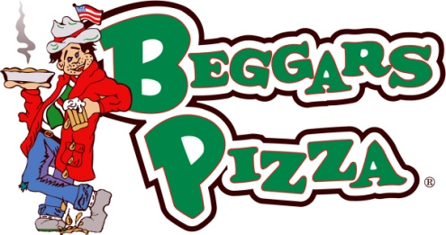
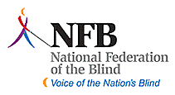
Support The National Federation of the Blind with Beggars Pizza at the locations listed below on Wednesday, April 20th, 2016. You can dine in; get a delivery or carryout to help The National Federation of the Blind raise funds. All you have to do is turn in this voucher when you pay and Beggars Pizza will donate 20% of your bill (before taxes, gratuity, promotions, discounts, delivery fees and coupons) to The National Federation of the Blind Chicago Chapter.

310 S. Clinton Ave. Chicago- West Loop 312-588-0055
Anytime Between 11:00am to 11:00pm

There are a few simple guidelines for the Eat & Earn Fundraiser Day:
- This voucher can only be used at the locations listed above on Wednesday, April 20th 2016.
- You must present and turn in the voucher when ordering/paying to have the percentage donated to your organization.
- Make sure to make plenty of copies for your family, friends, co-workers and supporters of your organization!
- Coupons, discounts, gratuities, delivery fees, promotional discounts and taxes will not be included in the bill total.
- Vouchers valid for all order types including- Carry out, Dine In and Deliveries.
- Please refrain from soliciting our customers, for the purpose of your event, outside our stores’ premises.

The National Federation of the Blind Chicago Chapter
Eat & Earn Fundraiser Day at Beggars Pizza

