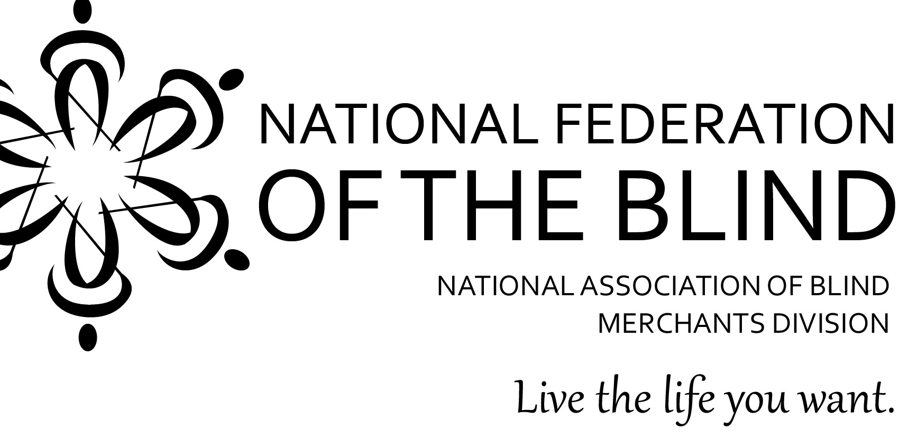

NATIONAL ASSOCIATION OF BLIND MERCHANTS
EMERGING LEADERS PROGRAM
Second Edition

Are you an aspiring leader? Do you want to make a difference? Do you want to be part of something very special? Do you want to preserve the Randolph-Sheppard Program for the next generation of blind people? Well, maybe the second edition of the National Association of Blind Merchants Emerging Leaders Program is right for you.

Who will be the Randolph-Sheppard leaders of tomorrow? Where are our future advocates? Where are the blind entrepreneurs who will set the example and find creative solutions to new challenges the next quarter century?

Leadership takes on many shapes and sizes. We need solid leadership on the state level as well as nationally. We need strong Elected Committees of Blind Vendors. Having capable blind people who can effectively advocate for themselves and the program is critical whether it be with government administrators or elected officials. The consumer groups also need effective leadership.

It is no secret that the Randolph-Sheppard population is aging and so is its leadership. It’s also no secret that the community has not done an effective job of developing the next generation of leaders. The National Association of Blind Merchants and the National Federation of the Blind’s Entrepreneurs Initiative are trying to help remedy that problem with our Emerging Leaders Program.

NABM President Nicky Gacos is making the Emerging Leaders Program a top priority because he believes in the future of the Randolph-Sheppard Program. He understands that tomorrow’s program will not look like today’s program but he wants blind people deciding what tomorrow’s program will look like. The Emerging Leaders Program will help develop our future leaders.

NABM is seeking people who meet the following criteria:

- Is a licensed Randolph-Sheppard vendor
- Possesses the desire to serve in a leadership capacity for the next decade and beyond
- Has a reputation as a quality business owner
- Has a history of being a positive influence
- Commits to devoting the time required to participate in this program, which will include some travel.

The Emerging Leaders Program will include:

- A two-day on-site training September 8-10, 2016, in Nashville, Tennessee at the Airport Marriott Hotel.
- Quarterly conference calls that will focus on leadership development and relevant issues impacting blind entrepreneurs nationally
- Special sessions at future BLAST conferences or at other times as might be determined

The current vision is to conduct training for new leaders on an annual basis. Each class will have approximately ten (10) participants. The alumni of all previous classes will participate on the quarterly conference calls and at the special sessions held in conjunction with BLAST.

One question that we can anticipate is who will pay for travel to the on-site training? The individual participant will be responsible for paying his/her own travel expenses or securing funding. NABM will encourage state licensing agencies to sponsor participants as several did last year. Training of this nature can be paid for with set aside and/or federal VR dollars as well as rest stop dollars. Other sources of funding should be considered. Based upon the availability of funds and the ability to get corporate sponsorships, NABM may consider financial assistance to those who simply cannot afford to attend on their own.

In order to participate in the Emerging Leaders Program, you do not have to be a member of NABM or the NFB. We welcome candidates who are not members. However, this is clearly an NABM/NFB Initiative and persons who have biases against either would not be good candidates for this program.

If you are interested in applying to be part of the Emerging Leaders Program, please visit www.blindmerchants.org where you can fill out and submit the application on-line or complete the attached application and email it to Terry Smith at tsmith@nfb.org. If you have questions about the program, you can contact either Ed Birmingham who President Gacos has appointed to lead this initiative.at 708-334-3243 or ebirm18@wowway.com. Also, feel free to call Nicky Gacos at 201-653-1777 or nickycolorado@netscape.net or Terry Smith at 865-599-7148 or tsmith@nfb.org.

The National Federation of the Blind knows that blindness is not the characteristic that defines you or your future. Every day we raise the expectations of blind people, because low expectations create obstacles between blind people and our dreams. You can live the life you want; blindness is not what holds you back.

