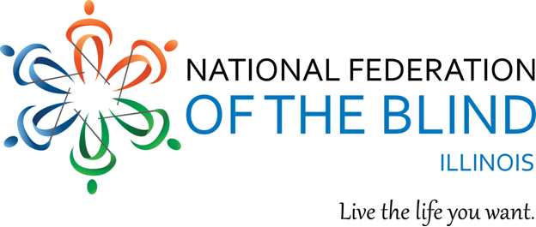
The Illinois Association of Blind Students, the student chapter of the National Federation of the Blind of Illinois, presents a 2017 Student Spring Seminar:

BEATING the BARRIERS

This year’s student seminar will be a full day of current and vital content for blind student success in education and life. We’ll have presentations by experts in topics of high interest to blind students, an engaging student panel, interactive workshops, energizing physical activity and more. This is a prime chance to network and share knowledge with blind students and professionals from near and far. The seminar will also include lunch and loads of valuable resources.
Here is what you want to know:
Who? | If you are a blind or low vision student, or you want to know more about and be a part of blind student life, this is your seminar!
WHEN? | Saturday, April 22nd, 2017
WHERE? | Holiday Inn Midway:  6624 S. Cicero Ave., Chicago, IL 60638.  To reserve your hotel room, call 708-563-6490. Tell the hotel you are booking with the National Federation of the Blind of Illinois for the special rate of $129 per night (plus tax).
HOW MUCH? | The Seminar costs only $15 per person. Financial assistance may be available for attendees outside Chicagoland through the NFBI Chappell-Dennis Memorial fund. Please apply by April 1,2017.
HOW TO REGISTER AND/OR APPLY FOR FINANCIAL ASSISTANCE: | Please register at the National Federation of the Blind of Illinois web site. Follow the links to Spring seminar.
WHY WAIT? | Registration ends April 14, 2017.
Special requests and questions should be directed to Emma Meyer at: MeyerEmma13@gmail.com. Sign up to our free listservs (IL-Talk and IABS-Talk) at nfb.org/listserv for updates and info (or to post questions or comments).
In the National Federation of the Blind, Blind Americans work together to break down barriers so that we can live the lives we want.

