**FOR IMMEDIATE RELEASE**

**Blind Beekeeper from Uganda Wins International Award to Support Blind and Low Vision Entrepreneurs**

*‘Hive Uganda’ Founder plans to bring honey production and beekeeping training to the blind community of Uganda as an inaugural winner of the Holman Prize.*

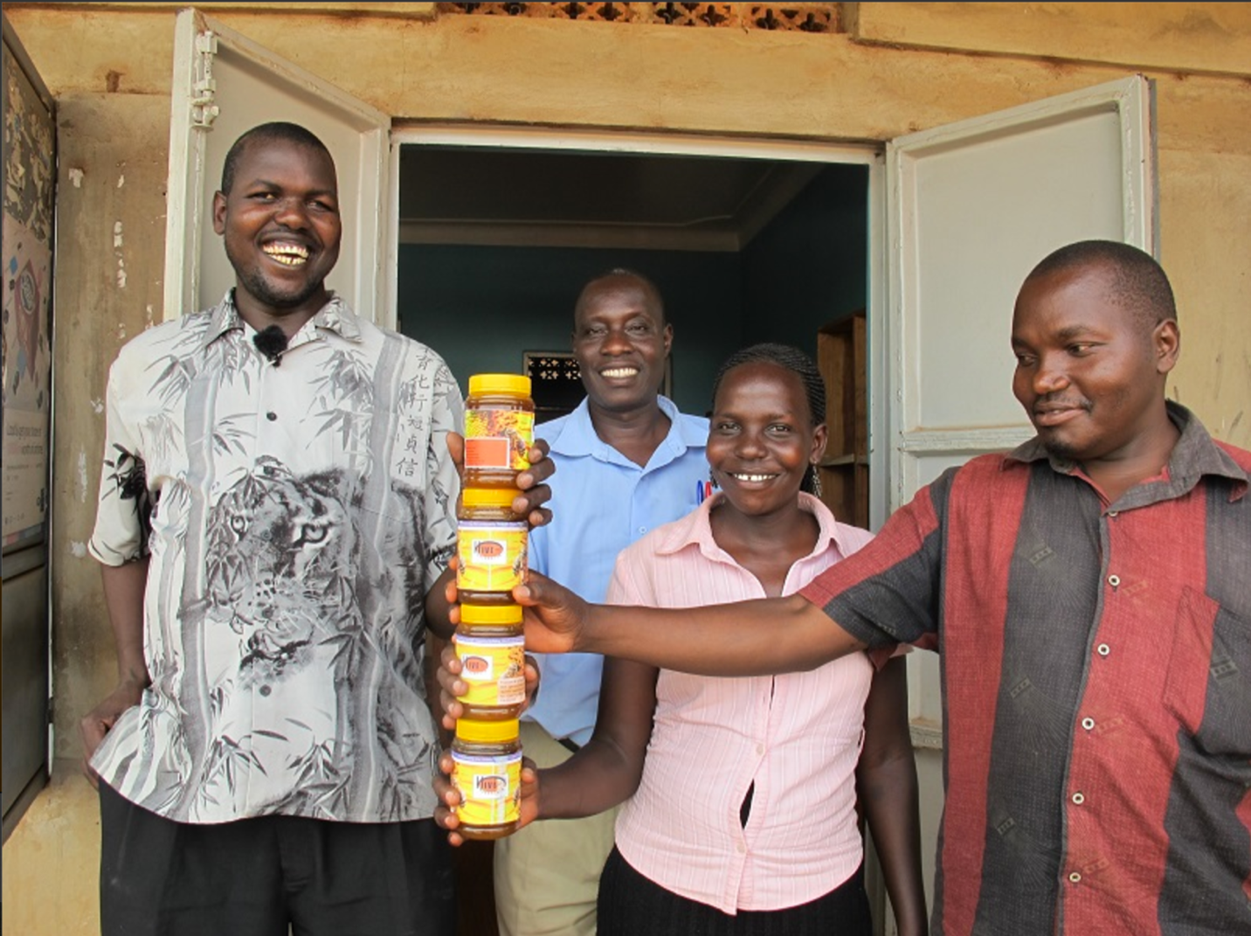

*Image: Ojok Simon, at left, holds jars of honey and stands with his colleagues.*

**GULU, UGANDA – June 29, 2017 –** Imagine tending a beehive – or a whole farm of bees – with hundreds of thousands of buzzing, pollen-loving insects crawling all over you, stingers at the ready. Now imagine doing it blind. Unimaginable for most, this is just a normal day for Ojok Simon.

Today, Ojok became one of the three inaugural winners of the [Holman Prize for Blind Ambition](http://www.holmanprize.org) – an unprecedented $25,000 award for blind and low vision adventurers offered by the [LightHouse for the Blind and Visually Impaired](http://www.lighthouse-sf.org) in San Francisco.

Ojok, who is in his mid-thirties, lost his vision more than 20 years ago when Ugandan rebels beat him severely and he incurred serious head injuries. Due to a lack of medical attention, his vision quickly deteriorated. Yet he didn’t stop pursuing his education, or later, his passion for beekeeping.

“I was walking in the bush closed to our home, when I found a clay pot with bees and honey inside,” says Ojok. “That became a turning point for me.” Now with more than 100 colonized hives, Ojok has become somewhat of a celebrity in his community – even more so now that he can call himself one of the three first-ever recipients of the Holman Prize.

Intriguingly, centuries before Ojok began cultivating honey, the scientific understanding of beekeeping biology was first worked out by a blind scientist, François Huber, who met blind adventurer James Holman during his world travels in the 19th century.

Ojok’s name was announced today along with two others, Penny Melville-Brown (UK) and Ahmet Ustunel (US by way of Turkey), who represent a wide variety of ambitions and geographical areas, with blindness being the unifying factor. Ojok will use the $25,000 Holman Prize to teach blind and low vision Ugandans to become beekeepers and entrepreneurs as part of his [HIVE Uganda](http://www.hiveuganda.org/) program. “I always feel a lot of pain when I see blind and partially sighted people living below the poverty line with limited employment opportunities,” he says.

The award will provide Ojok’s trainees with 60 high quality beehives and the necessary honey extraction equipment, as well as honey harvesting suits, gloves and boots, for a new generation of blind and low vision beekeepers. “I will prove to the whole world that being ‘out of sight’ does not mean ‘out of mind,” says Ojok.

[**Read about all three Holman Prize winners in-depth**](http://lighthouse-sf.org/blog/lighthouse-announces-three-inaugural-holman-prizewinners/)**.**

**Holman Honorees:** [**Meet this year’s finalists**](http://lighthouse-sf.org/blog/announcing-the-2017-holman-prize-finalists/)**.**

[**Meet the blind judges who picked the winners**](http://lighthouse-sf.org/blog/holman-committee-meet-the-blind-judges-selecting-our-inaugural-prizewinners/)**.**

[**Support The Holman Prize**](https://www.holmanprize.org/donate)

The LightHouse for the Blind and Visually Impaired, which is a 501(c)(3) nonprofit organization based in San Francisco, is actively seeking sponsorships and support for the 2018 Holman Prize, including donations of equipment for the winner’s projects. To offer your support, contact [holman@lighthouse-sf.org](mailto:holman@lighthouse-sf.org). Individuals may donate any amount using [LightHouse’s secure form](https://secure.qgiv.com/for/thp). For sponsorship inquiries, email us or call +1 (415) 694-7333.

**About LightHouse for the Blind and Visually Impaired**

Founded in 1902, San Francisco’s LightHouse for the Blind and Visually Impaired promotes the independence, equality and self-reliance of people who are blind or have low vision. LightHouse offers blindness skills training and relevant services such as access to employment, education, government, information, recreation, transportation and the environment. LightHouse also pursues the development of new technology, encourages innovation, and amplifies the voices of blind individuals around the world. To receive services, volunteer or make a donation, visit [lighthouse-sf.org](http://lighthouse-sf.org/).

**CONTACT**

**Will Butler, Director of Communications**

**+1 (415) 855-1642**

**press@lighthouse-sf.org**