Homewood-Flossmoor, ILAdvertise Log inSign up
- 81°F
- Nearby
- Local News
- Neighbor Posts
- Classifieds
- Calendar
- Real Estate
- Town Info
- Get Tickets

Sports
Shared from Chicago, IL

Blind Teen Triathlete Races For National Titles With Racing Buddy

Fast Friends: After Owen Cravens suddenly lost his sight. he partnered with Eric Palmquist to become a national champion paratriathlete.

By Phil Rockrohr, Patch Contributing Writer
Blind teenager Owen Cravens (right) competes in paratriathlons with the help of his racing guide Eric Palmquist. (Photo provided)
NILES, IL — From the front seat of a tandem racing bicycle, 15-year-old Eric Palmquist spotted a sharp turn, a crosswalk with potential pedestrians, bumpy pavement and two sets of train tracks rapidly approaching. He shouted warnings.
"Watch for the gaps between concrete and the tracks. Angle the bike, but lean less." Eric barked to his racing partner, Owen Cravens, who is legally blind.
That was two years ago, the first time the teen triathletes joined forces — tethered to each other for a 750-meter open-water swim, then a 20K bike race and a 5K sprint to the finish line. It's Eric's job to keep Cravens on track.
"We had to communicate. ... It was not a very friendly bike course," Cravens said. "You have to have a big degree of trust."
"It takes a lot of focus," Eric said. "When you're on the bike, it's not to be an easy pilot. It's meant to go fast. A race car is not easy to drive. If I mess up, I'm not just hurting myself."
After that race — particularly on the bike ride — it was clear to both boys that they made a good team. Better than good. With Eric as his guide, Cravens has developed into a two-time national junior paratriathlete champion. In March, Cravens finished fifth at his first international competition.
For Owen, each race gets him closer to his ultimate goal of competing with the U.S. Paralympic team at the 2024 games in Paris. Owen's mentor, Aaron Scheidies — a visually impared tri-athlete who competed in the 2016 Paralympic Games in Rio — says the Huntley High School junior has a real shot at earning a spot on the national team one day.
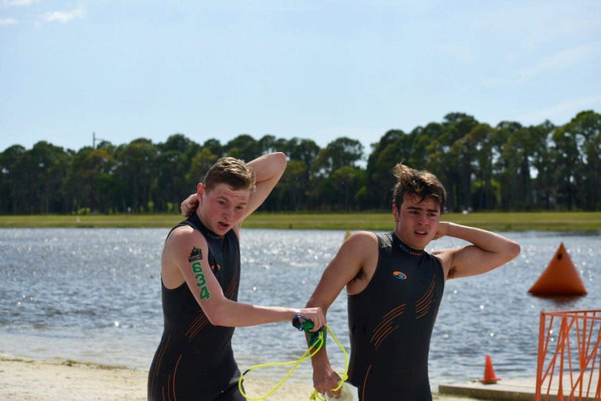Blind triathlete Owen Cravens swims tethered to his race guide Eric Palmquist. (Photo provided)
"Owen has drive, is focused and is passionate about where he wants to go," Scheidies said.
Six years ago, Owen's athletic future wasn't nearly as bright. He was a gifted youth soccer player until he suddenly started having trouble seeing the ball and had to give up his favorite sport. Owen started running cross-country and competing in triathlons when his vision started to rapidly deteriorate. During his fourth triathlon, Owen lost his way on the bike course.
"I felt confused, Owen said. "I didn't know what was happening."
Glasses did not help. Owen's parents tried vision therapy for six weeks with the hopes that it would improve his sight. During a follow-up visit with his optometrist, Owen couldn't read the top line of the eye chart. "The doctor said, 'We've got a problem,'" Owen's mom, Deidra "Dede" Cravens, said. "'Something else is going on.'"
A specialist diagnosed Owen with Stargardt Macular Degeneration, a condition that causes progressive damage to the part of the retina responsible for sharp, straight-ahead vision. Three other doctors confirmed the diagnosis.
"When the first ophthalmologist told Owen, he was dry and blunt, a little rough for my taste," Dede Cravens recalled. The doctor told Owen he would lose his central vision but retain full peripheral vision. Owen said, "'OK, so I won't go completely blind,'" she said. "I'm trying to hold myself together and the doctor said, 'Yes, that's how it will be.'"
Owen said he never felt scared. "It was such a slow progression, it was not terrifying at all," he said. "But it did change how I did things. I used to do everything independently. And then I had to change sports."
Instead, he got angry. "I used to get really mad, like just not being able to see stuff in class, not being able to do as well in most sports," Owen said. He literally can't take the lead in a cross-country race because he needs someone in front to guide him. "It's gotten a lot better, but it happens every once in a while," he said of the anger. "It kind of builds up."
The rest of the Craven family was shocked by the initial diagnosis. "OK, we've got a kid losing his vision. What do we do?" Dede Cravens said. "We didn't know what blindness was. There was nothing to familiarize us with the blind world." But with the exception of complaining that he can't drive like the rest of his friends, Owen really has rolled with it. "As much of a struggle as it is, I have had moments, but I have not seen Owen have that moment," she said.
Dede Cravens said the family has surrounded Owen with support since his diagnosis at age 10. Owen says he has enough help to get him through the basic activities of everyday life, and his peripheral vision provides essential guidance. "I have pretty good-enough vision where I can avoid most dangerous stuff," he said.
The Cravens lean on their Christian faith to teach their kids that all things happen for a reason and use examples of their own past to illustrate the point. Owen's dad, Jerry Craven, was offered a soccer scholarship in high school, but turned it down after his girlfriend became pregnant. Dede grew up in an alcoholic home.
"We give them a Bible verse and try to explain God has a plan for all of us," Dede Cravens said. "I tell them, 'This sucks right now, but we'll get through this. These things happen to build your character and make you stronger and become who you're going to be. Everyday you're going to mess up and seem like you can't get through it, but you probably can.'"
Owen says faith provides moral guidance in his family. "You take on whatever's coming toward you head first," he said. "Be accepting and know the world is not going to be bad towards you. Even if you have something wrong with you. You always have the opportunity to prove yourself and prove somebody wrong."
Dede and Owen now say he was lucky he lost his vision in grade school. "It would be a lot harder if it happened now," Owen said. I would have my driver's license by now. It would definitely be a bigger change." Dede Cravens said she couldn't imagine dealing with it when he turned 16 earlier this month. "There is no good time to lose your vision but 10 years old is kind of a moldable age," she said. People who lost their vision say they know they got the diagnosis when they were supposed to get it."
Now, Owen's view of the road ahead is like looking through Vaseline-smeared glasses.
He refuses to let that stop him from, well anything. He attends Huntley High School with help from a "vision itinerant" and a computer loaded with special software that allows him to keep up with his classwork.
"I wouldn't say I'm bummed because (losing my vision) gave me tons of opportunities in my life," he said. "It just changed my life in a positive way. It helped me experience a different way of life," he said. "I have to adjust things for my well-being. I have to advocate more in general."
Owen's parents helped keep him racing by connecting him with groups that assist athletes with disabilities, including Chicago-based Dare2Tri Paratriathlon Club.
That's where racing coach Chris Palmquist first saw Owen in action.
"He was very fast, especially for his age," Palmquist said. She introduced Cravens to her son, Eric, at a triathlon club workout in St. Charles. "I thought they would have fun together," she said.
The boys became fast friends.
"I definitely felt some sort of connection to him and to the team," Owen said "It took off from there."
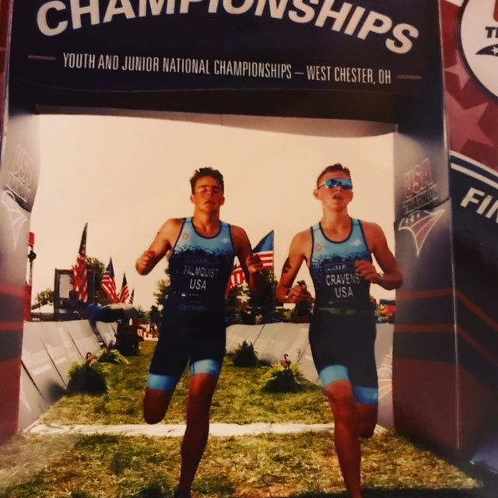Blind triathlete Owen Cravens (right) crosses the finish line with his racing guide, Eric Palmquist. (Photo provided)
Eric helped him connect his bike to Computrainer, an antiquated Nintendo system that creates a virtual riding landscape using modern Windows software, and guided him through practice. Over the years, they've traveled to dozens of races and, Eric says, "bonded through arguments," as competitive boys sometimes do.
"Sometimes we're opposites, just to challenge each other," Eric said. "He's into EDM that comes with a parental rating, and I'm into indie folk, the cry in the tree kind of stuff."
Eric enjoys engaging in playful banter with Cravens, who isn't as shy anymore and quick to stand up for himself. The way Eric sees it, their disagreements are "opportunities to get my points across.
"Once in a blue moon, when [Cravens} happens to be right, I do learn something," Eric said.
Their arguments are mostly about simple things, like whether chemistry or physics is a better class, which is the best year of high school to take either, and which is more important in the real world. "He's very one-sided," Owen said. "Once he says something, he believes it and doesn't change his mind."
Eric laughs at the exchanges. "None of it is malicious," he said. "It's just in good fun."
On the race course, though, the boys are all business.
Before each race, they review every course terrain in great detail, making mental notes to ensure there are no surprises — particularly when they're peddling a tandem bike 40 mph downhill on hot asphalt or 23 mph on flat terrain — like the one time Owen convinced Eric to be a backseat driver in practice.
Owen wanted to try something different. He didn't know what it was like to ride the front end of a tandem. "I rode normal bikes all my life," he said. "It was difficult to steer it. We just basically fell off onto the street. It was not like a crash. It was more like a tumble. We fell over and got up. We were fine." For the record — Owen wants everyone to know — he's now fully capable of leading the tandem.
The boys have developed their own race language that Cravens calls "broken speak" that helps them communicate without disrupting their breathing.
"'Big tired, small energy, leg machines broke,' is a way we might say how exhausted we are," Eric offered as examples.
"We go hard enough that you can't have a descriptive conversation," Owen said. "You have to be efficient."
Up until this year, the boys have focused on training and competing in situations where they are largely trying to beat their own times and expectations. "It's difficult to compare times because every course and condition is different," Eric said. "We're comparing how well we've adapted to conditions. We're seeing how capable we are at handling certain courses."
This year they began racing competitively at the International Triathlon Union's Sarasota-Bradenton CAMTRI Sprint Triathlon American Cup in Sarasota, Florida.
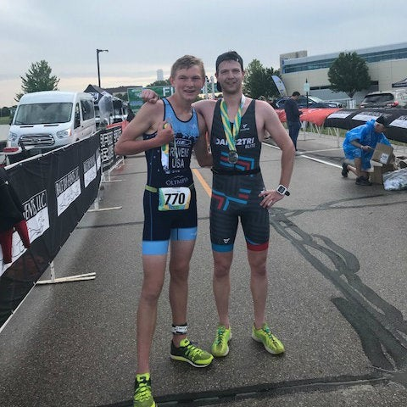Owen Cravens and Eric Palmquist (Photo provided)
In the fall, Eric will be a senior and Owen enters his junior year. Eric plans to go to college at a larger school such as the University of Iowa or Iowa State, both of which he visited this month while racing in Des Moines. Eric says he plans to continue competing as Owen's guide but knows that decision isn't up to him.
If Owen has what it takes to make the 2024 U.S. team, he and his parents will continue to seek sponsorship and grants to offset the cost of training and competing at that level — up to $50,000 a year. That much money is only required for overseas races, a competitive level Owen has not yet reached.
"We have means to do a lot out of pocket," Dede Cravens said. "It's hard to ask for money, but we have learned there are people who want to help disabled athletes and want to help us."
Will Eric be the one to guide Cravens there? Neither of the boys can see the future. The fact is that a paratriathlete's guide is as an important part of his race gear as his bicycle, running shoes and swim suit. That typically means taking on a seasoned professional triathlete suggested by the U.S. Paralympic Team committee.
"Even if Eric and I are great friends, I have to find the best [guide]," Owen said of their racing future. Eric says he's fine with whatever his racing buddy decides.
"That's still up to him and his personal path," he said. "I plan on at least continuing a heavy dosage of endurance sports for as long as I can. That plan is not dependent on him, but I can definitely accommodate any future endeavors."
On Saturday, Cravens will compete in the USA Triathlon Paratriathlon National Championships in Long Beach, California. It's the first paratriathlon national championship to offer a cash prize to the victors — $36,750 split among the winners in each division.
Because Palmquist needed to travel overseas with his cross-country team a few weeks before the national competition, Owen chose their coach, Ryan Giuliano, a semi-pro triathlete, to be his guide for the Long Beach race.
Still, the racing buddies expect to compete together again.
And when they do, Eric says, "We'll probably return stronger."
— Freelancer Mike Danahey contributed to this story.

