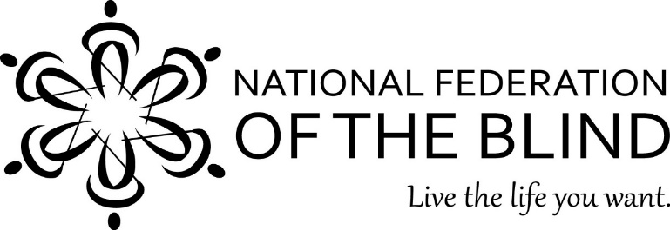
Illinois Association of Blind Students
2019 Teaching Excellence Award
Guidelines and Instructions

Background: The Illinois Association of Blind Students (IABS), a division of the National Federation of the Blind of Illinois and a chapter of the National Association of Blind Students, presents two Excellence in Teaching Blind Students Awards to deserving educators at the NFBI State Convention each fall. This year’s presentation will take place in Springfield, Illinois, on Saturday, October 19, 2019. IABS will present two awards to deserving teachers of blind children, teachers of blind adults, or general education teachers who have taught blind students in their classrooms. In order to qualify, the educator must provide educational instruction, training, resources or itinerant services to blind and visually impaired students in the State of Illinois.

Instructions: Please complete this form and submit it by September 2, 2019. You may email or mail your completed nomination form to:

Dkent5817@att.net

Deborah Kent Stein
5817 N Nina Ave
Chicago, IL 60631

If you have any questions, please write to the above addresses or call (773) 203-1394. No nominations will be accepted after September 2, 2019.

Illinois Association of Blind Students
2019 Teaching Excellence Award
Nomination Form

Name of Nominee: ___________________________________________

Please check one:

Teacher of Blind Children

Teacher of Blind Adults

General education teacher

School or Organization where Teacher Works: ____________________________

Teacher’s Phone Number: ____________________________________

Teacher’s Email Address: _____________________________________

Nominator’s Name (Person completing this form): __________________________

Nominator’s Phone Number: ___________________________________________

Nominator’s Email Address: ___________________________________________ _________________________________________

Please discuss the characteristics of the teacher that make her or him an excellent teacher of blind students. Be thorough and concise. Please limit your narrative to no more than 500 words.

