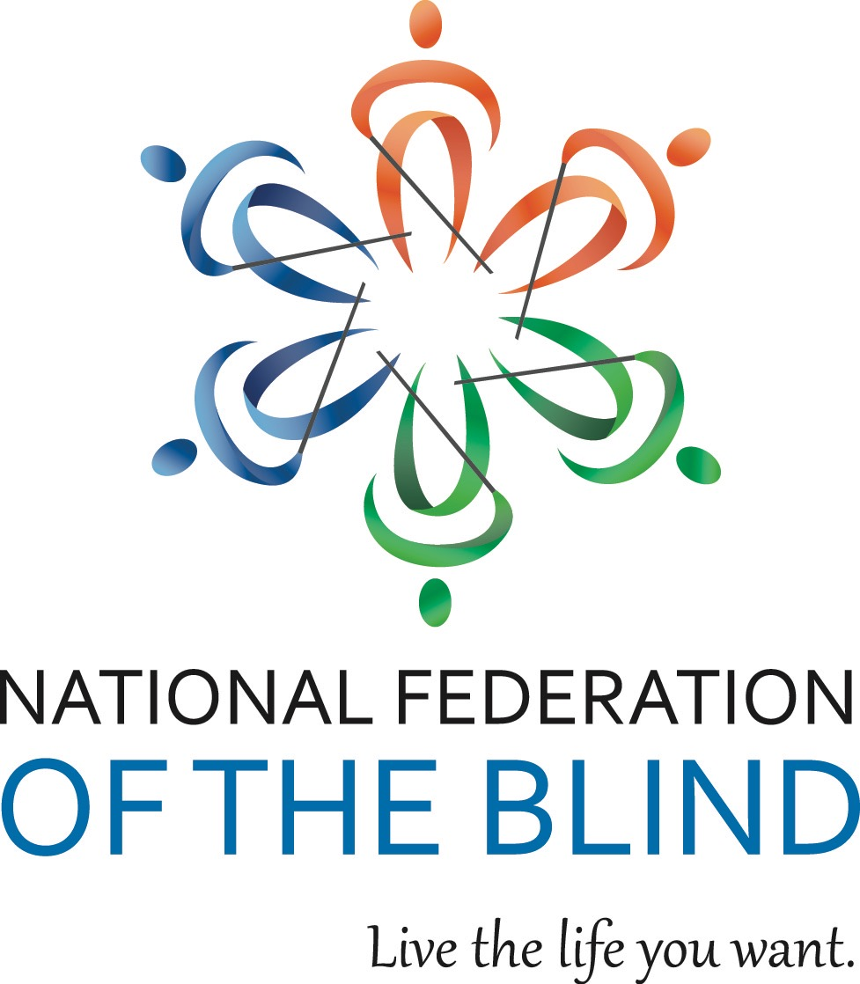

NATIONAL FEDERATION OF THE BLIND OF ILLINOIS
2019 CONVENTION BULLETIN

“ON THE CUTTING EDGE OF LEADERSHIP”

On October 18, 19, and 20, 2019, enthusiastic Federationists will assemble in Springfield, Illinois to renew our dedication in the pursuit of security, equality, and opportunity for all blind people.

The site for our convention will be the Wyndham Springfield City Center, 700 E. Adams St., Springfield, Il, 62701 phone 217-789-1530. Room rates are $99 per night plus applicable taxes. Please indicate that you are with the NFBI to get this special rate. Make reservations by calling 217-789-1530, Ext. 4111. Reservations must be guaranteed with a credit card or a one-night deposit. Our cutoff date for reservations is September 27.

This year’s convention will kick off on Friday with a fun sculpting activity. It will be followed by our resolutions committee meeting. Come learn and participate in our governing process.

The Resolutions Committee will be chaired by Patti Chang. ALL resolutions must be submitted by September 15, 2019. She may be contacted at (773) 307-6440 or e-mail at pattischang@gmail.com.

IABS IDOL will occur Friday evening. Those wanting to perform during the IABS Idol should contact IABS by e-mailing Ellen Bartelt at embartelt@gmail.com or calling or texting her at 608-556-5277. Please put IABS IDOL in your subject line.

Our general session will convene on Saturday, October 19, at 9 a.m. During Saturday’s general sessions we will hear a National Report regarding NFB happenings delivered by our National Representative, Dan S. Wenzel, Director of the Wisconsin Center for the Visually Impaired. We will have a report from the National Association of Blind Students by Elizabeth Rouse, a NABS board member.

We will have an employment panel facilitated by Doctor Brian Dulude, Assistant Director of Blind Inc., a presentation on the Illinois Achieving A Better Life Experience, (ABLE) program for people with disabilities. We will also be joined by Nancy Foster, supervisor of Region 5 of the Illinois Bureau of Blind Services to talk about services for the blind in our state, and two of the agencies counselors to register eligible customers with BBS. We will have breakout sessions on state legislation, Microsoft Office, and much more.

We will have a Saturday parent breakfast and a Sunday student breakfast. We will have both student and parent luncheons on Saturday. In addition, there will be a breakout session for parents of blind children.

Saturday evening will culminate with our annual banquet, featuring an inspiring address from our National Representative, Dan S. Wenzel. We will also see the much-anticipated scholarship awards.

Sunday morning’s general session will begin with Braille is Beautiful and we will hear from other blind people sharing their experiences. Resolutions will be voted on during the Sunday morning session. Adjournment is scheduled for 12:00 p.m. on October 20.

Advance registration for the convention made before October 4 is $5. Registration and meal preferences after that date or at convention will increase. This year you can register and pay online at www.nfbofillinois.org. Online registration is strongly preferred. If you need assistance with registering online, please call Patti Chang at 773-307-6440 or David Meyer at 708-606-7091.

We will host a meeting for parents of blind children at 7 a.m. on Saturday. The student business meeting will be held on Sunday morning at 7:00 a.m. These are both breakfast meetings.

Two breakfasts are planned. Their preregistration cost is $10. We will have two luncheons for all those interested in student and/or parent issues on Saturday. The cost for either luncheon will be $15 if you preregister. The banquet on Saturday night will start at 7 p.m. and tickets will cost $30 with preregistration.

Those with special dietary needs for any of the meals should contact Patti Chang, (773) 307-6440 or pattischang@gmail.com. The deadline for such requests is October 4.

Kids’ Kamp (childcare) will be available on Saturday from 8:30 a.m. to 5:30 p.m. Kids’ Kamp is free to all children ages 3 to 12 who are registered for the convention. A separate release form must be filled out at time of drop-off.

Federation conventions change the lives of blind and sighted people alike! Don’t miss out on this opportunity for change! Join us for our best convention yet! Come and live the life you want!!!

