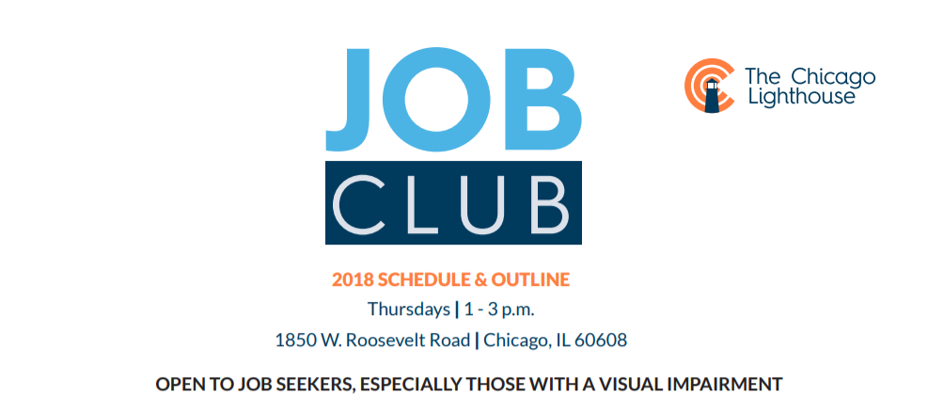

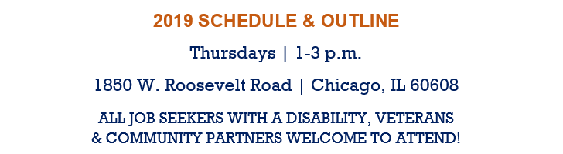
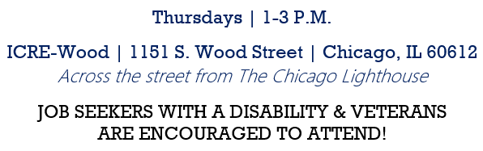
Mondays 1:30 – 3:30 PM
The Chicago Lighthouse l 1850 West Roosevelt Road
Chicago 60608

DATE | ITINERARY

September 23 | Employment Goals
September 30 | Marketing Yourself
October 7 | Social Security Benefits

October 14 | Financial Literacy
October 21 | Resumes, Cover Letters & Job Applications
October 28 | Federal and State Employment
November 4 | Disability Disclosure/Employment & the ADA

November 11 | Interviewing Techniques / Mock Job Interviews
November 18 | Transportation Options
December 2 | Assistive & Adaptive Technology
December 9 | Long Term Success in Your New Role

If you need an accommodation or use of a sign language interpreter, please notify us at least one week in advance of the session.

Questions or RSVPs:
Maureen Reid, Job Placement Counselor & Scholarship Coordinator Maureen.Reid@chicagolighthouse.org | 312-666-1331 Ext. 3655

